

United Nations Development Programme
Country: CHINA
PROJECT DOCUMENT

Project Description: Enabling Solid State Lighting Market Transformation & Promotion of Light Emitting Diode (LED) Lighting

UNDAF Outcomes: Main outcomes of UNDP strategic planning on environment and sustainable development:

Secondary Outcomes of UNDP strategic planning: Improve the quality of SSL, and promote the widespread application of SSL products in China
Expected CP outcomes: Apply and implement appropriate policies, laws, rules and regulations to establish and operate a sustainable financial and delivery mechanism
Expected CPAP outcomes: Establish energy efficiency policy and system, promote investment and financing for energy efficiency, improve the quality and output of SSL products and save the energy sources
Executing entity: National Development and Reform Commission of the PRC
Enforcement entity: National Energy Conservation Center of the PRC

Brief Description

This project aims to reduce energy consumption for lighting in China through the improvement of the quality and energy efficiency of lighting products and promoting their application to save electricity and reduce the greenhouse gas emission directly or consequentially. This will be facilitated through the improvement of the quality and energy performance of locally produced solid state lighting (SSL) products, and popularize and promote the widespread application of such lighting products in China. A carefully designed set of activities will be carried out under this Project to achieve the following outcomes: (1) Enabling of enhanced and strategic SSL technology and market developments based on comprehensively assessed and documented up-to-date status of the SSL industry and market in China; (2) Facilitation of support and incentives in the local production of quality SSL products, and in the application of SSL products compliant with established quality and energy performance standards; (3) Increased penetration rate of SSL products especially in the residential sector in China; and, (4) Enhanced quality and energy performance of locally produced SSL products both for the domestic and international markets. The project is expected to bring about increased utilization of SSL products in lighting system applications in the country, which are expected to be energy saving, and consequently contribute to the country’s global climate change mitigation targets.

Program Period: 36 months  Atlas Award ID: 87736  Atlas Project ID: 94657  PIMS: 5120  Start Date: 1 February 2016  End Date: 28 February 2019  Management Arrangements: NIM | Total Resources Required: USD 32,697,694  Total Allocated Resources: USD 32,697,694  GEF: USD 6,242,694  Government: USD 25,300,000  UNDP: USD 225,000  Industrial Association: USD 930,000

Agreed by (Government):
Date/Month/Year:

Agreed by (Executing Entity/Implementing Partner):

Date/Month/Year:

Agreed by (UNDP):
Date/Month/Year:
Table of Contents

List of Acronyms 4
Ⅰ Situation Analysis 7
1. Context and Global Significance 7
2. Barrier Analysis 12
3. Stakeholders Analysis 14
4. Baseline Analysis 16
Ⅱ Strategy 18
1. Project Justification and Policy Conformity 18
2. Country Eligibility 19
3. Country Driving Factors 20
4. Designing Principles and Strategic Considerations 20
5. Alternative Scenario 20
6. Project Goal, Objective, Outcomes and Output/Activities 21
7. Key Indicators and Risks 40
8. Cost Effectiveness 42
9. Sustainability and Scaling-up Potential 43
Ⅲ Project Results Framework 45
1. PRF List 45
2. Total budget and workplan 47
Ⅳ Management Arrangements 55
1. Project Institutional Framework 61
2. General Arrangement 63
Ⅴ Monitoring Framework and Evaluation 64
Ⅵ Legal Context 67
AnnexⅠ: Risk Analysis 68
Annex II: CO-FINANCING LETTERS 72
Annex III：Estimation of GHG Emission Reductions 76
Annex IV: Annual Project Targets 81
Annex V: Terms of Reference for Project Staff and Consultants 83
Annex VI: Description of Demonstrations 86
ANNEX VII: Service Agreement between UNDP and NDRC…………………..93
ANNEX VIII: Social and Environmental Screening……………………………96

List of Acronyms

ACRONYM | MEANING
AQSIQ | General Administration of Quality Supervision, Inspection and Quarantine
APEC | The Asia-Pacific Economic Cooperation
BRICS | Brazil, Russia, India, China, South Africa
C&R | Commercial and Residential
CALI | China Association of Lighting Industry
CDM | Clean Development Mechanism
CFL | Compact Fluorescent Lamp
ICFL | Integrated Compact Fluorescent Lamp (i.e. including electronic ballast)
CHUEE | China Utility-Based Energy Efficiency
CICETE | China International Center for Economic and Technical Exchange
CIP | Cleaner Industrial Process
CNIS | China National Institute of Standards
CO2 | Carbon Dioxide
CSC | China Standards Certification Center
CSA | China Solid State Lighting Alliance
CTA | Chief Technical Advisor
DSM | Demand Side Management
EE | Energy Efficiency
ELI | Efficient Lighting Initiative
EMCA | Energy Management Company Association
EOI | Expression of Interest
ERI | Energy Research Institute
ESL | Energy Saving Lamps
EUEEP | End-Use Energy Efficiency Project
FL | Linear Fluorescent Lamp
FSP | Full-Size Project Document
GDP | Gross Domestic Product
GEF | Global Environment Facility
GHG | Greenhouse Gas
GLIC | Green Lights Information Center
GLS | General Lighting Service
GOC | Government of China
GWh | Giga Watt Hours = 10⁹ Wh
Hg | Mercury (chemical)
IFC | International Finance Corporation
IL | Incandescent Lamp
ISA | International SSL Alliance
kW | Kilowatt = 1000W
LED | Light Emitting Diode
LFA | Logical Framework Analysis
M&E | Monitoring and Evaluation
Mtons | Million Tons
MIIT | Ministry of Industry and Information Technology
MOF | Ministry of Finance
MOHURD | Ministry of Housing and Urban-Rural
MOST | Ministry of Science and Technology
MT | Metric Tons
MWh | Mega Watt Hours = 106 Wh
NDRC | National Development and Reform Commission
NECC | National Energy Conservation Center
NLTC | National Lighting Test Center
NPD | National Project Director
OLED | Organic Light Emitting Diode
PAC | Project Assurance Committee
PIF | GEF Project Identification Form
PILESLAMP | Phasing-out of Incandescent Lamps and Energy Saving Lamps Promotion
PMO | Project Management Office
PPP | Public Private Partnership
SAC | Standardization Administration of China
SSL | Solid State Lighting
TWh | Terra Watt Hours=1012 Wh
UNDP | United Nations Development Programme

List of Figures

Number | Title | Page
1 | Output of all kinds of lighting products of China | 10
2 | Domestic market share of LED lighting products of China (domestic sales volume) | 10
3 | Export market structure of China’s LED lighting products in 2014 | 11
4 | Comparison for the domestic market shares of quality standard compliant LED lighting products with and without GEF fund | 22

List of Tables

Number | Title | Page
1 | Comparison of Lighting Efficiency of Main LED Lighting Products and Traditional Lighting Products in 2014 | 8
2 | Comparison of Full Life Circle Energy Consumption of Three Light Sources | 8
3 | Work Plan and Budget for Evaluation | 61

ⅠSituation Analysis

1. Context and Global Significance

- Lighting is an important necessity for people, for society and for almost all human activities. It is also accounts fora significant portion of energy consumption both at the sectoral, national and global levels. Currently, global lighting energy consumption accounts for about 19%of the global electricity consumption. This is equivalent to 8.9% of worldwide energy consumption and accounts for 0.63% of the global GDP. The popularization of green lighting technologies has become an effective option for countries all over the world to promote and realize energy savings and GHG emission reductions in tackling the global issue of climate change.

- Mankind has been using electric lamps since the incandescent lamp was invented in 1879. With the progress of lighting technology, various kinds of new lighting devices have been developed to further enhance the quality of lighting but also improve lamp efficacy. The current electric lighting technologies that are available in China include: (a) thermal radiation lamps (e.g., incandescent lamps, halogen tungsten lamps); (b)gas-discharge lamps (e.g., fluorescent lamps, high pressure mercury lamps, high pressure sodium lamps, metal halide lamps); and, (c)solid state lamps (e.g., light emitting diode (LED) and organic light emitting diode (OLED) lamps.

- Solid State Lighting (SSL) refers to the lighting devices made from semiconductor materials and organic materials. These have such advantages as low power consumption, long life, rich colors, as well as good applicability and controllability. Since heavy metal elements such as Hg are not added during the manufacturing of SSL products and with long life and high lamp efficiency, these are becoming popular application products in the area of green lighting. SSL technology is recognized worldwide. In 2014, three inventors of blue LED were awarded the Nobel Prize in Physics, which brought the SSL into the public view, and also represented the highest recognition of the development and energy conservation value of the SSL industry.

- SSL has tremendous energy saving potentials. The maximum theoretical lamp efficacy of LED lamps is 370 lm/W. At present, the typical efficacy of LED lamps is more than 75lm/W. Incandescent lamp, CFL and LED lamp share the same life cycle energy consumption percentage, i.e., more than 90% at service stage, and less than 1% at manufacturing and transportation stage. In 2011, the energy consumption of an incandescent lamp is nearly 4 times of that of a LED lamp (based on the same illumination level). With the technical progress for LED, it is expected that the life cycle energy consumption of incandescent lamp in 2015 will be 8.6 times of that of a LED lamp, and the energy consumption of CFL will be about 2.2 times of that of an LED lamp.

Table 1: Comparison of Lighting Efficiency of Main LED Lighting Products and Traditional Lighting Products in 2014

LED Lighting Products | Lighting Efficiency (lm/W) | Traditional Lighting Products | Lighting Efficiency (lm/W)
LED bulb | 75 | CFL/halogen lamp/incandescent lamp | 65/20/15
LED spotlight | 75 | Halogen tungsten lamp | 20
LED tube lamp | 100 | T8 fluorescent tube | 80
LED down lamp | 80 | CFL | 65
LED street lamp/tunnel lamp | 110 | High pressure sodium lamp(light source) | 110

Table 2: Comparison of Life Circle Energy Consumptions of Three Light Sources
Unit: MJ/20M lumen-hours

Life Cycle Stages | Incandescent Lamp | CFL | LED Bulb (2011) | LED Bulb (Expected by 2015)
Production of raw materials | 42.2 | 170 | 87.3 | 58.5
LED packaging | - | - | 256 | 73.0
Subtotal of manufacture | 42.2 | 170 | 343 | 132
Logistics | 0.27 | 1.57 | 2.71 | 1.69
Use | 15,100 | 3,780 | 3,540 | 1,630
Total energy consumption of each lighting service | 15,142 | 3,952 | 3,886 | 1,764

- Under the influence of the need to save energy and compliance with environmental protection regulations, countries all over the world have begun to use more energy efficient lighting products, as well as issue orders/regulations to restrict or ban the use of less efficient lighting products such as the incandescent lamp. Since 2014, some countries have banned the use of incandescent lamps. For example, since 1 January 2014, incandescent lamps above 40W have been banned for sales in the USA; and, China prohibited the selling or importing of incandescent lamps above 60W for use in general lighting starting 1 October 2014. It can be expected that the global lighting demand will continue to increase in the future, and the use of more energy efficient lighting products and systems (i.e., green lighting) will be among the typical interventions countries will carry out in contributing to the worldwide effort to save energy and deal with the issue of climate change.

- The SSL industry in China has been growing at a rapid pace. With the technical progress and increased market demand, the scale of global SSL market is constantly expanding, as the technical breakthrough exceeds expectation and products are updated rapidly. The forms and business models of lighting industry will experience earthshaking changes in the future.

- China has become the biggest energy consumer in the world. Suppose the energy consumption per GDP of every five years reduces by 20% continuously, the energy consumption of China after 2019 will account for more than 30% of the world’s total energy consumption. At present, China tops the world in power generating capacity. The total power generating capacity of China in 2014 was 5.55T kWh, with a year-on-year growth of 3.6%.The country-wide electricity consumption is 5.52T kWh, with a year-on-year growth of 3.8%.More than 80% of the electricity production in China is based on thermal power generation (mainly using coal), making the power generation industry an important source of carbon emission. The carbon emission of coal-fired power generation in China accounts for nearly half of the country’s total carbon emission. Thus power generation not only causes large amount of coal consumption, but also becomes a major source of pollution (air, water and land).

- In 2012, the lighting energy consumption of China accounted for 13.79%of the total electricity consumption of the whole country. Since the Green Lighting Project was implemented in 1996, significant amounts of lighting energy saving has been achieved. The UNDP-GEF project on phasing out incandescent lamps and promoting the utilization of energy saving lamps implemented from 2009 to 2014 has pushed the country’s efforts in the area of lighting energy savings into a new level, one that has brought more development opportunities for more energy efficient lighting technologies such as solid state lighting (SSL).

- China is a major producer and consumer of lighting products (including SSL or LED products). The quality and energy efficiency of China's lighting products has made great contributions to the lighting power saving and greenhouse gas emission reduction of China and even the world. The volume of lighting products (all types) that were made in China in 2013 was about 18.8 billion pieces, ranking the country top in the world in lighting products production. The CFL production was about 5 billion, accounting for more than 70% of the world output. The general LED lighting products production in 2014 was about 1.67 billion, with domestic sales of about 0.75 billion. The domestic market share (domestic sales quantity of LED general lighting products/total domestic sales quantity of general lighting products) of general LED lighting products reached 16.4%, 7 percentage point higher than the 8.9% in 2013.

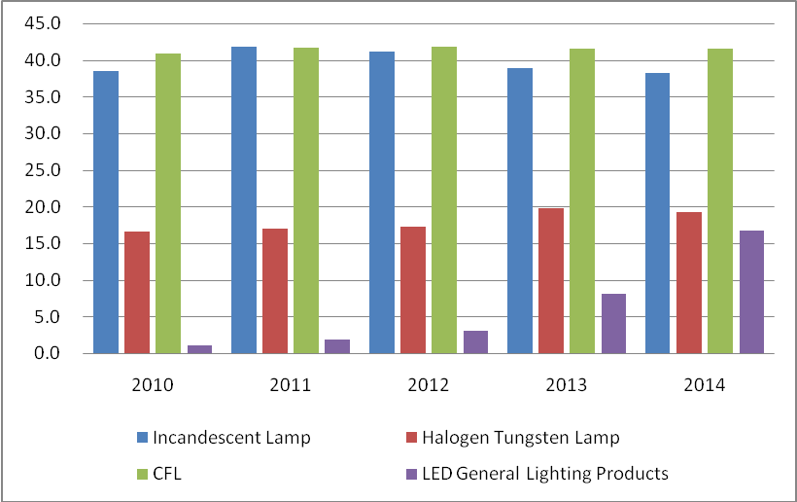

Fig. 1: Output of All Kinds of Lighting Products in China（Unit:100Million pcs）

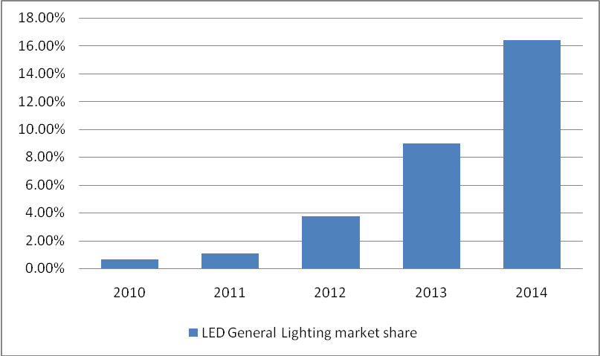

Fig. 2: Domestic Market Share of LED Lighting Products (Domestic Sales Volume)

- China has become a main exporter of LED lighting products in the world. At present, China's LED lighting products exports to three main markets in the world: European Union, United States of America, and Japan account for 50.2% of its total exports. There are also new markets for Chinese-made LED products such as the BRICS countries, and those in the Middle East and Southeast Asia. The share of the locally produced LEDs in the country’s export market in the BRICS countries has increased by 6.8%, Middle East by 2.1% and Southeast Asia by 1.3%. This type of information gives a general impression that there is already substantial progress made in quality improvements in the SSL industry in China. However, hearing the views and concerns of the local lighting industry (e.g., NDRC, China Solid State Lighting Alliance, Standards Administration of China, International SSL Alliance), and reading articles in the China Daily News like “EU and U.S. Technological Barriers Besiege China LED Lighting Exports Again”, indicates there is something wrong in the industry. The often reported booming SSL products industry in the country is mainly in terms of SSL product exports (mainly those consigned to foreign buyers that have to comply with quality requirements), and does not include those that are low quality products that are sold domestically, and in some cases illegally sold across borders to other Asian countries. The low quality of SSL products in the local market is one of the main causes of consumer avoidance of using such lighting products. Thus it can be seen that the quality and output of China's LED lighting products production will be an important factor in the global popularization of high efficient lighting products.

- The government-led SSL demonstration project has promoted the applications of SSL in, a series of application demonstrations during the Beijing Olympics, Shanghai World Expo, and in the recent APEC Summit held in Beijing. In addition, there was also the SSL application demonstration project by the three ministries including NDRC, MOST and MOF that promoted the technical innovation and large-scale application of SSL products. Such demonstrations also generated a wealth of experience in conducting market-oriented pilot demonstrations.

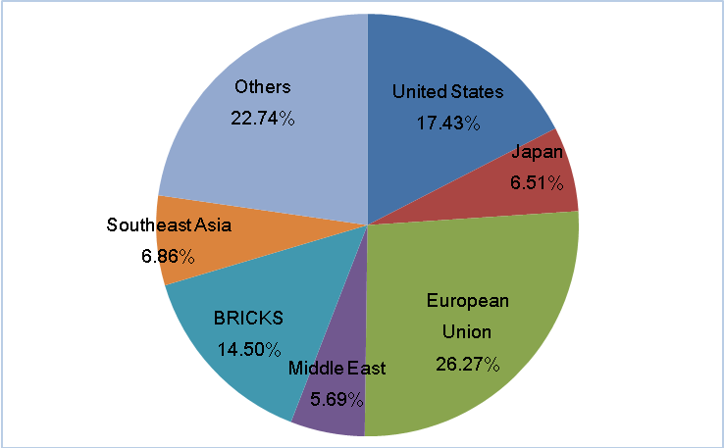

Fig. 3 Export Market Structure of China's LED Lighting Products in 2014

- As a consequence of rapid urbanization, the rate of growth building construction in China has increased. This created a very significant market demand for lighting products. By 2019, up to 14 million people are expected to move into towns or cities, generating substantial potential market demand for green lighting products including LED lamps for lighting streets and public and residential buildings.

- At the end of 2012, there were still 597 thousand families (or 2.527 million people) suffering from power shortage. Characterized by low-voltage and direct current, the SSL is suitable for lighting as is or in combination with alternative energy sources (e.g., solar and other renewable energy resources, particularly in off-grid locations). The popularization of off-grid LED lighting system can improve the quality of life for people in remote areas that are currently without power supply.

- SSL products manufacturing has become a major field for investments. In 2014, investments in China's SSL industry, was very significant. There were several applications for SSL manufacturing investments and the number of such projects reached more than 200, accounting for 74.6%of the total investment projects. In addition, the large-scale mergers, acquisitions and reorganization of the lighting industry chain also brought good opportunities for foreign investments in SSL manufacturing. This however resulted in many of these new manufacturing entities producing so much SSL products, with qualities that are generally suspect. Low quality SSL products flooded the market, and almost 50% of the annual SSL product output were adjudged as of low quality.

- The Chinese government has also incorporated SSL into the strategic merging industry as an important part. In recent years, several central government departments including NDRC, MOST, MIIT, MOHURD and AQSIQ have issued many policies measures, including Guidelines on SSL Energy Saving Industry Development, SSL Energy Saving Industry Planning and SSL Technology Development Planning, to promote the technical innovation and industrial development of SSL design and manufacturing.

- Although China’s SSL industry has made a remarkable progress, the improvement of the quality and energy performance of Chinese-made SSL products and popularization of the application of these products still face a lot of challenges although there are a lot of improvement opportunities, in contrast to the great market space and energy saving benefits. The main reasons for this include:

- Data gathering, investigation and analysis systems are still not well-established for the SSL industry. Hence, the timely availability of relevant information concerning the industry and technology developments cannot be followed closely; and the formulation, approval and enforcement of much needed policies cannot be effectively supported;
- Relevant support policy and regulatory framework systems such as technical innovation, quality improvement and application promotion for SSL products are inadequate to support the rapid development of the local SSL industry;
- There are very limited documented on-the-ground applications of SSL technologies that can be used as models or at least reference for the widespread promotion and use of SSL in lighting systems (new and retrofit); including market-oriented mechanisms for financing SSL initiatives. This contributes to the current status of SSL not being popular and consequently lower than expected penetration rates; and,
- Outdated system of SSL product certification characterized by not up to date SSL product standards (quality and energy performance), and non-established and non-enforced SSL application specifications and guidance. These led to the current inadequate system for controlling the quality of SSL products that are produced and sold within, and outside, the country.

In summary, the main problem that affects the widespread production and utilization of SSL in China is the low quality (durability and energy performance) of locally produced SSL products. All of the above barriers contribute to this core problem.

2. Barrier Analysis

- The current state of affairs in the local SSL industry and market in China is the proliferation of locally made low quality SSL products and the rather low level of application of SSL in the country. This problem is caused by 4 main problems or barriers to the widespread domestic production and utilization SSL products in China. These main barriers are the following:

    - Lack of Systematic Analysis on Status of SSL Industry and Applications - The Chinese SSL industry is rapidly growing along with its associated value chain and broad applications. At the same time, the ongoing development work of various entities involved in the local SSL industry is opening up with different types of SSL products for different applications. Since there is currently no GOC agency that is specifically responsible for the industry, the various SSL manufacturers in the country adopt different methods and tools for accounting their respective production volumes and sales data. Moreover, there is no single category or classification code for the SSL industry in the Chinese statistical system, and there is also no specific custom code for SSL products. To date, there are lots of discrepancies between the production and sales data about the China SSL industry issued by the China Solid State Lighting Alliance or the other organizations and institutions. In this regard, there are currently no reliable and accurate global SSL industrial and market data. The information from leading marketing and consultant companies are also not accurate, making the comparison of the SSL industries between different countries not reliable. In addition, given the lack of comprehensive industry data monitoring and analysis system, the environmental, social and economic impacts of the SSL industry have not really been fully understood. As in any industry, it is essential to have a reliable data monitoring and analysis system for the local SSL industry, including that of the associated value chain. Currently, the available data are from various statistics gathered and published by various sources. These various sources do not even have common definitions of terminologies used. Without the first hand, reliable and timely information at national level, it is hard for both the national and provincial governments to formulate and enforce appropriate policies to address the specific needs of this industry. There is urgent need to come up with a unified/integrated monitoring and analysis system for the industry, and to make the information available to the public.

    - Absence of a Systematic Supporting Policy Framework on SSL Market Transformation – The Chinese SSL industry is one of the country’s strategic emerging industries. While there is an officially mandated national government agency to administer it, there have been several government ministries, such as NDRC, MOST, and MIIT that have, in one way or another, carried out initiatives towards the development of this industry. Although several SSL-related policies have been issued, because of the lack of cross-ministerial synergy, these policies proved to be ineffective due to lack of appropriate institutional structure or mechanism. Moreover, these policies are not integrated. New business models, such as energy management service and other incentive mechanisms are not existent. Clear strategy and policies of balancing the SSL product development with that of other energy saving lamp types are not available. There is also misalignment of the development strategies and policies at the central government level with regional (province or city level) governments, causing non-sustainable investment.

    - Lack of Guidelines for SSL Products Application & Low Level of Social Awareness - The lack of technical guidelines on the applications of SSL products has affected their popularization and promotion. With very limited previous successful application models, the suitable utilization of SSL products for different various lighting requirements are yet to be clearly established. Although it is widely known that China produces a wide range of SSL products, the currently is still considered in the nascent stages of establishing the appropriate applications of these products. This is mainly due to the rather trial and error approach in the SSL product applications, which lead to poor system performance. In this regard, the advantages and benefits of using SSL products are not yet really fully demonstrated particularly in the residential sector where bulk of the consumers have been targeted to make up bulk of the prospective users of these energy saving lamp types. And this is among the main reasons for the rather lack of social awareness in the use of these products. Another reason is the non-use of these products by building designers and energy management companies because of the relatively higher cost and the non-guaranteed quality of the locally made lighting products. These has led to a lower than expected market share of SSL products, accounting for only3% of LED lighting.

    - Inadequate Standard SSL Testing, Quality Assurance and Certification System - There is currently some SSL standards that are in place in the country, but these are outdated and are not in sync with the present variety of SSL products that are being produced in the country. There is no fully developed and established standard set of SSL testing, quality control and certification system in the country. This has led to the production of various SSL products of various performance and quality. The present SSL products standards and testing method development lag far behind the SSL industry development. This significantly impacts on achieving a large scale market introduction of SSL products. The consequences are manifold: (i) huge variations in product quality; (ii) very long testing time for lumen-maintenance qualification; and, (iii) uncertainties in product lifetime. For example, the lack of standardization in common interface for interchangeability between different SSL products has resulted in high cost and their inability for large-scale production. Traditional lighting product testing methods are not suitable, nor applicable for SSL products, due to their totally different failure modes, performance specifications and testing duration. Another factor that exacerbate the problem of inadequate standard SSL testing, quality assurance and certification system is the fact that the other stakeholders (lighting product manufacturers, academia, research and development institutions, and regional governments) are working on their own “standards” separately, lacking of integrated and joint effort from all relevant key players. In the international arena, different standardization bodies and like-minded manufacturing consortia have also come up with their own initiatives to set the SSL lighting standards. Furthermore, the lack of uniform testing methods for SSL products and huge variations in the capabilities between different lighting product laboratories have resulted in non-uniformity between the testing results. In addition, the current SSL Energy Conservation Product Certification process in China is hampered by limited technical knowledge in SSL product quality inspection. All of these have contributed to the rather chaotic situation in the country’s SSL industry, particularly in regards to SSL product quality and pricing. For sure, such situation will not build the sought after confidence of the lighting product consumers.

- These barriers should be addressed and removed to facilitate a sustainable SSL industry in China, that will not only generate revenues that will support local and national economic development but also speed up the large scale production and utilization of energy saving devices such as SSL products to realize potential of energy saving and pollution reduction.

3. Stakeholders Analysis

- The stakeholders involved in the proposed project include national and local government agencies, non-governmental organizations as guilds and unions, technical organizations such as relevant appliance standards, testing and certification agencies, service agencies such as Energy Service Companies (ESCOs), and lighting system designers, lighting products manufacturers, retailers, bulk users and end consumers, etc.

- Government Agencies
- National Development and Reform Commission (NDRC) will be responsible for coordination of the MOF and UNDP and contact with local governments where the SSL industry is located; project implementation management and accounting management;
- Ministry of Science and Technology (MOST) will support research and development activities for improving SSL product quality and on the demonstration of integrated SSL technology applications;
- Ministry of Housing and Urban-Rural Development (MOHURD) will be involved in the formulation and implementation of urban green lighting policy pilots or demonstrations;
- Ministry of Transport of the PRC (MOT) will be involved in the formulation and implementation of green lighting policies for transport systems;
- National Government Offices Administration (NGOA) will be involved in the formulation and implementation of green lighting policies for government buildings
- Ministry of Industry and Information Technology of the PRC (MIIT) will be involved in the formulation and implementation of green lighting policies in industries;
- Standardization Administration of the People's Republic of China (SAC) will be involved in the formulation and enforcement of national product and energy efficiency standards for SSL;
- National Energy Conservation Center (NECC) will coordinate project planning and provide technology support and capacity development;
- Local government units will provide assistance in the implementation of the designed pilot/demonstration activities in their localities.

- Non-Government Organization
- Relevant industry organizations (e.g., Solid State Lighting Alliance; China Association of Lighting Industry (CALI); and, International SSL Alliance (ISA) – China) – These will assist in the design and implementation of SSL products and application demonstrations; collect various information of the market application of SSL products, which include data/information about the local/national lighting (including intelligent lighting) market. These will provide information on the various SSL projects that have been carried out in China by the private sector, and other institutions, as well as potential interventions in removing barriers to the development of the local SSL industry and market.

- Technical Agencies (e.g., CNIS, CNCA, CQC, NLTC)
- Technical research institutes will carry out the research on the technology to enhance the quality of the products and on the quality reliability test method;
- Standard, test and certification agencies will assist to formulate and implement test and quality certification, etc.

- Lighting products manufacturers, energy service companies (ESCOs), lighting system service agencies, lighting products retailers, and consumers
- Manufacturing enterprises and design units will participate in the demonstration project. These will be among the demonstration hosts on the production of SSL products, and will be involved in the design of the incremental technical assistance and capacity development activities of the project;
- Consumer products marketing and sales entities (e.g., lighting product distributors, suppliers and retailers) will provide relevant information that will be considered in the formulation of the standards of SSL products; participate in SSL application technology training courses and promote the adoption of SSL application systems;
- Energy Saving Company (ESCO) will apply and promote the widespread application of SSL in various lighting systems.

- United Nations Development Program (Beijing Office) will provide technical guidance and management assistance for the design and implementation of the Project.

4. Baseline Analysis

- In line with its efforts to promote the production and utilization of energy saving lamps, China has also carried out and planned to carry out in the next 5 years initiatives to improve the quality of the products produced by the local SSL industry, as well as in promoting the widespread use of SSLs in the lighting energy end use sectors. In regards the lighting market transformation, some research have been launched to study and determine appropriate policies related to efficient lighting applications focusing on energy saving lighting products like CFLs and SSLs.

- In terms of demonstration and promotion of the application of SSL, the MOST has launched "Thousands of Lights in Ten Cities" Project and launched SSL application pilot demonstration in more than 30 cities such as Tianjin and Harbin, etc. in 2009. The NDRC has initiated SSL application demonstration project and planned to launch 50 SSL application demonstration projects in 2010. These demonstration projects are essential in the promotion of the application of SSL products.

- In terms of capacity for quality control of SSL products, the SSL industry is yet to catch up with the SSL quality assurance and certification systems established in developed countries. Presently, there are about 25 SSL standards/norms in China. SSL quality testing techniques for SSL products have been constantly improved with trainings on new testing procedures and protocols. There are many lighting product testing laboratories in the country, but the testing procedures are not unified and quality control inspection capacity is inadequate.

- The following summarizes the current programs/projects in China that address the abovementioned issues concerning the energy saving lamps promotion, in general, and the SSL industry, in particular, in the country. In some of these ongoing initiatives, specific actions are targeted also on SSL but would need additional support for certain specific aspects that are not currently being addressed, nor are expected to be tackled in the next 5 to 10 years.

- In 2014, China’s output of LED general lighting products was about 1.67 billion pieces and the sales volume reached about 0.75 billion pieces. The export volume was about 0.92 billion pieces and LED general lighting products accounted for about 16.4% of the country’s lighting market share. The utilization of these annual volume of LED sold are expected to result to about 16 billion kWh saved annually, and CO₂ emission reduction of about 15 million tons in China. Considering the utilization of the exported LED products, that is expected to bring about annual energy savings of about 36 billion kWh and CO₂ emission reductions by about 33 million tons worldwide.

Baseline Project | Brief Description | Implementation Period | Owner or Implementer | Annual Budget, US$
SSL Market Development Enhancements  (Component 1 baseline activities addressing systematic analysis of SSL industry and market development, and SSL products applications) | Market Survey of LED Enterprise Operating Performance | Ongoing since 2014 | Government of China/ CSA, Related Institutions | 100,000
 | China LED Products Import and Export Data Analysis | Ongoing since 2013 | Government of China/CSA | 100,000
 | Established and operational SSL Technology Information Exchange Service | Starting 2014 | Government of China/ CSA, Related Institutions | 100,000
 | Road Map of SSL Industry | Starting 2014 | Government of China/ CSA, Related Institutions | 150,000
SSL Market Transformation Policies and Mechanisms(Component 2 baseline activities on the development of supporting policy framework on SSL market transformation) | SSL Manufacturers Accreditation Scheme | Ongoing since 2013 | Government of China/ CSA, Related Institutions | 100,000
 | Energy Conservation Transformation Project, including Green Lighting Project, Universal support technologies mature LED lighting products in hotels, commercial buildings, roads, tunnels, airports and others | Ongoing since 2013 | Government of China | 1,200,000
 | Project to Benefit People with Energy Saving Product (including: Financial subsidies to promote the work of LED products) | Ongoing since 2012 | Government of China | 150,000
SSL Application Demonstration  (Component 3 baseline activities on demonstrating SSL applications and enhancing the awareness levels of the consumers on the benefits and economics of using SSL Products | Energy-saving technology industrialization demonstration projects (including: LED demonstration project, Improved LED industry development, manufacturing, systems integration and industrial capacity) | Ongoing since 2013 | Government of China | 1,200,000
 | China SSL Industry Exhibition and Forum | Ongoing since 2003 | Government of China/CSA | 200,000
 | Demonstration Project for Commercialization of Energy Saving Technology | Ongoing since 2011 | Government of China | 4,000,000
Strengthening of SSL Quality Assurance Capabilities  (Component 4 baseline activities on research and development of SSL product testing procedures and quality assurance standards | Assessment report on the impacts of the SSL product standards implementation | Starting 2014 | Government of China/ Related Institutions | 175,000
 | Research on identified Potential Improvements in SSL Products | Starting 2014 | Government of China/ Related Institutions | 200,000
 | Development of National Standards for SSL Products | Ongoing since 2006 | Government of China/ Standardization Administration of China / CSA | 500,000
 | Energy Saving Certification of SSL Products | Ongoing since 2012 | Government of China/ Related Institutions | 500,000

Business-as-Usual (Baseline Scenario)

- With the ongoing and planned baseline projects/activities of the government and the local lighting products manufacturing industry, by 2018, the market shares of quality compliant LED general lighting products in China can only reach 18.5% (in 2014, the domestic market shares of qualified LED general lighting products was 8%, and that of the quality compliant LED products was supposed to be at 50%.) and the domestic sales volume of quality compliant LED products will only reach 1.4 billion.

Ⅱ Strategy

1. Project Justification and Policy Conformity

- Developing the SSL industry, which produces and sells energy efficient products specifically the SSL products (i.e., LED lamps), is an effective action that is in line with Low-Carbon (LC) development, which is of great significance to promoting global energy savings and GHG emission reduction. It is something that contributes to the improvement and conservation of the natural environment. In that regard, the project is also consistent with the GEF’s goal of supporting developing countries and economies in transition toward a low-carbon development path through the widespread application and practice of energy efficiency.

- The proposed Energy Efficiency project is in line with one of the GEF-5 Climate Change Mitigation Strategy, which is on the promotion of market transformation for energy efficiency in industry and the building sectors (CCM-2).The project will focus on eliminating the identified barriers to the widespread application of SSL products in China. This is also is in line with the global UNEP-GEF En.Lighten program that aims at promoting the global high-efficiency lighting. In that regard, this project, will promote the transformation of global commercial market of high-efficiency lighting technologies and products and provide professional technical support for the developing countries. This will serve as an important supplement to the on-going UNEP-GEF En.Lighten program.

- The proposed project is also in line with the Chinese Government’s efforts and strategies to accelerate the process of SSL market transformation and promote achieving the goal of energy saving and emission reduction. Among the national policies and strategies that the project will conform to are the following:

- The 12th Five-Year Plan for National Economic and Social Development of the People's Republic of China – This aims to establish a resource-saving and environment-friendly society; establish green and low carbon ideas, focus on energy saving and emission reduction, positively cope with the global climate change, strengthen resource saving and management, energetically develop circular economy and make more efforts to protect the environment; vigorously promote the energy saving and consumption reduction, the green consumption pattern and government green procurement; promote the advanced energy-saving technologies and products, accelerate the development and application of low-carbon technologies, and control the emissions of GHGs. The Plan targets that the energy consumption per GDP reduces 16% while the CO₂ emissions per GDP reduces 17%.
- Decision on Speeding up Cultivating and Developing Strategic Emerging Industries of the State Council – This aims at the development of 7 strategic industries, among which is the one focusing on energy saving technologies and new materials. The SSL industry falls within these 2 emerging industry categories.
- The Outline of the National Program for Long and Medium-Term Scientific and Technological Development (2006-2020) – This lists "the high-efficiency, energy-saving and long-life SSL products" as one of the first priority subjects (industrial energy saving) in the most important area (energy). SSL is in line with the direction of the scientific and technological development of China.
- The Opinions on Development of SSL Energy Saving Industry – This sets more specific goals and guidance for the development of SSL industry, noting to vigorously implement the green lighting project , make breakthroughs on key technologies and crossover on key points of the industry, cultivate and revitalize the SSL energy-saving industry in China, promote energy saving and emission reduction and steady and rapid economic development in the key areas including SSL technologies and equipment, lighting products and service system.
- The Special Plan for Long and Medium-Term Energy Saving in 2004 lists "lighting fixtures" into the key areas of energy saving and lists the "Green Lighting Project" as one of the Top 10 Key Projects of Energy Saving; while Energy Conservation Law requests to support the promotion and application of energy-saving lighting fixtures and other products via financial subsidies. In 2009, the Chinese Government set an goal of greenhouse gas emission control, that is, the emissions of CO2 per GDP in 2020 shall be 40~45% lower than that in 2005. The implementation of this Project is an effective way to implement such policies.
- The Program for SSL Industry – This was issued by the 6 ministries and administrations in 2013 and defined the guiding concepts, basic principles and development goals in the 12th Five-Year Plan on the basis of in-depth research on the development situation of SSL and energy-saving industry.
- The Plan for the Building of National Independent Innovation Capacity in the 12th Five-Year Plan issued by the State Council in 2013 – This identified that the utilization of energy-saving lamps is among the key points in the innovation capacity building of the Chinese manufacturing industry and that SSL utilization is among the key points in the innovation capacity building of strategic emerging industries.
- The Opinions on Speeding up Developing Energy-Saving and Environment-Protection Industries issued by the State Council in 2013 – This defined the development goals in the next 3 years, including a more than 15% annual average growth rate of the production outputs of the energy-saving and environment-protection industry.
- The Plan for the Special Campaign of Energy-Saving and Emission Reduction Science and Technology in 2014-2015 issued by MOST and MIIT – This encouraged production of SSL products and other important energy-saving and emission-reduction technologies with definitive industrialization prospect.
- The Plan of Action for Energy Saving, Emission Reduction and Low-Carbon Development in 2014-2015 issued by the State Council in 2014 – This requires vigorous implementation of the improved programs on energy-saving technologies development, the energy efficiency leader, and SSL promotion and application.

2. Country Eligibility

- The Chinese Government signed the UN Framework Convention on Climate Change on January 5, 1993. China has completed and submitted its Second National Communications to the UNFCCC, which highlighted the promotion and utilization of energy saving devices, appliances and equipment are among the strategies adopted to contribute to the achievement of the country’s target GHG emission reductions.

3. Country Drivenness

- Stakeholder consultations have been held in conjunction with the logical framework analysis (LFA) exercise to obtain inputs/insights from LED manufacturers and other stakeholders regarding project-related issues, concerns, and barriers regarding promotion, application and commercialization of SSL products. The LFA exercise was the basis for the activities proposed to be carried out under the proposed SSLED Project, including project implementation and management arrangements.

4. Designing Principles and Strategic Considerations

- The GEF fund support will facilitate the realization of a more robust and sustainable SSL industry in China. It will supplement the current and planned projects/programs of the government in SSL commercialization, thereby realizing the potential energy-savings and GHG emission-reductions from the use of SSL products for lighting in the various sectors of the economy, as well as open up opportunities for more energy conserving design and applications of LED lighting systems.

- The proposed project intends to facilitate the realization of the potential CO₂ emission reductions (aside from the reduction in the emission of other air pollutants) by removing the identified barriers that prevents the realization of substantial GHG emission reductions that would contribute to the achievement of the country’s climate change mitigation targets. These are barriers related to the widespread production and utilization of quality SSL products in China. As in previous market transformation projects in the country, the strategy is to employ a combination of “technology push” and “market pull” activities to enhance the overall performance levels of locally produced SSL products by enabling the effective promotion and application of SSL production and application technologies and techniques.

- Based on the LFA exercise that was carried out, the relevant project outcomes and outputs were identified. The principal theme in the project design strategy has been to emphasize tangible results with clear links towards the widespread production and utilization of quality (in terms of durability, energy performance) SSL products. A demonstration strategy is adopted in many key areas of the project, and central to the project will be the demonstrations on the more cost-effective production of high quality (i.e., at par with foreign-made) SSL products, the application of SSL products in various types of lighting systems, and the piloting of proposed policies that are new in China and will support the increased production and widespread application of high quality SSL products.

- In the awareness enhancement area, more focused capacity development activities will be designed and carried out. Involving the lighting products distributors and retailers in the promotional efforts to enhance public awareness is employed. The enhancement of the technical capacity of people in the SSL industry in the area of product inspection, standard and certification of the SSL products in China, and the provision of technical support for the sustainable development of the SSL technologies and industry are part of the strategies that are applied in the design of this proposed project.

5. Alternative Scenario

- The proposed GEF-funded project addresses the identified barriers that are hindering the enhanced production and widespread application of quality SSL products in China. It comprise of baseline and incremental activities that will enhance the outputs of the currently implemented and planned programs and activities in the country by the GOC, provincial governments and the local lighting products manufacturers in improving the quality and market share of energy saving lamps, in general, and SSL/LED products, in particular. These include, among others, activities on enhancing strategic research, creation and implementation of the SSL industry development roadmap (inclusive of the associated value chain components), formulation and enforcement of ESL and SSL market transformation support policies, establishment and enforcement of SSL products testing, quality assurance and certification system, exploring new business models to enhance the penetration rate of SSL products in the domestic market, improving technical innovation and products quality control capabilities, raising the social awareness and building authoritative public information services.

- The designed barrier removal activities are expected to influence or bring about the realization of lighting energy savings and associated GHG emission reductions (from power plants producing electricity that is used for lighting) not only in China, but also in other countries where the Chinese-made SSL products are exported, sold and utilized. Considering the baseline scenario, by end 2018 the penetration rate of the quality standard compliant SSL products would only be 18.5% (from the 8% in 2014). Through the proposed project, an alternative scenario wherein the quality standards compliant SSL products penetration rate is higher at 28% can be realized. This modest 9.5 percentage point increase in penetration rate, when comparing the alternative scenario to the baseline scenario, translates to an additional of 10 million locally manufactured SSL products (that are of high-quality) into the market, mostly to the residential households. Hence, a direct consequence of this is an additional annual 937.2 GWh of electricity savings and 850.4 kilotons of CO₂ emission reduction.

- During the project design/preparation stage (PPG exercise), it was estimated that the market shares of high quality SSL/LED general lighting products in China will increase by 9.5 percentage point by 2018 relative to 18.5% without the GEF funding assistance for the implementation of the proposed incremental activities (especially in indoor lighting). The market share of high quality SSL products is expected to increase from 50% (without this GEF project) to 70% (with this GEF project). The total incremental electricity savings from the utilization of these high quality SSL products is estimated to be about 937.2 GWh and the corresponding incremental CO₂ emission reduction would be about 850.4 kilotons throughout the implementation period of the this project²⁵.

- It is expected that the total amount of electricity savings in China shall be more than 1,833 GWh and CO₂ emission shall be reduced by 1.664 million tons through the 3-year execution of the project²⁶. When this GEF Project is completed (by end 2018), the target market share of 28% (from 8% in 2014) of high quality LED general lighting products in China is expected to be achieved. Without this GEF project the expected market share by end 2018 is only about 18.5%²⁷.

6. Project Goal, Objective, Outcomes and Output/Activities

- Project Goal: The goal of this project is the reduction of GHG emissions in power generation in China. The GHG emission reduction is in terms of the avoided electricity generation (mainly from coal-fired power generation) due to electricity savings from the use of SSL systems in energy end-use sectors with lighting requirements. Energy savings in lighting will result in the reduction of electricity consumption and demand for lighting. Since, electricity is the most common form of energy used for lighting, the electricity savings translates to the reduction in electricity generation in China, and consequently reduced GHG emissions from the use of fossil fuel (mostly coal) in power generation. With this goal, this project is in line with GEF’s goal of supporting developing countries and economies in transition toward a low-carbon development path through the widespread application and practice of energy efficiency.

- Project Objective: The project objective is the facilitation of the enhanced production and widespread application of quality solid state lighting (SSL) products in China. This project objective will be achieved through the elimination of the barriers to the transformation of the Chinese lighting market to SSL. The barrier removal activities will be carried out under 4 project components that will: (a) define and strengthen the bases for SSL market development; (b) establish and enforce appropriate policies, rules and regulations, and mechanisms for SSL market transformation; (c) showcase the proper design, planning, financing and implementation of SSL product design, manufacturing and applications; and, (d) establish and enforce quality assurance standards for SSL products.

- Component 1: SSL Market Development Enhancements -This project component will address the current concerns regarding the rather undefined SSL industry and market in China. The expected outcome is the enabling of strategic SSL technology and market developments based on comprehensively assessed and documented up-to-date status of the SSL industry and market in China. To realize this outcome, the following planned activities will be carried out under this component:

Fig. 4 Comparison for the Domestic Market Shares of Quality SSL Products with and without GEF Project

Output | Activities
Output 1.1: Completed Comprehensive SSL Industry and Market Survey | - Conduct of a comprehensive survey of all registered SSL product manufacturers in the country (provincial government-owned enterprises, foreign-owned/licensed lighting product manufacturers, and private small-to-medium enterprises) covering all types of SSL products produced for general lighting purposes and for other applications. Existing organizations that also carry out their own surveys will also be consulted and where possible make use also of their statistical data.
 | - Design and establishment of the mechanisms for the data gathering work for the survey that will be used (and when necessary also updated) after the end of the project. Among the data that will be gathered and included in the database are SSL production volumes, sales, prices, market shares and exports and imports according to SSL product classification and application areas.
 | - Organization and conduct of a workshop for the lighting product manufacturers, distributors/retailers, and end users, to discuss and understand the current status of the industry, and the various actions that need to be done collectively to address the barriers/issues to increased production of high-quality (i.e., at least at par in durability and energy performance with foreign brand SSL products) and to the widespread application of quality SSL products in China.
 | - Preparation of the annual reports on the status and trends in the Chinese SSL industry and market. Among the major information in the annual reports are the following: (a) Annual production volume (billion pieces); (b) Annual value (billion RMB); and (c) Annual export value (billion RMB), of quality standards compliant SSL products produced in China.
Output 1.2: Established and Operational SSL Industry Database | - Conduct of a promotional campaign to solicit the cooperation and support of various SSL industry organizations in the country, SSL product manufacturers and retailers, and other business entities within the SSL industry chain on the creation, operationalization and maintenance of a unified SSL industry database system.
 | - Conduct of research/study on the requirements and appropriate procedures for data sourcing, data collection, categorization, processing, verification, and encoding, as well as data updating. Among the important market data/information to collect are the names and profiles of SSL product manufacturers (production capacity, types of SSL products produced, output value of products, and import and export volume/amount, domestic sales volume; types and number of users and typical applications, etc.). Also included are up to date SSL technologies development and applications in China and in other countries for use by SSL manufacturers in SSL lighting research and development.
 | - Design and development of a unified national SSL industry database. This is the SSL Industry Database System (SLIDS), which will include the profiles of all SSL product manufacturers who will be accredited by the government for the manufacture of SSL performance standards-compliant products for the domestic and foreign markets. The SLIDS shall be housed in one of the Non-Government Organization, which will be responsible for the operations and upkeep of the database.
 | - Consolidation of all available statistics for the purpose of coming out with a unified and integrated national database that will cover all SSL technology-, and market-related organizations in the country.
 | - Design and establishment of the mechanisms for the data gathering work not only within the country (i.e., among the current SSL technology-, and market-related organizations) but also in the international SSL market that will be used (and when necessary also updated) after the end of the project. This is part of the database maintenance.
 | - Promotion and advocacy for the institutionalization of the activity of monitoring both the local and foreign SSL market (prices, sales volume, and availability of the different types and brands of SSL products sold in the market and their corresponding market shares). Actions to ensure that this will become part of the regular activities of the relevant government agency to ensure sustainability of the process will be carried out.
 | - Development of SSL procurement guides using the information derived from the market monitoring activities, as well as the technical and energy performance specifications of the various SSL products in the market, for the purpose of enabling consumers to choose the appropriate SSL products.
 | - Design, preparation and conduct of the following events for the SSL industry: (a) Workshop to review the operation, performance of the SLIDS database; (b) Conference on the operationalization and maintenance of the SLIDS, and how SSL industry chain business entities as well as consumers can make use of publicly available information in SLIDS; and, (c) Special training for SSL industry on the utilization and maintenance of the SLIDS (including reporting procedures by member SSL product manufacturers).
Output 1.3: Established and Operational SSL Technology Information Exchange Service | - Preparation and publication of a White Paper on China SSL Technology and Industry Development (in Chinese and English) that include the propose information exchange service that will be operated and managed by one of the Non-Government Organizations.
 | - Conduct of an international workshop to present and promote the prepared white paper, and to get the cooperation and support of participating local and international SSL product manufacturers and suppliers, and SSL technology providers on the establishment and operationalization of an SSL Technology Information Exchange service. Arrangements regarding the data/information sharing and use, including requirements and terms and conditions will be discussed and agreed during the workshop. If necessary further discussion meetings (online) will be carried out to reach agreement.
 | - Design and development of a SSL technology information exchange (STIX) service program to be managed and operated by one of the Non-Government Organizations. This will be in line with the SLIDS development and operation.
 | - Conduct of analyses using the data/information in the SLIDS on various important issues, trends and developments in international and domestic SSL industries and SSL applications; forecast demand and application trends; SSL application socio-economic and environmental impacts; future potential technological and application advances, etc.
 | - Operationalization of the STIX services program – This program will enable sharing of latest SSL technology and market development information among SSL technology users and SSL product users in China and other SSL manufacturers in other countries with big SSL industries and markets.
 | - Organization and conduct of workshops to strengthen technical and information exchanges among domestic SSL enterprises, and between domestic and foreign SSL companies. These will be on the: (a) Review of the operation, performance and impacts of the STIX service to identify potential improvements; and, (b) Sustenance and improvement of the utilization and maintenance of the STIX service.
Output 1.4: Established and Operational SSL Applications Service Industry Accreditation System | - Conduct of research study on existing applicable accreditation and certification systems for individual professionals and companies in China as well as in other countries. The research study shall also cover the development and implementation of evaluation and rating schemes for accredited/certified entities.
 | - Design of a suitable accreditation/certification scheme for lighting system service providers (e.g., lighting system designers, installers and consultants; engineering/architectural firms involved in lighting system design, etc.) taking into consideration local requirements and best practices both in China and in other countries. This includes also the design of an appropriate evaluation and rating scheme for the accredited/certified lighting system service providers.
 | - Promotion of the accreditation/certification scheme, and the evaluation and rating scheme, to both local and foreign lighting system service providers, including to relevant government agencies and authorities. The requirements and qualifications for entities applying for accreditation/certification shall be made known to them.
 | - Setting up of the approved accreditation/certification and evaluation and rating system for lighting system service providers in China that are qualified to design and implement lighting system projects that will make use of SSL products and accessories.
 | - Implementation of the established and approved accreditation/certification and evaluation and rating systems for lighting system service providers. The operation of these systems will be regularly monitored and comments/recommendations from the accredited/certified entities will be gathered and used for improving (when necessary) them.
 | - Publication and dissemination of annual reports on the accredited/certified lighting system service providers and their rankings.
 | - Planning and conduct of capacity development events on the accreditation/certification scheme: (a) Workshop on the review of the operation, performance and impacts of the accreditation/certification scheme; (b) Special training for the lighting system service providers on the compliance to the requirements of the accreditation/certification scheme; and, (c) Capacity building sessions on advanced design, applications, installation and maintenance of SSL lighting systems.
Output 1:5:Completed and Operational SSL Product Manufacturer Support Program and Rating Scheme | - Conduct review of previous experiences in China, and in other countries, on schemes that were designed and implemented mainly to encourage accredited/certified appliance and equipment manufacturers to market their products to rural areas of the country.
 | - Design of a promotion and incentive program for SSL manufacturers to produce quality SSL products for the domestic market in China, particularly the rural areas. Consultations dialogs with SSL product manufacturers and suppliers/retailers will be organized and conducted during the design of the program, and also to solicit their support and cooperation for the designed program.
 | - Design of a rating scheme for SSL product manufacturers that support the program. The scheme would be based on the magnitude of the electricity savings that the manufacturer has influenced to be realized through the documented sales of the SSL products that they have produced.
 | - Conduct of advocacy/promotional work to secure the approval of the program and the rating scheme by relevant government agencies/authorities.
 | - Establishment and operationalization of the approved programs on SSL product manufacturers’ promotion and incentives, and rating scheme. The operation of these program and scheme will be regularly monitored and comments/recommendations from the accredited/certified entities will be gathered and used for improving (when necessary) them.
 | - Preparation and conduct of a workshop on the: (a) Review of the operation, performance and impacts of the program and rating scheme; and, (b) Follow-up actions on sustaining the operation of the program and scheme.

- Component 2: SSL Market Transformation Policies and Mechanisms. This component of the SSLED Project will address the barriers related to SSL market transformation policies and mechanisms for SSL sustainable development. It will also address the lack of institutional mechanisms to implement SSL industry and market supportive policies and regulations. The expected outcome from the outputs that will be delivered under this component is the facilitation of support and incentives to accredited SSL manufacturers in the local production of quality SSL products, and to lighting system professionals and SSL product distributors/retailers in the application of SSL products that are compliant with established quality and energy performance standards. To realize this outcome, this project component will comprise of the following planned activities:

Output | Activities
Output 2.1: Completed Research Report on Energy Saving Lamp Policies and Regulations | - Conduct of a comprehensive research on applicable policies and regulations in support of the local manufacturing and applications of ESLs, in general, and SSL products, in particular, in China and in other countries. The specific items to be investigated are: (a) Policies and regulations on lighting market transformation to ESLs, and specifically to SSL products; (b) Challenges and constraints in the implementation of such policies and regulations; (c) Their impacts on enhancing the realization of target market shares, and increased production of ESLs, particularly SSL products; (d) Policies and regulations on the promotion of the increased utilization of ESLs, and specifically SSL products; (e) Difficulties and limitations in the implementation of such policies and regulations; and, (f) Their impacts in terms of magnitude of contribution to national energy saving and GHG emission reduction targets. Careful considerations shall be provided to the ongoing ESL-related projects in China, particularly the GEF-supported ESL projects such as PILESLAMP, and En.Lighten, to avoid duplication of efforts and suggested actions, but also to enhance potential synergies and complementarity.
 | - Publication of findings and recommendations of the research study and presentation of these in a workshop participated in by government policy and decision makers.
Output 2.2: Approved and Implemented SSL Industry Development Plans | - Formulation of a roadmap for the local SSL industry and market that will focus on achieving the planned 28% penetration rate of SSL products (particularly in the residential sector) by the end 2018.
 | - Formulation of a medium term and a long term plan to implement the necessary actions to realize the set 28% target, and develop quality and standards-compliant SSL products for both the domestic and foreign markets, respectively. These will form part of the SSL industry’s input to China’s 13th Five Year Plan (13th FYP) preparation.
 | - Promotion of the road map and the medium-, and long-term plans, to the project stakeholders such as the SSL product producers, lighting system service providers, including to relevant government agencies and authorities. This will be done through a series of consultations to solicit comments and recommendations, and consolidate them for use in the revision of the drafts.
 | - Finalization of the road map and the SSL industry development plans utilizing the consolidated comments and recommendations provided by the project stakeholders. These will be presented to the stakeholders in a workshop to secure their agreement/approval.
 | - Implementation of the finalized road map and short- and medium-term development plans. The implementation and results of the road map and plans will be regularly monitored and comments/recommendations from the accredited/certified entities will be gathered and used for improving (when necessary) them.
 | - Review of the road map and development plans implementation for purposes of (a) Determining the impacts of their implementation; (b) Forecasting of future SSL production trends and lighting energy consumption; and, (c) Development of follow-up actions that the SSL industry will recommend for the 14th FYP preparation.
Output 2.3: Enforced Policy and Regulatory Frameworks for Supporting the SSL Industry | - Review of existing EE policies on lighting energy systems or “green lighting systems”, and development of recommendations for potential policy revisions and new policies for supporting the development of the local SSL industry. The review will take into account results of the researches done in Activity 2.1.1.
 | - Revision of relevant existing policies on EE/green lighting systems, as well as formulation of new policies (e.g., on SSL product standards) based on the policy researches and SSL industry development planning works that will be carried out in coming up with the applicable mechanisms and incentives that will be in turn be supported by appropriate policies that will be formulated. The incentives and support mechanisms that will be considered will be based on the findings from the policy researches but may include: (a) fiscal incentives in the local production and export of locally made SSL products; (b) incentives for technical innovations in the SSL industry; and, (c) financing incentives.
 | - Presentation and promotion of the recommended policy revisions and new policies on EE/green lighting (e.g., SSL product manufacturing and application specifications and standards) to relevant government agencies/authorities, as well as the key players in the SSL industry. Follow-up advocacy/lobbying work with the relevant entities and authorities will be carried out until the proposed policy revisions and the recommended new policies are approved.
 | - Formulation of the supporting implementing rules and regulations (IRRs) based on the approved policies, and on the quality specifications and energy performance standards (that meets international acceptance) for locally produced SSL products.
 | - Finalization of the SSL policy framework based on the approved policies and IRRs. The SSL policy framework shall be presented and promoted to relevant government agencies and authorities, as well as the key players in the SSL industry.
 | - Implementation of necessary advocacy/lobbying work for the approval and enforcement of the SSL policy framework. The implementation and results of the policy framework implementation will be regularly monitored and comments/recommendations from the SSL industry players will be gathered and used for improving (when necessary) framework. Among the major impact that will be investigated is the market share of quality standards compliant SSL products.
 | - Organization and conduct of a workshop to review the impacts of the implementation of the policy framework, and to discuss and agree on recommendations for improving and making the policies and IRRs up to date.
Output 2.4: Established and Operational SSL Financing Scheme | - Review of existing operational financing schemes of the GOC, local governments and the private sector (e.g., commercial banks, ESCOs) on the implementation of EE projects, purchase and installation of EE appliances or equipment. The review will assess the feasibility of applying the same strategies and mechanics in coming up with financial assistance schemes for supporting the development of the local SSL industry. The review will also identify appropriate policies that will support the financing of ESL (specifically SSL products) manufacturing and utilization projects, and will take into account results of the researches done in Activity 2.1.1.
Output 2.4: Established and Operational SSL Financing Scheme | - Design of applicable financing schemes for SSL technology innovations (including those in the ESL industry chain), financing support applications with banks and financial institutions for SSL product quality improvements; and for SSL products promotion. This will involve designing the type and mechanics of the selected appropriate financing scheme. The potential schemes that can be considered include: (1) Financing scheme (e.g., soft loans) for SMEs for improving their SSL production lines and processes, for improved product quality and design, and for improved quality control systems; (2) Financing for incremental cost of using LED lighting (compared to other ESLs) in the implementation of lighting system projects (e.g., lamp replacement, lighting system retrofit) of building owners, and lighting system service companies; (3) Financing for SMEs for their R&D efforts to come up with high quality and performance SSL products; and, (4) Financial assistance schemes for LED lamp retailers, as well as for incentive programs such as rebates scheme for consumers for the purchase of SSL products (or for bulk purchase of SSL products).
Output 2.4: Established and Operational SSL Financing Scheme | - Development of an incentive scheme for SSL product retailers (including shops and E-business channels) that will be implemented by either the government (national/local) or interested banks/financial institutions. This includes the preparation of the business plan for the scheme implementation
Output 2.4: Established and Operational SSL Financing Scheme | - Establishment and operationalization of the selected financing scheme(s) by the government (national and local) and partner banks/financial institutions, including the ESL retailer incentive scheme. The operation of these schemes will be regularly monitored and comments/recommendations from the accredited/certified entities will be gathered and used for improving (when necessary) them.
Output 2.4: Established and Operational SSL Financing Scheme | - Conduct of campaigns (in partnership with the relevant government entity and participating banks/financial institutions) for the promotion of the established and operationalized financing scheme(s), and retailer incentive scheme.
Output 2.4: Established and Operational SSL Financing Scheme | - Planning and conduct of capacity development activities for ESL enterprises (manufacturers/suppliers) that are within the SME category on: (1) Designing, planning and implementing ESL/SSL application projects that are supported by financing schemes; and, (2) Financial feasibility analysis of ESL/SSL manufacturing and supply improvement projects.
Output 2.5: Established and Operational SSL Manufacturers Accreditation Scheme | - Conduct of research study on existing applicable accreditation and certification systems for SSL product manufacturers in China and in other countries. The study shall also cover the development and implementation of evaluation and rating schemes for accredited/certified SSL product manufacturer.
 | - Design of a suitable accreditation/certification scheme for SSL product manufacturers taking into account local requirements and best practices in China and in other countries. This includes also the design of an appropriate evaluation and rating scheme for the accredited/certified SSL product manufacturers.
 | - Promotion of the accreditation/certification scheme, and the evaluation and rating scheme, to both local and foreign SSL product manufacturers, including to relevant government agencies and authorities. The requirements and qualifications for SSL product manufacturers applying for accreditation/certification shall be made known to them.
 | - Establishment of the approved accreditation/certification and evaluation and rating system for SSL product manufacturers.
 | - Implementation of the established and approved accreditation/certification and evaluation and rating systems for SSL product manufacturers. The operation of these systems will be regularly monitored and comments/recommendations from the accredited/certified manufacturers will be gathered and used for improving (when necessary) them.
 | - Publication and dissemination of annual reports on the accredited/certified SSL product manufacturers and their rankings.
 | - Preparation and conduct of capacity development events on the accreditation/certification scheme: (a) Workshop on the review of the operation, performance and impacts of the scheme; (b) Special training for SSL product manufacturers (particularly SMEs) on the compliance to the requirements of the accreditation/certification scheme; and, (c) Capacity building sessions on advanced SSL product design and manufacturing technologies, approaches and strategies.
Output 2.6: Completed technical assistance program for local SSL products manufacturers in the design and manufacture of quality compliant SSL products | - Selection of suitable local SSL manufacturers for assistance in design and manufacture of quality standards compliant SSL products. Evaluation of the technical capacity needs of each manufacturer.
 | - Development of action plan tailored to the technical capacity needs of each selected manufacturer for them to achieve enhanced levels of technical capacity in designing and producing quality standards compliant SSL products
 | - Conduct of individual technical assistance for local SSL product manufacturers in the design and manufacture of quality standards compliant SSL products. This is to help the manufacturers achieve targets in increased quality and energy performance as well as reduced cost of SSL products. The specific assistance will enable manufacturers to improve their own SSL product design and SSL production lines and processes. Foreign and local SSL experts will provide one-on-one mentoring on the various aspects of SSL product design and important stages of production. The manufacturers will be coached in optimization of the production process via improved operating strategy/conditions, system controls and associated software. Considerable attention will also be given in design guidance to safety issues. The technical assistance to the manufacturers will be carried out through company visits and conference calls.
 | - Conduct of a series of workshops to address the needs of the entire local SSL industry in producing quality compliant SSL products that can meet global quality and energy performance standards. Subjects to be covered could include: (a) Global and local status of SSL product technology, policy, and market; (b) SSL product design, including luminaires and controls; (c) burning hours; (d) lamp efficacy; (e) illumination levels and quality; (f) production controls and associated software; (g) global and domestic sourcing of high quality and optimum cost SSL raw materials and components; and (h) safety of SSL product application.
 | - Evaluation of the impacts of one-on-one technical assistance program, and the capacity development program. This evaluation will gather information on whether these programs have significantly impacted the technical capacity of the local SSL industry. A recommended sustainable follow-up program will be developed for further enhancements of the technical capacity in the SSL industry.
 | - Publication and dissemination of information on improved SSL product design and production in China that were achieved through the SSLED Project. Two written reports (by mid-term and near end-of-project) on project’s achievements in improved SSL product design and production and steps taken to reach those achievements.

Component 3: SSL Application Demonstration. This project component will focus on the demonstration of the following: (1) Production of quality SSL products that are compliant with set SSL quality and performance standards; and, (2) Application of SSL products in lighting systems in the public/institutional and residential sectors. The demonstrations shall showcase the socio-economics and environmental benefits of SSL technology applications. The expected outcome from this component is the increased penetration rate of SSL products especially in the residential sector in China. The following activities are planned to deliver the relevant outputs that will help realize this outcome:

Output | Activities
Output 3.1: Completed Demonstrations on SSL Product Manufacturing and SSL Product Lighting Applications | - Review of the potential demo/pilot projects that were identified during the project preparation stage as to their financial and technical viability, the magnitude of energy savings and GHG emission reductions that can be realized, and the commitment of the owners/implementers to be the demo/pilot host. A set of criteria will be developed for use in the final selection of the demos/pilots and the demo/pilot host entities. The pre-feasibility analyses that were conducted during the project preparation phase will be reviewed to determine and verify project implementation requirements. Further feasibility assessments will be carried out by the demonstration hosts.  It is recommended the demos/pilots be in conjunction with the government programs: “One Belt, One Road”, and the development plan for Yangtze River Belt. In this regard, the SSL product application demos/pilots shall be carried out in selected central government agency buildings, nursing homes, “Hope Primary Schools”, large stadiums, transport infrastructure facilities, in 50 cities/towns including those located in high altitude and cold areas of the country. These demos/pilots will be a combination of indoor and outdoor SSL product applications in different end-use sectors and climate conditions. Where and when feasibly applicable (financially and technically), the demonstrations would include energy efficient lighting for public buildings, residential buildings, industrial lighting, traffic lighting, intelligent lighting systems and applications that are in conjunction with the application of renewable energy sources. These demos/pilots shall showcase not only the energy saving features of SSL, but also its capability to provide high-quality lighting to meet different demands. The demos/pilots shall focus on innovative applications.
 | - Finalization of the line-up of confirmed SSL product manufacturing and application demos/pilots. About 3 to 5 SSL manufacturers will be selected for the SSL production demonstrations; and about 1 or 2 cities/towns each (total of 50) in 30 provinces will be selected for the SSL applications demonstrations in households, high-rise residential buildings, as well outdoor lighting applications (e.g., lighting of streets, public parks and open air sport arenas). One of the applications that will be demonstrated shall be in conjunction with the application of renewable energy applications (e.g., solar PV powered battery charging stations for energizing LED lanterns). The estimated total number of SSLs (baseline and incremental) that will be involved in the demonstrations is around 13,200,000 with a combined wattage of about 92,400,000 watts or 92.4 MW @ average 7W/lamp. The incremental number of SSLs for the demo is 714,000 with a combined wattage of 5,000,000 or 5 MW @ average 7W/lamp.
 | - Design of the demonstration schemes. This will involve carrying forward the existing feasibility studies for the identified demo/pilot projects to detailed technical design and engineering, budget cost calculation, design of ownership and management models, cost-benefit analysis, design of operation and maintenance concept, and assessment of financing aspects. It will also include the establishment of baseline data for each demo/pilot project such as the baseline lighting energy consumption of the relevant application. The operating performance targets for each demo/pilot project will also be established. This activity could be carried out in conjunction with the review/conduct of the feasibility analyses.
 | - Preparation and conduct of a seminar-workshop to promote the demonstration schemes. This activity will be for purposes of informing the stakeholders and in particular the SSL industry what these are all about, the objectives, and the expected results and impacts.
 | - Finalization of the design of demo/pilot projects. The demo/pilot hosts will be assisted (if requested) in the comprehensive technical and economic feasibility evaluations, and engineering design. Assistance will also be provided in the processing of financing applications of the demo/pilot hosts for the financing of the operation and maintenance of each demo/pilot site. This is for the host companies that are availing of the financing from banks/financial institutions for their SSL-related projects that will serve as demos/pilots for this GEF project.
 | - Implementation of the SSL product manufacturing and application demonstrations. Generally, the implementation will be carried out by the demo/pilot hosts with the support of the project team to ensure that all requirements for the successful implementation of the demos/pilots are in place. The demos/pilots shall also be in conjunction with the promotion of the SSL Product Standards in Component 4, inasmuch as the SSL products that will be used for the demos/pilots shall be those that are compliant with set China SSL product quality and energy performance standards, Each demo/pilot project will be regularly monitored by the host and the SSLED project personnel using a common M&E system that will be designed and employed for this purpose.
Output 3.2: Completed Report on the Demonstration Scheme Results Evaluation and Dissemination | - Preparation of the project profiles (as case studies) of the SSL product manufacturing and application demonstrations/pilots that will be carried out. An inventory of the demo/pilot project results, which will also include similar and other SSL technology production and application projects that were implemented in other countries. Each project report will be summarized into project profiles (or case studies) following an agreed presentation format. These project profiles will be inputted into the SLIDS. The project profiles will be stored in a specific module of the SLIDS.
 | - Conduct of an overall performance evaluation of the demo/pilots projects, including the dissemination of the demonstration results and recommendations. Technical guidance materials (web-based and printed media) on specific SSL applications (apart from those that will be showcased) will also be prepared and disseminated. The results of the demonstrations will all be inputted in SLIDS.
 | - Organization and conduct of a workshop to discuss the results of the demo/pilot projects. The demo/pilot hosts will present their respective project highlighting the specific aspect of SSL technology involved, the scheme, the investment involved, results, energy savings achieved, actual project economics, estimated GHG emission reductions, and their respective recommendations for the SSL technology demonstration under the SSLED Project. The workshop will assess the overall performance of the demonstration program and will come up with recommendations to the Project Steering Committee concerning the relevance of such kind of programs to support the country’s SSL industry.
 | - Documentation, publication and dissemination of the workshop proceedings for the purpose of influencing both the ESL industry and government policy/decision makers. This will also provide important opportunities for networking, for high level discussions, exposure to regional and possibly overseas expertise etc. The publication will also include information about the accomplishments of the project thus far, and work in progress. It will also include the detailed information on the results and evaluation of the impacts of the implemented demos/pilots. Among the impacts that will be tracked are the penetration rates of SSL products in the: (a) general lighting market; and, (b) residential lighting market, in China.
Output 3.3: Documented Sustainable Follow-up Program Design for Financially Supporting SSL Technology Innovations, and Production of New SSL Products and their Applications | - Evaluation of additional capacity development needs of the SSL industry taking into account the results and recommendations of the demos/pilots that were conducted, and other capacity building interventions that were carried out for the SSL product manufacturers and the lighting system service providers.
 | - Conduct of an assessment of the applicable SSL technology innovations both in the manufacturing and application aspects that should be further developed in the country for increasing SSL product exports and domestic SSL product applications.
 | - Based on the results of Activity 3.3.2, design a sustainable follow-up program for financially supporting the SSL technology innovations, and production of new SSL products and their applications.
 | - Preparation and conduct of seminar-workshop to: (a) Present and solicit support from the government (national/local) and the ESL industry in the approval and implementation of the developed sustainable follow-up program; and, (b) Introduce new innovative ESL product design, manufacturing and application to the ESL industry.

Component 4: Strengthening of SSL Quality Assurance Capabilities. This component of the SSLED project will address the barriers related to SSL product quality assurance and the need to improve the current quality and performance of locally made SSL products. The expected outputs from the planned activities that will comprise this project component are expected to contribute to the realization of enhanced quality and energy performance of locally produced SSL products both for the domestic and international markets. These activities are listed and described below. The policy and regulatory aspects for the SSL product quality and energy performance standards will be addressed in Component 2. The formulation and development of the standards will be covered under this project component.

Output | Activities
Output 4.1: Completed Study on SSL Quality and Energy Performance Standards | - Conduct of a comprehensive research on the quality (including durability and safety) and energy performance standards that various SSL-related organizations in China have developed and are recommending (including that from the GOC-mandated product standards and quality agencies).
 | - Assessment of applicable SSL product manufacturing and product standards (and testing procedures) used in other SSL manufacturing countries; and the application of currently imposed standards by countries that import China-made SSL products and accessories.
 | - Preparation of a report presenting the proposed potential SSL product manufacturing and product standards, including product testing procedures. The report also includes the SSL product compliance requirements in line with applicable photobiological safety standards, as well as those for the safe disposal of waste SSL products, and anticipated CFL and FL wastes that will be replaced by SSLs.
 | - Organization and conduct of a workshop for the lighting product manufacturers, distributors/retailers, and end users, to discuss and understand the proposed standards and procedures.
 | - Preparation of the report on the workshop proceedings summarizing the comments and recommendations of the stakeholders.
Output 4.2: Documented Identified Potential Improvements in SSL Products | - Conduct of quality and energy performance tests of representative samples of SSL products produced by various SSL manufacturers in the country. The cooperation and support of the selected SSL manufacturers are required not only for the SSL product testing but for subsequent applications of recommended improvements in the SSL product design and manufacturing.
 | - Assessment of the various SSL products used for general lighting that are produced in China. It will entail the assessment of the typical quality and energy performance parameters for SSL products used for general lighting service, including any specific parameter for certain general lighting applications.
 | - Assessment of the current SSL manufacturing technology, techniques and standard operating practices that are employed by the local lighting product manufacturers, in general, and by SSL product manufacturers, in particular. Operating requirements as well as operating limitations and problems will also be evaluated. The factors related to lamp production that affect the present quality levels and performances of the SSL products in the domestic market will also be determined.
 | - Identification of the potential improvements in the design, manufacture, and application of each type of SSL product. Recommendations for adopting identified improvements on SSL product design, manufacture and application will be prepared based on the assessments made.
Output 4.3:Documentation on Completed Research and Development on SSL Product Improvements | - Conduct of specific R&D work on determining the specific requirements and methodologies for the application of the identified improvements in SSL product design, manufacturing and application.
 | - Assessment of the feasibility (technical and economic) of the identified SSL product improvements (design, production and application). The appropriate application of each improvement, as well as the resources and investments required will be evaluated.
 | - Development of the methodologies for implementation of each improvement that are established as technically and economically feasible. These will be for the manufacturing and application of SSL products.
 | - Development of a specific technical guidebook (based on the R&D work) for SSL product manufacturers on SSL product design, manufacturing and application improvements. The specific requirements (resources and investments) and methodologies for the application of the improvements are included in the guidebook.
 | - Design and conduct of a seminar-workshop for local SSL manufacturers and lighting system service providers (designers, installers, etc.) on the feasible improvements in the design, manufacturing and application of SSL products, including the specific requirements (resources and investments) and methodologies for the application of these improvements.
Output 4.4: Established and Enforced Chinese Standards for SSL Products | - Review current procedures in China as well as in other countries on the setting up and enforcing standards/codes for ESL products, in general, and SSL products, in particular. The objective is develop and set standards/codes for the local manufacture of SSL products (including guidance in the design/modification of production lines), and the product testing procedures, as well specifications for the various applications of SSL products.
 | - Development of unified set of quality and energy performance standards that will be implemented in China. The existing rather limited standards on SSLs will also be updated.
 | - Development of the associated testing procedures for compliance with the established SSL product standards will also be developed.
 | - Development of unified set of standards and specifications for the application of SSL products. This will include guidance on the proper design, installation and operation of lighting systems that will make use of SSL products.
Output 4.5: Completed Capacity Building Program on the Application of SSL Product Standards | - Conduct of capacity needs assessment in the local SSL industry on various aspects of SSL product design, manufacturing and application. The capacity development program shall be designed based on the results and recommendations of the assessment.
 | - Design and development of capacity building programs for: (a) Educating and assisting local lamp manufacturers (particularly SSL product manufacturers) in complying with the set standards/codes for the manufacturing of SSL products; (2) Educating local lighting system service companies (designers, installers, maintenance) on the proper design and operation of lighting systems that make use of SSL products; and, (3) Enhancing the awareness of the energy consumers in the various energy end-use sectors on the benefits of the application of SSL systems, including the awareness about any significant photobiological safety concerns on the use of SSL products; and the proper disposal of waste SSL products, as well as lighting devices that are replaced with SSLs (e.g., Hg-containing CFLs).
 | - Implementation and evaluation of the capacity building programs. Post-training (after a year) evaluation will be carried out to determine the impacts of the programs, and an evaluation report will be prepared to be used in advising for future energy efficiency policy making.
Output 4.6: Established and Operational SSL Product Testing and Certification System | - Review current procedures in China as well as in other countries on the setting up and enforcing product testing and certification system for ESLs, in general, and SSL products, in particular. The general idea is to develop and set a system for product testing (in line with the set quality and energy performance standards/codes) and product certification for locally manufactured SSL products.
 | - Development of the SSL product testing procedures (based on findings from the completed review in Activity 4.6.1), as well as specifications for the appropriate testing facilities for SSL products.
 | - Design and conduct of a SSL product testing pilot employing the developed test procedures. Results from the pilot shall be used in finalizing the recommended SSL product testing procedures, and testing facility specifications.
 | - Design and development of a system for the inspection/testing and certification of the various SSL products that comply with the set SSL product quality and energy performance standards. The certified products will be labeled accordingly for sales purposes. The showcasing of the production and application of standards-compliant SSL products will be carried out under Component 3.
 | - Establishment and operationalization of the SSL Product Testing and Certification System. This include pre-establishment activities such as the presentation of the proposed system to SSL product manufacturers, and the advocacy/lobbying work that are necessary for soliciting the support and cooperation of the local SSL industry, and the approving national/local government agencies and authorities.
Output 4.7: Completed Assessment of the Impacts of the SSL Product Standards Implementation | - Development of the monitoring & evaluation (M&E) procedures and plan for determining the impacts of the enforcement of the implementation of the SSL Product Standards, as well as the policy (and implementing rules and regulations). This will cover local SSL product manufacturers, and SSL product suppliers/retailers and users.
 | - Conduct the planned M&E activities (data gathering, processing, and verification). This will be done in specifically identified areas such as those where SSL product manufacturers are located, and areas where SSL promotional campaigns were carried out.
 | - Conduct of assessment of the impacts of the SSL product standards on the quality of local SSL products manufactured and sold in the country. The impact assessment shall also include the effectiveness of the relevant policies and IRRs.
 | - Preparation of the report on the impacts of the SSL product standards implementation. Among the impacts that will be investigated are the following: (a) SSL quality and energy efficiency certificates issued by state-certified institutions; and, (b) Local SSL manufacturers that are complying to the new EE standard/label for SSL products. This impact assessment will be supported by the M&E work that will be done in tracking the energy savings and CO2 emission reductions that are attributable to the SSLED Project.

Project Flow Chart

Component 1: SSL Market Development Enhancements

Component 2: SSL Market Transformation Policies and Mechanisms

Component 3: SSL Application Demonstration

Component 4: Strengthening of SSL Quality Assurance Capabilities
Reduced greenhouse gas emissions (directly or consequentially) in the electricity sector.

Enhanced production and widespread application of quality solid state lighting (SSL) products in China
Lack of systematic analysis of industry and market
Unsound policy framework for market transformation
Lack of guidance for technologies and product application
Unsound testing, standard and certification system
Proliferation of locally made low quality SSL products and low level of application of SSL in the country

Pre-Project
Project
Implementation

Post-Project

Project Implementation Schedule
Component | 2015 |  |  | 2016 |  |  |  |  |  |  |  |  |  |  |  | 2017 |  |  |  |  |  |  |  |  |  |  |  | 2018
1.Enhancing the basis for SSL market development
1.1 Completed Comprehensive SSL Industry and Market Survey
1.2 Established and operational SSL Industry Database
1.3 Established and operational SSL Technology Information Exchange Service
1.4 Established and operational SSL Applications Service Industry Accreditation System
1.5 Completed SSL manufacturer rating scheme
2.SSL Market Transformation Policies and Mechanisms
2.1 Completed research study on Energy Saving Lamp Policies and Regulations
2.2 Approved and implemented SSL Industry Development Plans
2.3 Enforced Policy and Regulatory Frameworks for Supporting the SSL Industry
2.4Established and operational SSL financing scheme
2.5Established and operational SSL Manufacturers Accreditation Scheme
3. SSL Application Demonstration
3.1 Completed demonstrations on SSL product manufacturing and SSL product lighting applications in 50 cities/towns in 30 provinces.
3.2 Completed report on the demonstration scheme results evaluation and dissemination
  - Documented sustainable follow-up program design
for financially supporting the SSL technology innovations, and the production of new SSL products and their applications
4. Strengthening of SSL Quality Assurance Capabilities
4.1 Completed study on SSL Quality and Energy Performance Standards
4.2 Documentation of identified Potential Improvements in SSL Products
4.3 Documentation on completed research and development on SSL Product Improvements
4.4 Established and enforced China Standards for SSL Products
4.5 Completed capacity building on the application of SSL Product Standards
4.6 Established and operational SSL Product Testing and Certification System
4.7 Completed assessment on the impacts of the SSL product standards implementation

 | Main activities |  | Intermittent activities

7. Key Indicators and Risks

- The key performance indicators of the project are the following:

Indicator | Target
Annual direct energy savings in China by EOP (GWh) | 937.2
Annual direct CO₂ emissions reduced in China by EOP (kilotons) | 850.4
No. of new jobs available in the ESL industry by EOP | 1,000
No. of women employed in new jobs in the ESL industry by EOP | 200
Value of quality standards compliant SSL products produced in China by EOP (billion RMB) | 184
Export value of quality standards compliant SSL products produced in China by EOP (billion USD) | 13.8
No. of policy recommendations adopted and enforced by relevant government agency departments by EOP | 6
Percentage of lighting products in the domestic lighting market that are quality standards compliant SSL products by EOP | 70%
Market share of qualified SSL products in general lighting market in China by EOP | 28%
No. of SSL quality and energy efficiency certificates issued by state-certified institutions by EOP | 1,500
No. of local SSL manufacturers that are complying to the new EE standard/label for SSL products by EOP | 100

Risks

- In the implementation of project, there are several risks may impacted its objectives. It is necessary to adopt mitigation measures to the risks. The table below lists possible risks and mitigation measures:

Risk | Level of Risk | Mitigation Actions
Inefficient organization and coordination of stakeholders, such as government agencies, lighting system design companies, SSL producers, research institutions, experts and end users | Low | UNDP’s implementing partner for this project, NDRC is experienced in implementing projects on energy savings, GHG emission reduction, and environmental protection. The establishment of a National Project Steering Committee, led by NDRC and participated in by government agencies (such as MOF, MOST, Ministry of Housing and Urban-Rural Development, Ministry of Transport, Ministry of Environmental Protection, and General Administration of Quality Supervision, Inspection and Quarantine), which are relevant to the promotion of ESLs (including SSL products), will ensure an effective coordination mechanism in the project planning and design and implementation, on the basis of past practices and experiences.
Failure to achieve timely and full distribution of co-financing and matching funds for project implementation | Low | The project development team, with the support of the NDRC will ensure that co-financing and matching fund guarantees (or at least the documented expression of interests) from the identified project partners will have been secured prior to launching of the project. Broad consultations with domestic financial institutions and communication with investors will be carried out during the project development stage to ensure the availability of the co-financing for the subsumed baseline activities.
Disbursements of funds by the government agencies for demonstration projects do not meet the scheduled dates | Medium | Identification of serious demonstration partners, setting-up of a realistic schedule and cost-sharing arrangements among responsible agencies during the project design stage.
Ineffective coordination in research contents and execution periods for the numerous inter-related sub-projects | Medium | Clear understanding of the requirements (timing and budget) for each of the planned activities will be ensured by the project development team during the project development stage. The team will also ensure that the project schedule will be synchronized with the implementation schedules of the project partners, particularly in regards to the implementation of the baseline activities. Securing firm commitments of responsible agencies during the project design stage.
Low level of participation from the SSL manufacturers | Low | Ensure involvement of the SSL manufacturers starting from the project design stage, dissemination of the latest information through right channels and identification of their needs and demand through continuous dialogue.
Low level of government support in the effective enforcement or proposed policies and regulations | Low | Incorporation of the necessary interventions for the formulation of the SSL support policies, including the accompanying implementing rules and regulations, as well improving the institutional arrangements for the enforcement of the proposed SSL standards/codes.
Continued use of CFLs will minimize the realization of benefits from SSL product applications | Low | The target 20% penetration rate is on the premise that CFLs will also be gradually replaced by SSL products. Close coordination with regional and global CFL initiatives (e.g., GEF-supported En.Lighten project) will be carried out concerning decisions and plans to keep an optimum balance of LED and CFL promotions and applications beyond the end-of-project.
Exporting countries impose more stringent technical and quality requirements of LED lamp exports from China | Medium | The policy work that will be done under the project will also focus on the establishment and enforcement of approved policies and implementing rules and regulations on the quality and energy performance standards that meets international acceptance (including those from the LED trade partners of China) for locally produced SSL products.
Failure of the market transformation policy and mechanism to facilitate supporting and incentivizing the local production of high quality SSL products | Low | Activities that will come up with the appropriate institutional framework and institutional capacity to enforce policies that are supportive of the manufacture, sale and applications of SSL products in the residential and commercial sectors will be designed and implemented under this proposed project. Adequate lobbying with the relevant GOC authorities will be done to ensure approval and strict enforcement of the formulated market transformation policies and mechanisms for the local SSL industry.
Not enough capacity at testing centers to test the increasing amount of SSL products from market producers. | Medium | The activity on the development of a standardized system for the inspection/testing and certification of the various SSL products that comply with the set SSL product quality and energy performance standards, and the associated capacity building on the implementation of such system will facilitate the proper testing and certification of SSL products in the market. Private testing laboratories can be accredited to take up the increased volume of SSL products to be tested once the testing procedures are standardized and simplified and the lab people of the SSL manufacturers become technically capable with the SS product testing.
Overall Risk Level | Low

- In the context of product shipment delays because of climate change related conditions in China, particularly in the major industrial hubs, one can say that climate change impacts may indirectly affect the Chinese SSL industry, like any industry for that matter. However, viewed from the perspective of climate change mitigation, the increasing awareness of people in China about the need to mitigate climate change through wise, efficient and effective use of energy could spur interest and motivation in using energy saving items, such as ESLs, in general, and LED lamps, in particular.

8. Cost Effectiveness

- Considering the incremental increase (9.5 percentage points) in market share of SSL products (general lighting services) in the alternative scenario compared to that in the baseline scenario, it is estimated that about 937.2 GWh of cumulative incremental electricity savings (from the use of quality standards compliant Chinese-made SSL products that will be involved in the project) and a cumulative incremental CO₂ emission reduction of 850.4 ktons will be realized by end of project. This is a rather conservative estimate since the potential electricity savings, and the associated GHG emission reductions that are attributable to the utilization of exported Chinese made SSL products in other countries are not included in this.

- Considering only the SSL products that are involved in the project, the total lifetime direct CO2 emission reductions that can be realized from the use of these lamps is about 1,802.7 ktons. Based on these estimated incremental lifetime CO₂ emissions reduction, the approximate unit abatement cost (UAC) is about US$ 3.46/ton CO₂ (i.e., GEF$ per ton CO₂), which is lower than the average US$ 5.63/ton CO₂ based on the CBEEX.

- Apart from energy conserving, SSL products are mercury-free lighting devices, and would therefore not be detrimental to the natural environment when disposed-off after their useful lives. SSL products have rich colors without infrared and ultraviolet radiations, so they can provide more healthy and comfortable living environment. These products match renewable energy power supply systems and therefore allows for green lighting in areas without electricity such as in Western China. The downstream of the SSL industry chain is typically labor intensive industry. This proposed project will involve the demonstration of improved SSL product manufacturing systems that will also provide potential employment for women because most of the SSL product assembly work are more suitable for women. SSL can also help reduce indoor air conditioning, and indirectly reduce investments on additional power generation and distribution systems.

- The successful implementation of the proposed GEF project is expected to bring the following prominent benefits:

- Development of small and medium-sized SSL production enterprises;
- Boost low-carbon and sustainable development of Chinese cities and towns;
- Provide high quality energy efficient lighting system in rural areas;
- Improve employment level of Chinese women, which will be made possible through the implementation of professional training and skills enhancement under the project;
- Contribution to the worldwide efforts on energy conservation and GHG emission reduction (considering the fact that China is the largest lighting products producer in the world).

9. Sustainability and Scaling-up Potential

- Innovation: This project is an attempt to initiate efforts to unify/integrate all the current separated and disjointed efforts of the various SSL manufacturers in China to establish a real local SSL industry, something that has not yet been done in China. And for that matter, such effort is regarded as innovative in regards to the promotion and facilitation of the commercialization and widespread application of SSL products, enhancing its market share, boosting the development of SMEs in this sector, enhancing progress in related industries (particularly those making up the SSL value chain), as well as in the other applications of SSL technology such as liquid crystal display, automobile lights and new materials. Through this innovative approach of establishing cohesiveness in the current local SSL industry will bring about the local production of quality SSL products that consumers will use more confidently thereby enhancing the penetration rate of such products particularly in the residential sector . The downstream activities along the SSL value chain are labor-intensive, and are viewed as something helpful for providing income generation opportunities in rural areas particularly for women. Since most of the lighting products (including ESLs like SSL products) are exported, the implementation of the proposed GEF project will bring more premium “green” and energy efficient light sources to the world, yielding distinct consequential benefits by virtue of their contribution to global energy savings and GHG emission reduction, and the improvement of lighting quality in such less developed regions as those in the African continent.

- Sustainability: The proposed project is essential for the local SSL industry development. The expected outputs that will be delivered are meant not only to provide the enabling conditions for cohesive efforts to sustain and guide the commercial development of the industry. The strategy to continuously facilitate the effectiveness of these enabling conditions involves their development, establishment and institutionalization, and in so doing also sustain them. For example, instruments that will be developed and produced by the project for enhancing the SSL market development, such as the SSL Industry Database; SSL Technology Information Exchange Service; SSL Applications Service Industry Accreditation System; and, SSL manufacturer rating scheme will help in sustaining these facilitative interventions even beyond the completion of this proposed project. Component 3 of the project also includes the development of a sustainable follow-up program design for financially supporting the SSL technology innovations, and the production of new SSL products and their applications.

- Scale-up Potential: Several of the project interventions can be replicated in other regions of the country where the SSL product manufacturing is present to further enhance the efforts to promote the utilization of SSL products. Also, the planned demonstrations can be scaled up to involve more manufacturers, distributors and retailers of SSL products in the promotion efforts. Moreover, since this project will most likely be contributing to the realization of the objective of the ongoing global UNEP-GEF En.Lighten project, the potential for scale up of some of the interventions is there particularly beyond China since the country is a major global source of lighting products such as SSL/LED light products.

Ⅲ Project Results Framework

This project will contribute to achieving the following Country Programme Outcome as defined in CPAP or CPD:
Country Programme Outcome Indicators:
Primary applicable Key Environment and Sustainable Development Key Result Area (same as that on the cover page, circle one): 1. Mainstreaming environment and energy OR
2. Catalyzing environmental finance OR 3. Promote climate change adaptation OR4. Expanding access to environmental and energy services for the poor.
Applicable GEF Strategic Objective and Program: GEF-5 CCM Strategic Program SP2: promote market transformation for energy efficiency in industry and the building sectors
Climate change (energy efficiency)
Applicable GEF Expected Outcomes: Appropriate policy, legal and regulatory frameworks adopted and enforced; Sustainable financing and delivery mechanisms established and operational
Applicable GEF Outcome Indicators: Energy efficiency policy and regulation in place; Investment mobilized; Energy savings achieved
Strategy | Objectively Verifiable Indicators |  |  | Source of Verification | Critical Risks
Strategy | Indicator | Baseline | Target | Source of Verification | Critical Risks
Project Objective:  Facilitation of the enhanced production and widespread application of quality solid state lighting (SSL) products in China | - Annual direct energy savings in China by EOP (GWh)  - Annual direct CO₂ emissions reduced in China by EOP (kilotons)  - No. of new jobs available in the ESL industry by EOP  - No. of women employed in new jobs in the ESL industry by EOP | •158  •143  - 0  - 0 | • 937.2  • 850.4  •1000  •200 | - Progress reports on the demonstrations  - Project monitoring and evaluation reports  - Project Final Report  - Survey Report | - Stable economic growth in China will be sustained
Outcome 1  Enabling of enhanced and strategic SSL technology and market developments based on comprehensively assessed and documented up-to-date status of the SSL industry and market in China | - Value of quality standards compliant SSL products produced in China by EOP (billion RMB)  - Export value of quality standards compliant SSL products produced in China by EOP (billion USD) | • 58.6  • 5.4 | •184  •13.8 | - Annual reports on China SSL industry  - Annual export reports on China SSL products
Outcome2  Facilitation of support and incentives in the local production of quality SSL products, and in the application of SSL products compliant with established quality and energy performance standards. | - No. of policy recommendations adopted and enforced by relevant government agency departments by EOP  - Percentage of lighting products in the domestic lighting market that are quality standards compliant SSL products by EOP | • 3  •50% | • 6  •70% | - Documents on the recommendations referred in related policy  - Monitoring reports on SSL product quality | - Sustained support of Chinese government for SSL industry
Outcome 3  Increased penetration rate of SSL products especially in the residential sector in China | - Market share of qualified SSL products in general lighting market in China by EOP | •8.2% | •28% | - Market research reports on the SSL market | - Demonstration projects can be completed as scheduled
Outcome 4  Enhanced quality and energy performance of locally produced SSL products both for the domestic and international markets | - No. of SSL quality and energy efficiency certificates issued by state-certified institutions by EOP  - No. of local SSL manufacturers that are complying to the new EE standard/label for SSL products by EOP | •1200  • 0 | •1500  •100 | - Records of the issuance of certificates of energy efficiency and quality | - The government strengthen the supervision of SSL market continuously

2. Total Budget and Work Plan

Award ID: | 87736 | Project ID(s): | 94657
Award Title: |  | Country Name Project Title  Enabling SSL Market Transformation & Promotion of Light Emitting Diode (LED) Lighting
Business Unit: |  | CHN10
Project Title: |  | Country Name Project Title: Enabling SSL Market Transformation & Promotion of Light Emitting Diode (LED) Lighting
PIMS no. |  | 5121
Implementing Partner (Executing Agency) |  | National Development and Reforms Commission (NDRC)

Activity | Responsible Agency | Source of Fund | Budget Code | Description | Annual Expenses |  |  |  | Notes
 |  |  |  |  | Year 1 | Year 2 | Year 3 | Total | Notes
Component 1: SSL Market Development Enhancements
Output 1.1: Completed Comprehensive SSL Industry and Market Survey | NECC | GEF | 71300 | Local Consultants | 3,000 | 3,000 | 3,000 | 9,000 | 1
 | NECC | GEF | 71600 | Travel | 1,000 | 2,000 | 1,000 | 4,000 | 2
 | NECC | GEF | 74200 | AV & Printing Production Cost | 0 | 5000 | 5000 | 10,000 | 3
 | NECC | GEF | 74500 | Miscellaneous Expenses | 0 | 500 | 500 | 1,000 | 4
 | NECC | GEF | 72100 | Contractual Services - Companies | 16,000 | 20,000 | 21,300 | 57,300 | 5
 | NECC | GEF | 75700 | Training/Workshop/Meetings | 2200 | 2650 | 2650 | 7,500 | 6
 | NECC | GEF | 72500 | Office Supplies Cost | 500 | 500 | 1,000 | 2,000 | 7
 | NECC | GEF | 72400 | Communication & AV Equipment | 0 | 300 | 300 | 600 | 8
Sub-Total |  |  |  |  | 22,700 | 33,950 | 34,750 | 91,400
Output 1.2: Established and Operational SSL Industry Database | NECC | GEF | 71200 | International Consultants | 4,500 | 10,500 | 0 | 15,000 | 9
 | NECC | GEF | 71300 | Local Consultants | 3,000 | 3,000 | 3,000 | 9,000 | 10
 | NECC | GEF | 71600 | Travel | 3,300 | 7,700 | 0 | 11,000 | 11
 | NECC | GEF | 74500 | Miscellaneous Expenses | 250 | 1,000 | 750 | 2,000 | 4
 | NECC | GEF | 72100 | Contractual Services - Companies | 15,000 | 24,000 | 10,350 | 49,350 | 12
 | NECC | GEF | 75700 | Training/Workshop/Meetings | 7,500 | 10,000 | 2,500 | 20,000 | 13
 | NECC | GEF | 72500 | Office Supplies Cost | 600 | 1,000 | 500 | 2,100 | 14
 | NECC | GEF | 72400 | Communication & AV Equipment | 1,000 | 500 | 500 | 2,000 | 15
Sub-Total |  |  |  |  | 35,150 | 57,700 | 17,600 | 110,450
Output 1.3: Established and Operational SSL Technology Information Exchange Service | NECC | GEF | 71200 | International Consultants | 0 | 4,500 | 0 | 4,500 | 16
 | NECC | GEF | 71300 | Local Consultants | 0 | 4,500 | 0 | 4,500 | 17
 | NECC | GEF | 71600 | Travel | 0 | 8,000 | 2,000 | 10,000 | 18
 | NECC | GEF | 74500 | Miscellaneous Expenses | 0 | 600 | 600 | 1,200 | 4
 | NECC | GEF | 72100 | Contractual Services - Companies | 0 | 34,000 | 14,450 | 48,450 | 19
 | NECC | GEF | 75700 | Training/Workshop/Meetings | 0 | 10,000 | 5,000 | 15,000 | 20
 | NECC | GEF | 72500 | Office Supplies Cost | 0 | 600 | 600 | 1,200 | 21
 | NECC | GEF | 72400 | Communication & AV Equipment | 0 | 600 | 600 | 1,200 | 22
Sub-Total |  |  |  |  | 0 | 62,800 | 23,250 | 86,050
Output 1.4: Established and Operational SSL Applications Service Industry Accreditation System | NECC | GEF | 71200 | International Consultants | 0 | 3,750 | 0 | 3,750 | 23
 | NECC | GEF | 71300 | Local Consultants | 0 | 3,750 | 0 | 3,750 | 24
 | NECC | GEF | 71600 | Travel | 0 | 6,500 | 2,000 | 8,500 | 25
 | NECC | GEF | 74500 | Miscellaneous Expenses | 0 | 1,000 | 500 | 1,500 | 4
 | NECC | GEF | 72100 | Contractual Services - Companies | 5,000 | 45,000 | 13,800 | 63,800 | 26
 | NECC | GEF | 75700 | Training/Workshop/Meetings | 0 | 7,500 | 7,500 | 15,000 | 27
 | NECC | GEF | 72500 | Office Supplies Cost | 0 | 1,500 | 1,000 | 2,500 | 28
 | NECC | GEF | 72400 | Communication & AV Equipment | 0 | 1,000 | 900 | 1,900 | 29
Sub-Total |  |  |  |  | 5,000 | 70,000 | 25,700 | 100,700
Output 1:5: Completed SSL Product Manufacturer Support Program and Rating Scheme | NECC | GEF | 71300 | Local Consultants | 0 | 1,500 | 1,500 | 3,000 | 30
 | NECC | GEF | 71600 | Travel | 0 | 2,500 | 2,500 | 5,000 | 31
 | NECC | GEF | 74500 | Miscellaneous Expenses | 0 | 450 | 450 | 900 | 4
 | NECC | GEF | 72100 | Contractual Services - Companies | 0 | 30,000 | 9,400 | 39,400 | 32
 | NECC | GEF | 75700 | Training/Workshop/Meetings | 0 | 7,500 | 2,500 | 10,000 | 33
 | NECC | GEF | 72500 | Office Supplies Cost | 0 | 1,000 | 700 | 1,700 | 34
 | NECC | GEF | 72400 | Communication & AV Equipment | 0 | 500 | 400 | 900 | 35
Sub-Total |  |  |  |  | 0 | 43,450 | 17,450 | 60,900
Component 1 Total |  |  |  |  | 62,850 | 267,900 | 118,750 | 449,500
Component 2: SSL Market Transformation Policies and Mechanisms
Output 2.1: Completed Research on Energy Saving Lamp Policies and Regulations | NECC | GEF | 71200 | International Consultants | 20,000 | 17,500 | 0 | 37,500 | 36
 | NECC | GEF | 71300 | Local Consultants | 12,500 | 10,000 | 6,000 | 28,500 | 37
 | NECC | GEF | 71600 | Travel | 30,000 | 16,000 | 9,500 | 55,500 | 38
 | NECC | GEF | 74200 | Audio Visual & Print Prod Costs | 2,500 | 7,500 | 0 | 10,000 | 39
 | NECC | GEF | 74500 | Miscellaneous Expenses | 1,000 | 1,000 |  | 2,000 | 4
 | NECC | GEF | 75700 | Training/Workshop/Meetings | 5,000 | 20,000 | 10,000 | 35,000 | 40
 | NECC | GEF | 72500 | Office Supplies Cost | 1,800 | 1,800 | 1,800 | 5,400 | 41
 | NECC | GEF | 72400 | Communication & AV Equipment | 1000 | 500 | 500 | 2,000 | 42
Sub-Total |  |  |  |  | 73,800 | 74,300 | 27,800 | 175,900
Output 2.2: Approved and implemented SSL Industry Development Plans | NECC | GEF | 71200 | International Consultants | 10,000 | 5,000 | 0 | 15,000 | 43
 | NECC | GEF | 71300 | Local Consultants | 8,000 | 5,000 | 2,000 | 15,000 | 44
 | NECC | GEF | 71600 | Travel | 12,000 | 10,000 | 4,000 | 26,000 | 45
 | NECC | GEF | 74500 | Miscellaneous Expenses | 1,000 | 500 | 500 | 2,000 | 4
 | NECC | GEF | 72100 | Contractual Services - Companies | 30,000 | 20,000 | 8,700 | 58,700 | 46
 | NECC | GEF | 75700 | Training/Workshop/Meetings | 2,500 | 5,000 | 2,500 | 10,000 | 47
 | NECC | GEF | 72500 | Office Supplies Cost | 1,000 | 500 | 500 | 2,000 | 48
 | NECC | GEF | 72400 | Communication & AV Equipment | 1,000 | 500 | 500 | 2,000 | 49
Sub-Total |  |  |  |  | 65,500 | 46,500 | 18,700 | 130,700
Output 2.3: Enforced Policy and Regulatory Frameworks for Supporting the SSL Industry | NECC | GEF | 71200 | International Consultants | 10,000 | 10,000 | 2,500 | 22,500 | 50
 | NECC | GEF | 71300 | Local Consultants | 0 | 10,000 | 2,000 | 12,000 | 51
 | NECC | GEF | 71600 | Travel | 2,500 | 10,000 | 6,500 | 19,000 | 52
 | NECC | GEF | 74200 | Audio Visual & Print Prod Costs |  | 5,000 | 5,000 | 10,000 | 53
 | NECC | GEF | 74500 | Miscellaneous Expenses | 500 | 1,000 | 500 | 2,000 | 4
 | NECC | GEF | 72100 | Contractual Services - Companies | 15,050 | 65,000 | 19,700 | 99,750 | 54
 | NECC | GEF | 75700 | Training/Workshop/Meetings | 2,500 | 10,000 | 5,000 | 17,500 | 55
 | NECC | GEF | 72500 | Office Supplies Cost | 500 | 1,000 | 500 | 2,000 | 56
 | NECC | GEF | 72400 | Communication & AV Equipment | 500 | 1,000 | 500 | 2,000 | 57
Sub-Total |  |  |  |  | 31,550 | 113,000 | 42,200 | 186,750
Output 2.4: Established and Operational SSL Financing Scheme | NECC | GEF | 71200 | International Consultants | 0 | 25,000 | 20,000 | 45,000 | 58
Output 2.4: Established and Operational SSL Financing Scheme | NECC | GEF | 71300 | Local Consultants | 2,000 | 8,000 | 5,000 | 15,000 | 59
Output 2.4: Established and Operational SSL Financing Scheme | NECC | GEF | 71600 | Travel | 1,000 | 10,000 | 7,500 | 18,500 | 60
Output 2.4: Established and Operational SSL Financing Scheme | NECC | GEF | 74200 | Audio Visual & Print Prod Costs | 0 | 7,500 | 2,500 | 10,000 | 61
Output 2.4: Established and Operational SSL Financing Scheme | NECC | GEF | 74500 | Miscellaneous Expenses | 500 | 1,000 | 500 | 2,000 | 4
Output 2.4: Established and Operational SSL Financing Scheme | NECC | GEF | 72100 | Contractual Services - Companies | 10,000 | 35,000 | 18,600 | 63,600 | 62
Output 2.4: Established and Operational SSL Financing Scheme | NECC | GEF | 75700 | Training/Workshop/Meetings | 5,000 | 5,000 | 5,000 | 15,000 | 63
Output 2.4: Established and Operational SSL Financing Scheme | NECC | GEF | 72500 | Office Supplies Cost | 500 | 1,000 | 500 | 2,000 | 64
Output 2.4: Established and Operational SSL Financing Scheme | NECC | GEF | 72400 | Communication & AV Equipment | 500 | 1,000 | 500 | 2,000 | 65
Sub-Total |  |  |  |  | 19,500 | 93,500 | 60,100 | 173,100
Output 2.5: Established and Operational SSL Manufacturers Accreditation Scheme | NECC | GEF | 71200 | International Consultants | 10,000 | 20,000 | 7,500 | 37,500 | 66
 | NECC | GEF | 71300 | Local Consultants | 2,500 | 10,000 | 2,500 | 15,000 | 67
 | NECC | GEF | 71600 | Travel | 7,500 | 10,000 | 4,800 | 22,300 | 68
 | NECC | GEF | 74200 | Audio Visual & Print Prod Costs | 5,000 | 15,000 | 10,000 | 30,000 | 69
 | NECC | GEF | 74500 | Miscellaneous Expenses | 500 | 1,000 | 500 | 2,000 | 4
 | NECC | GEF | 72100 | Contractual Services - Companies | 10,000 | 30,000 | 15,350 | 55,350 | 70
 | NECC | GEF | 75700 | Training/Workshop/Meetings | 5,000 | 25,000 | 10,000 | 40,000 | 71
 | NECC | GEF | 72500 | Office Supplies Cost | 500 | 1,000 | 500 | 2,000 | 72
 | NECC | GEF | 72400 | Communication & AV Equipment | 500 | 1,000 | 500 | 2,000 | 73
Sub-Total |  |  |  |  | 41,500 | 113,000 | 51,650 | 206,150
Output 2.6: Completed TA program for local SSL products manufacturers in design and manufacture of quality compliant SSL products | NECC | GEF | 71200 | International Consultants | 10,000 | 45,000 | 8,750 | 63,750 | 74
 | NECC | GEF | 71300 | Local Consultants | 7,500 | 25,000 | 5,000 | 37,500 | 75
 | NECC | GEF | 71600 | Travel | 10,000 | 25,000 | 5,200 | 40,200 | 76
 | NECC | GEF | 74200 | Audio Visual & Print Prod Costs | 5,000 | 9,000 | 10,000 | 24,000 | 77
 | NECC | GEF | 74500 | Miscellaneous Expenses | 950 | 1,000 | 1,000 | 2,950 | 4
 | NECC | GEF | 75700 | Training/Workshop/Meetings | 5,000 | 10,000 | 10,000 | 25,000 | 78
 | NECC | GEF | 72500 | Office Supplies Cost | 1,000 | 1,000 | 1,000 | 3,000 | 79
 | NECC | GEF | 72400 | Communication & AV Equipment | 1,000 | 2,000 | 500 | 3,500 | 80
Sub-Total |  |  |  |  | 40,450 | 118,000 | 41,450 | 199,900
Component 2 Total |  |  |  |  | 272,300 | 558,300 | 241,900 | 1,072,500
Component 3: SSL Application Demonstration
Output 3.1: Completed Demonstrations on SSL Product Manufacturing and SSL Product Lighting Applications | NECC | GEF | 71200 | International Consultants | 5,000 | 2,500 | 0 | 7,500 | 81
 | NECC | GEF | 71300 | Local Consultants | 4,000 | 2,000 | 0 | 6,000 | 82
 | NECC | GEF | 71600 | Travel | 12,500 | 20,000 | 22,000 | 54,500 | 83
 | NECC | GEF | 72200 | Equipment & Furniture | 900000 | 1100000 | 872,000 | 2,872,000 | 84
 | NECC | GEF | 74200 | Audio Visual & Print Prod Costs | 0 | 2,500 | 7,500 | 10,000 | 85
 | NECC | GEF | 74500 | Miscellaneous Expenses | 0 | 500 | 1,000 | 1,500 | 4
 | NECC | GEF | 72100 | Contractual Services - Companies | 35,000 | 35,000 | 39,150 | 109,150 | 86
 | NECC | GEF | 75700 | Training/Workshop/Meetings | 2,500 | 5,000 | 5,000 | 12,500 | 87
 | NECC | GEF | 72500 | Office Supplies Cost | 0 | 500 | 500 | 1,000 | 88
 | NECC | GEF | 72400 | Communication & AV Equipment | 0 | 1,000 | 273 | 1,273 | 89
Sub-Total |  |  |  |  | 959,000 | 1,169,000 | 947,423 | 3,075,423
Output 3.2: Completed Report on the Demonstration Scheme Results Evaluation and Dissemination | NECC | GEF | 71200 | International Consultants | 0 | 5,000 | 10,000 | 15,000 | 90
 | NECC | GEF | 71300 | Local Consultants | 2,750 | 7,500 | 10,000 | 20,250 | 91
 | NECC | GEF | 71600 | Travel | 3,800 | 12,500 | 12,500 | 28,800 | 92
 | NECC | GEF | 74200 | Audio Visual & Print Prod Costs | 0 | 7,500 | 12,500 | 20,000 | 93
 | NECC | GEF | 74500 | Miscellaneous Expenses | 1,000 | 1,000 | 2,000 | 4,000 | 4
 | NECC | GEF | 75700 | Training/Workshop/Meetings | 5,000 | 20,000 | 25,000 | 50,000 | 94
 | NECC | GEF | 72500 | Office Supplies Cost | 1,000 | 1,000 | 2,000 | 4,000 | 95
 | NECC | GEF | 72400 | Communication & AV Equipment | 1,000 | 2,500 | 2,500 | 6,000 | 96
Sub-Total |  |  |  |  | 14,550 | 57,000 | 76,500 | 148,050
Output 3.3: Sustainable Follow-up Program Design of SSL Technology Innovations, and Production of New SSL Products and their Applications | NECC | GEF | 71200 | International Consultants | 0 | 5,000 | 17,500 | 22,500 | 97
 | NECC | GEF | 71300 | Local Consultants | 0 | 2,000 | 11,500 | 13,500 | 98
 | NECC | GEF | 71600 | Travel | 0 | 2,000 | 7,300 | 9,300 | 99
 | NECC | GEF | 74200 | Audio Visual & Print Prod Costs | 0 | 3,000 | 10,000 | 13,000 | 100
 | NECC | GEF | 74500 | Miscellaneous Expenses | 0 | 3,000 | 3,000 | 6,000 | 4
 | NECC | GEF | 72100 | Contractual Services - Companies | 0 | 15,000 | 23,350 | 38,350 | 101
 | NECC | GEF | 75700 | Training/Workshop/Meetings | 0 | 15,000 | 22,500 | 37,500 | 102
 | NECC | GEF | 72500 | Office Supplies Cost | 0 | 1,500 | 1,500 | 3,000 | 103
 | NECC | GEF | 72400 | Communication & AV Equipment | 0 | 2000 | 2500 | 4,500 | 104
Sub-Total |  |  |  |  | 0 | 48,500 | 99,150 | 147,650
Component 3 Total |  |  |  |  | 973,550 | 1,274,500 | 1,123,073 | 3,371,123
Component 4： Strengthening of SSL Quality Assurance Capabilities
Output 4.1: Completed Research on SSL Quality and Energy Performance Standards | NECC | GEF | 71200 | International Consultants | 0 | 10000 | 5000 | 15,000 | 105
 | NECC | GEF | 71300 | Local Consultants | 2,750 | 12,500 | 5,750 | 21,000 | 106
 | NECC | GEF | 71600 | Travel | 0 | 7,500 | 6,800 | 14,300 | 107
 | NECC | GEF | 74200 | Audio Visual & Print Prod Costs | 0 | 2,500 | 7,500 | 10,000 | 108
 | NECC | GEF | 74500 | Miscellaneous Expenses | 0 | 3,000 | 2,965 | 5,965 | 4
 | NECC | GEF | 72100 | Contractual Services - Companies | 0 | 20,000 | 26,150 | 46,150 | 109
 | NECC | GEF | 75700 | Training/Workshop/Meetings | 2,500 | 10,000 | 15,000 | 27,500 | 110
 | NECC | GEF | 72500 | Office Supplies Cost | 500 | 1,500 | 1,000 | 3,000 | 111
 | NECC | GEF | 72400 | Communication & AV Equipment | 500 | 1500 | 2000 | 4,000 | 112
Sub-Total |  |  |  |  | 6,250 | 68,500 | 72,165 | 146,915
Output 4.2: Documented Identified Potential Improvements in SSL Products | NECC | GEF | 72100 | Contractual Services - Companies | 24,000 | 50,000 | 29,650 | 103,650 | 113
Sub-Total |  |  |  |  | 24,000 | 50,000 | 29,650 | 103,650
Output 4.3: Completed Research and Development on SSL Product Improvements | NECC | GEF | 71200 | International Consultants | 0 | 7500 | 0 | 7,500 | 114
 | NECC | GEF | 71300 | Local Consultants | 0 | 4,000 | 2,000 | 6,000 | 115
 | NECC | GEF | 71600 | Travel | 0 | 3,000 | 2,000 | 5,000 | 116
 | NECC | GEF | 74200 | Audio Visual & Print Prod Costs | 0 | 5,000 | 5,000 | 10,000 | 117
 | NECC | GEF | 74500 | Miscellaneous Expenses | 0 | 1,000 | 1,500 | 2,500 | 4
 | NECC | GEF | 72100 | Contractual Services - Companies | 10,000 | 25,000 | 22,310 | 57,310 | 118
 | NECC | GEF | 75700 | Training/Workshop/Meetings | 0 | 10,000 | 15,000 | 25,000 | 119
 | NECC | GEF | 72500 | Office Supplies Cost | 0 | 500 | 500 | 1,000 | 120
 | NECC | GEF | 72400 | Communication & AV Equipment | 0 | 750 | 750 | 1,500 | 121
Sub-Total |  |  |  |  | 10,000 | 56,750 | 49,060 | 115,810
Output 4.4: Established and Enforced China Standards for SSL Products | NECC | GEF | 71200 | International Consultants | 0 | 3,750 | 0 | 3,750 | 122
 | NECC | GEF | 71300 | Local Consultants | 0 | 2,500 | 3,500 | 6,000 | 123
 | NECC | GEF | 71600 | Travel | 0 | 500 | 1,500 | 2,000 | 124
 | NECC | GEF | 74200 | Audio Visual & Print Prod Costs | 0 | 0 | 1,000 | 1,000 | 125
 | NECC | GEF | 74500 | Miscellaneous Expenses | 0 | 500 | 2,000 | 2,500 | 4
 | NECC | GEF | 72100 | Contractual Services - Companies | 0 | 10,000 | 19,510 | 29,510 | 126
 | NECC | GEF | 75700 | Training/Workshop/Meetings | 0 | 2,500 | 2,500 | 5,000 | 127
 | NECC | GEF | 72500 | Office Supplies Cost | 0 | 500 | 500 | 1,000 | 128
 | NECC | GEF | 72400 | Communication & AV Equipment | 0 | 500 | 1000 | 1,500 | 129
Sub-Total |  |  |  |  | 0 | 20,750 | 31,510 | 52,260
Output 4.5: Completed Capacity Building Program on the Application of SSL Product Standards | NECC | GEF | 71200 | International Consultants | 0 | 10,000 | 8,750 | 18,750 | 130
 | NECC | GEF | 71300 | Local Consultants | 1,000 | 8,000 | 4,500 | 13,500 | 131
 | NECC | GEF | 71600 | Travel | 0 | 5,500 | 4,000 | 9,500 | 132
 | NECC | GEF | 74200 | Audio Visual & Print Prod Costs | 0 | 3,000 | 3,000 | 6,000 | 133
 | NECC | GEF | 74500 | Miscellaneous Expenses | 500 | 2,000 | 2,500 | 5,000 | 4
 | NECC | GEF | 72100 | Contractual Services - Companies | 0 | 15,000 | 9,800 | 24,800 | 134
 | NECC | GEF | 75700 | Training/Workshop/Meetings | 0 | 10,000 | 10,000 | 20,000 | 135
 | NECC | GEF | 72500 | Office Supplies Cost | 250 | 1,000 | 750 | 2,000 | 136
 | NECC | GEF | 72400 | Communication & AV Equipment | 0 | 1500 | 1500 | 3,000 | 137
Sub-Total |  |  |  |  | 1,750 | 56,000 | 44,800 | 102,550
Output 4.6: Established and Operational SSL Product Testing and Certification System | NECC | GEF | 71200 | International Consultants | 5000 | 10,000 | 3,750 | 18,750 | 138
 | NECC | GEF | 71300 | Local Consultants | 1,000 | 10,000 | 4,000 | 15,000 | 139
 | NECC | GEF | 71600 | Travel | 0 | 5,000 | 2,500 | 7,500 | 140
 | NECC | GEF | 72200 | Equipment & Furniture | 0 | 150,000 | 150,000 | 300,000 | 141
 | NECC | GEF | 74200 | Audio Visual & Print Prod Costs |  | 1,000 | 1,000 | 2,000 | 142
 | NECC | GEF | 74500 | Miscellaneous Expenses | 500 | 2,500 | 2,500 | 5,500 | 4
 | NECC | GEF | 72100 | Contractual Services - Companies | 0 | 20,000 | 16,705 | 36,705 | 143
 | NECC | GEF | 75700 | Training/Workshop/Meetings | 5,000 | 20,000 | 20,000 | 45,000 | 144
 | NECC | GEF | 72500 | Office Supplies Cost | 500 | 1,500 | 1,500 | 3,500 | 145
 | NECC | GEF | 72400 | Communication & AV Equipment | 1500 | 1500 | 1500 | 4,500 | 146
Sub-Total |  |  |  |  | 13,500 | 221,500 | 203,455 | 438,455
Output 4.7: Completed Assessment of the Impacts of the SSL Product Standards Implementation | NECC | GEF | 71200 | International Consultants | 0 | 10,000 | 8,750 | 18,750 | 147
 | NECC | GEF | 71300 | Local Consultants | 0 | 10,000 | 5,000 | 15,000 | 148
 | NECC | GEF | 71600 | Travel | 0 | 5,000 | 3,000 | 8,000 | 149
 | NECC | GEF | 74500 | Miscellaneous Expenses | 0 | 2,500 | 2,500 | 5,000 | 4
 | NECC | GEF | 72100 | Contractual Services - Companies | 0 | 5,000 | 10,810 | 15,810 | 150
 | NECC | GEF | 75700 | Training/Workshop/Meetings | 0 | 10,000 | 15,000 | 25,000 | 151
 | NECC | GEF | 72500 | Office Supplies Cost | 0 | 1,000 | 1,000 | 2,000 | 152
 | NECC | GEF | 72400 | Communication & AV Equipment | 0 | 1500 | 1500 | 3,000 | 153
Sub-Total |  |  |  |  | 0 | 45,000 | 47,560 | 92,560
Component 4 Total |  |  |  |  | 55,500 | 518,500 | 478,200 | 1,052,200
GEF Sub-Total |  |  |  |  | 1,364,200 | 2,619,200 | 1,961,923 | 5,945,323
Project Management | NECC | GEF | 71200 | International Consultants | 0 | 11250 | 11250 | 22,500 | 154
Project Management | NECC | GEF | 71300 | Local Consultants | 57,500 | 57,500 | 57,500 | 172,500 | 155
Project Management | NECC | GEF | 71600 | Travel | 5,300 | 6,500 | 6,500 | 18,300 | 156
Project Management | NECC | GEF | 72200 | Equipment & Furniture | 5,000 | 2,500 | 0 | 7,500 | 157
Project Management | NECC | GEF | 74200 | Audio Visual & Print Prod Costs | 750 | 250 | 1,000 | 2,000 | 158
Project Management | NECC | GEF | 74500 | Miscellaneous Expenses | 4,500 | 4,200 | 4,000 | 12,700 | 4
Project Management | NECC | GEF | 74100 | Professional Services (Audit) | 3,000 | 3,000 | 3,000 | 9,000 | 159
Project Management | NECC | GEF | 75700 | Training/Workshop/Meetings | 10,000 | 5,000 | 10,000 | 25,000 | 160
Project Management | NECC | GEF | 72500 | Office Supplies Cost | 5,800 | 5,800 | 5,905 | 17,505 | 161
Project Management | NECC | GEF | 72400 | Communication & AV Equipment | 2,000 | 1,000 | 2,000 | 5,000 | 162
Project Management | PMO | GEF | 74500 | Direct Project Cost | 5,266 | 0 | 0 | 5,266 | 163
Project Management Cost |  |  |  |  | 97,116 | 101,000 | 99,155 | 297,271
GEF Total |  |  |  |  | 1,461,316 | 2,720,200 | 2,061,078 | 6,242,594

Budget Notes:

Number | Description
1 | LC Rate = US$ 100/day; 60 days (total) – for conduct of study, organization and conduct of workshop on China SSL industry and market status and trends.
2 | Local Per diem Rate = US$ 100/day; 8 days (total); US$ 800/domestic trip; 4 person-legs – for LCs local travel related to conduct of study
3 | US$ 100/print unit; 100 units – for documentation of study report and workshop proceedings
4 | Estimated sundries, extraordinary expenses.
5 | Sub-contract components: (1) Comprehensive market survey; and, (2) Design and establishment of survey data gathering mechanisms
6 | 3 days (total) workshop/training @ US$2,500 per workshop or training course – China SL industry and market status and trends
7 | Estimated cost for office supplies related to the market survey work
8 | Estimated communications cost for survey work
9 | IC Rate = US$ 750/day; 20 days (total) – for design and establishment of data gathering mechanisms, development of SSL procurement guides, design and conduct of SLIDS conference, and design and conduct of SLIDS operation and maintenance training.
10 | LC Rate = US$ 100/day; 60 days (total) – same purpose as ICs’, plus design and conduct of SLIDS database operation and maintenance.
11 | 2 international round trips @ US$ 2500/round trip; Local Per diem Rate = US$ 100/day; 12 days (total); US$ 800/domestic trip; 6 person-legs – for IC international travel, and LCs local travel related to SLIDS database development, etc.
12 | Sub-contract components: (1) Research/study on the database requirements and procedures; (2) Development of SLIDS; and, (3) Consolidation of statistics for SLIDS
13 | 8 days (total) workshop/training @ US$2,500 per workshop or training course – for SLIDS database operation and maintenance.
14 | Estimated cost for office supplies related to the SLIDS development work
15 | Estimated communications cost for statistical data gathering
16 | IC Rate = US$ 750/day; 6 days (total) – for conduct of workshop on the STIX service program.
17 | LC Rate = US$ 100/day; 30 days (total) – for preparation of white paper on China SSL Technology and Industry Development, organization and conduct of workshops on the operation and maintenance of the STIX program
18 | 2 international round trips @ US$ 2500/round trip; Local Per diem Rate = US$ 100/day; 10 days (total); US$ 800/domestic trip; 5 person-legs – for ICs’ international travel, and LCs local travel related to STIX program development.
19 | Sub-contract components: (1) Design and development of STIX service program; (2) SLIDS data analysis; and, (3) Operationalization of STIX
20 | 6 days (total) workshop/training @ US$2,500 per workshop or training course – for STIX program operation and maintenance.
21 | Estimated cost for office supplies related to the STIX development and operationalization work
22 | Estimated communications cost for STIX development work
23 | IC Rate = US$ 750/day; 5 days (total) – for design of accreditation/certification scheme for lighting system service providers
24 | LC Rate = US$ 100/day; 25 days (total) – for conduct of research, design, and promotion of the accreditation/certification scheme; design of training programs on compliance with scheme and capacity building on advanced SSL lighting system design, installation and maintenance.
25 | 1 international round trip @ US$ 2500/round trip; Local Per diem Rate = US$ 100/day; 12 days (total); US$ 800/domestic trip; 6 person-legs –for IC international travel, and LCs local travel related to the scheme research, design and promotion.
26 | Sub-contract components: (1) Set-up and implementation of accreditation/certification, evaluation, and rating system; (2) Publication of accreditation/certification results, (3) Workshop on impacts of system
27 | 6 days (total) workshop/training @ US$2,500 per workshop or training course – for accreditation/certification scheme compliance and advanced SSL lighting system design.
28 | Estimated cost for office supplies related to the accreditation/certification system development & implementation work
29 | Estimated communications cost for accreditation/certification system implementation and impact evaluation work
30 | LC Rate = US$ 100/day; 60 days (total) – for review schemes on marketing quality-compliant SSLs in rural areas, conduct of workshop on impact analysis of rating scheme, and follow-up plans for sustaining rating program.
31 | Local Per diem Rate = US$ 100/day; 10 days (total); US$ 800/domestic trip; 5 person-legs – for LCs local travel related to review of marketing schemes and SSL product rating schemes
32 | Sub-contract components: (1) Design of SSL manufacturer incentive program; (2) Design of SSL manufacturer rating scheme; (3) advocacy/promotional work for rating scheme approval; and, (4) Establishment and operationalization of program and scheme.
33 | 4 days (total) workshop/training @ US$2,500 per workshop or training course – for review of, and follow-up plan for, SSL product rating scheme
34 | Estimated cost for office supplies related to SSL manufacturer incentives program work
35 | Estimated communications cost for SSL manufacturer rating scheme work
36 | IC Rate = US$ 750/day; 30 days (total) – for comprehensive research on policies and regulations on SSL production, marketing and applications, conduct of workshop for government policy and decision makers.
37 | LC Rate = US$ 100/day; 50 days (total) – same as that of ICs (back-up and supplementary work)
38 | 3 international round trips @ US$ 2500/round trip; Local Per diem Rate = US$ 100/day; 15 days (total); US$ 800/domestic trip; 6 person-legs – for ICs’ international travel, and LCs local travel related to policy/regulatory frameworks research and workshops
39 | US$ 100/print unit; 100 units – for documentation of research work, and workshop proceedings
40 | 14 days (total) workshop/training @ US$2,500 per workshop or training course – for research meetings, and workshops on policy/regulatory frameworks on SSL production, marketing and applications.
41 | Estimated cost for office supplies related to the SSL policy research and formulation work
42 | Estimated communications cost for SSL policy research work
43 | IC Rate = US$ 750/day; 40 days (total) – for work required on the implementation of finalized road maps; and medium-, and long-term plans, and on the review (impacts and forecasts) of the road map implementations
44 | LC Rate = US$ 100/day; 150 days (total) – same as that of ICs (back-up and supplementary work)
45 | 6 international round trips @ US$ 2500/round trip; Local Per diem Rate = US$ 100/day; 60 days (total); US$ 800/domestic trip; 25 person-legs – for ICs’ international travel and LCs local travel related to road map implementation and review.
46 | Sub-contract components: (1) Formulation of SSL industry & market roadmap & medium and long term plans; (2) Promotion of roadmap and plans; and, (3) Finalization of roadmap and plans
47 | 6 days (total) workshop/training @ US$2,500 per workshop or training course – for workshops/meetings on the road map implementation reviews
48 | Estimated cost for office supplies related to the SSL industry & market road map and medium & long terms planning work
49 | Estimated communications cost for SSL industry & market road map and medium & long terms planning work
50 | IC Rate = US$ 750/day; 30 days (total) – for review of, and recommendations for, existing policies on green lighting systems, and SSL policy work; design of workshop on the review of the policy framework implementation
51 | LC Rate = US$ 100/day; 80 days (total) – same as that of ICs (back-up and supplementary work)
52 | 4 international round trips @ US$ 2500/round trip; Local Per diem Rate = US$ 100/day; 18 days (total); US$ 800/domestic trip; 9 person-legs – for ICs international travel, and LCs local travel related to the policy framework implementation review and workshop.
53 | US$ 100/print unit; 100 units – for documentation of policy framework implementation review, and workshop proceedings
54 | Sub-contract components: (1) Formulation and finalization of new policies & revision of existing ones, including the relevant IRRs on quality and energy performance of SSL products; (2) Promotion of policies; and, (3) Advocacy and lobbying work for approval and enforcement of policies
55 | 7 days (total) workshop/training @ US$2,500 per workshop or training course – on the results of policy framework implementation review
56 | Estimated cost for office supplies related to the SSL policy research and formulation work
57 | Estimated communications cost for SSL policy research work
58 | IC Rate = US$ 750/day; 60 days (total) – for review of financial policies, and recommendation on financial schemes for the SSL industry and consumers; design and conduct of capacity development program on ESL/SSL application projects and ESL/SSL manufacturing system improvements.
59 | LC Rate = US$ 100/day; 100 days (total) – same as that of ICs (back-up and supplementary work)
60 | 3 international round trips @ US$ 2500/round trip; Local Per diem Rate = US$ 100/day; 30 days (total); US$ 800/domestic trip; 10 person-legs – for ICs’ international travel, and LCs local travel related for the financial policies and schemes review and development.
61 | US$ 100/print unit; 1000 units – for documentation of financial policies and financing schemes, and workshop proceedings
62 | Sub-contract components: (1) Design of financing schemes for SSL technology innovations; (2) Design of SSL retailer incentive scheme; and, (3) Promotion and operationalization of financing schemes.
63 | 5 days (total) workshop/training @ US$2,500 per workshop or training course – on capacity development on ESL/SSL applications and manufacturing improvements
64 | Estimated cost for office supplies related to the financing schemes development work
65 | Estimated communications cost for financing scheme development and promotion work
66 | IC Rate = US$ 750/day; 50 days (total) – for research study on applicable accreditation/certification schemes for SSL product manufacturers; design of capacity development program on accreditation/certification scheme compliance and advance SSL product design and manufacturing, including workshop on the review of the impacts of the scheme.
67 | LC Rate = US$ 100/day; 100 days (total) – same as that of ICs (back-up and supplementary work)
68 | 4 international round trips @ US$ 2500/round trip; Local Per diem Rate = US$ 100/day; 35 days (total); US$ 800/domestic trip; 11 person-legs – for ICs’ international travel, and LCs local travel related to the research study, and consultations with SSL product manufacturers on the accreditation/certification scheme design
69 | US$ 100/print unit; 300 units – for documentation of the research study, and the proceedings of consultation meetings and workshops.
70 | Sub-contract components: (1) Design and promotion of SSL product manufacturer’s accreditation/certification, evaluation and rating schemes for SSL product manufacturers; (2) Establishment and implementation of schemes; and, (3) Publication of scheme implementation results.
71 | 16 days (total) workshop/training @ US$2,500 per workshop or training course – on the review of operation and impacts of the accreditation/certification scheme for SSL product manufacturers
72 | Estimated cost for office supplies related to SSL product manufacturer accreditation/certification scheme design and promotion work
73 | Estimated communications cost for accreditation/certification, evaluation and rating scheme implementation work
74 | IC Rate = US$ 750/day; 85 days (total) – for the conduct of one-on-one technical assistance to selected SSL product manufacturers on improved SSL product design and manufacturing; design of workshop on the technical requirements of SSL product manufacturers; evaluation of the one-on-one TA programs.
75 | LC Rate = US$ 100/day; 250 days (total) – for back-up and supplementary work same as tasks of ICs, plus the selection of SSL product manufacturers for one-on-one TA program, and development of information materials on improved SSL product design and manufacturing
76 | 8 international round trips @ US$ 2500/round trip; Local Per diem Rate = US$ 100/day; 90 days (total); US$ 800/domestic trip; 14 person-legs – for ICs’ international travel, and LCs local travel related to the one-on-one TA program.
77 | US$ 100/print unit; 240 units – for documentation of each one-on-one TA work, and proceedings of trainings and workshops
78 | 10 days (total) workshop/training @ US$2,500 per workshop or training course – on the technical needs of SSL product manufacturers in producing quality standards compliant SSL products
79 | Estimated cost for office supplies related to SSL product manufacturer one-on-one technical assistance work
80 | Estimated communications cost for SSL product manufacturer one-on-one technical assistance work
81 | IC Rate = US$ 750/day; 10 days (total) – for the review and feasibility analysis, and recommendation on the demonstrations that will be implemented.
82 | LC Rate = US$ 100/day; 40 days (total) – same as that of the ICs (back-up and supplementary work)
83 | 1 international round trip @ US$ 2500/round trip; Local Per diem Rate = US$ 100/day; 120 days (total); US$ 800/domestic trip; 50 person-legs – for ICs’ international travel, and LCs local travels related to the review, feasibility analysis and selection of demo hosts
84 | SSL products for SSL application demos - Quantity 351,530 units (bulb, downlight, street lamp) @ average cost = US$ 8.17/piece
85 | US$ 100/print unit; 100 units – for documentation of the demo project feasibility analyses
86 | Sub-contract components: (1) Design of demo schemes; (2) Promotion of demo schemes; (3) Finalization of demo/pilot projects; and, (4) Implementation of SSL product manufacturing and application demos.
87 | 5 days (total) workshop/training @ US$2,500 per workshop or training course – for workshop/meetings on the feasibility analyses of the demonstrations and pilots
88 | Estimated cost for office supplies related to SSL demo/pilot projects design and promotion work
89 | Estimated communications cost for SSL demo/pilot projects implementation work
90 | IC Rate = US$ 750/day; 20 days (total) – for overall performance evaluation of the demos; development of technical guidance materials on SSL product applications; design and conduct of demonstration program results and impacts.
91 | LC Rate = US$ 100/day; 135 days (total) – back-up and supplementary work for same tasks of ICs, plus preparation of demo project profiles
92 | 2 international round trip @ US$ 2500/round trip; Local Per diem Rate = US$ 100/day; 46 days (total); US$ 800/domestic trip; 24 person-legs – for ICs’ international travel and LCs local travels related to demo project performance analysis
93 | US$ 100/print unit; 200 units – for documentation of demo project profiles, demo performance evaluation, and workshop proceedings
94 | 20 days (total) workshop/training @ US$2,500 per workshop or training course on the performance evaluation and impacts of the demonstrations
95 | Estimated cost for office supplies related to SSL demo/pilot projects implementation evaluation work
96 | Estimated communications cost for SSL demo/pilot projects implementation evaluation work
97 | IC Rate = US$ 750/day; 30 days (total) – for evaluation of capacity development needs of SSL industry; assessment of applicable SSL technology innovations, and design of sustainable follow-up program on supporting SSL technology innovations and new SSL product manufacturing and applications.
98 | LC Rate = US$ 100/day; 90 days (total) – back-up and supplementary work for same tasks of ICs
99 | 1 international round trips @ US$ 2500/round trip; Local Per diem Rate = US$ 100/day; 20 days (total); US$ 800/domestic trip; 6 person-legs – for IC international travel, and LCs local travel related to the capacity needs assessment of the SSL industry
100 | US$ 100/print unit; 90 units – for documentation of capacity needs assessments, and consultation meetings and workshop proceedings
101 | Sub-contract components: (1) Seminar-workshop on (a) sustainable EE SSL follow-up program; (b) New ESL product design and production
102 | 15 days (total) workshop/training @ US$2,500 per workshop or training course – for consultation meetings and workshop
103 | Estimated cost for office supplies related to EE SSL follow-up program promotion and new ESL product design and production work
104 | Estimated communications cost for follow-up program promotion and new ESL product design and production
105 | IC Rate = US$ 750/day; 20 days (total) – for comprehensive research on, and development of, quality, safety and energy performance standards and testing methods for locally made SSL products; design and conduct of workshop on the proposed standards for SSL products
106 | LC Rate = US$ 100/day; 140 days (total) – back-up and supplementary work for same tasks as ICs, plus organization and conduct of the SSL standards workshop
107 | 2 international round trip @ US$ 2500/round trip; Local Per diem Rate = US$ 100/day; 45 days (total); US$ 800/domestic trip; 6 person-legs – for ICs’ international travel, and LCs local travel related to the SSL product quality standards evaluation and development.
108 | US$ 100/print unit; 100 units – for documentation of the standards development work, and workshop proceedings
109 | Sub-contract components: (1) Assessment of SSL product manufacturing technologies and product standards; and, (2) Preparation of proposed standards and testing procedures
110 | 11 days (total) workshop/training @ US$2,500 per workshop or training course – on SSL product quality standards and compliance
111 | Estimated cost for office supplies related to SSL product manufacturing and standards and testing methods development work
112 | Estimated communications cost for SSL product manufacturing and standards and testing methods development
113 | 2 Sub-contracts: (1) Quality and energy performance testing of representative samples of locally produced SSL products; and, (2) Assessment of current SSL production technologies; and development of potential improvements in SSL product manufacturing.
114 | IC Rate = US$ 750/day; 10 days (total) – for design and conduct of seminar-workshop on feasible improvements in the design, manufacturing and application of SSL products
115 | LC Rate = US$ 100/day; 40 days (total) – same as that of ICs (back-up and supplementary work)
116 | 1 international round trip @ US$ 2500/round trip; Local Per diem Rate = US$ 100/day; 25 days (total); US$ 800/domestic trip; 0 person-legs – for IC international travel, and LC local travel
117 | US$ 100/print unit; 100 units – for documentation of the seminar-workshop proceedings
118 | Sub-contract components: (1) R&D work on, and feasibility analysis of, specific requirements and methods for improvements in SSL product design and production; Development of methodologies; and, (3) Development of specific technical guidebook.
119 | 10 days (total) workshop/training @ US$2,500 per workshop or training course –on feasible improvements in the design, production and application, including financing of quality standards-compliant SSL products
120 | Estimated cost for office supplies related to R&D work and feasibility analyses of requirements for improvement of SSL product design and production
121 | Estimated communications cost for R&D work and feasibility analyses of requirements for improvement of SSL product design and production
122 | IC Rate = US$ 750/day; 5 days (total) – for review of, and recommendation for, procedures in setting up and enforcing standards/codes for ESL/SSL products, including development of technical guidance on testing procedures
123 | LC Rate = US$ 100/day; 40 days (total) – same as that of ICs (back-up and supplementary work)
124 | 0 international round trip @ US$ 2500/round trip; Local Per diem Rate = US$ 100/day; 20 days (total); US$ 800/domestic trip; 0 person-legs – no travel involved, IC works home-base
125 | US$ 100/print unit; 10 units – for documentation of recommended standards and codes, and technical guidance on testing procedures
126 | Sub-contract components: (1) Development of unified set of SSL quality and energy performance standards; (2) Development of testing procedures; and, (3) Development of unities set of standards and specs for SSL applications.
127 | 2 days (total) workshop/training @ US$2,500 per workshop or training course – mainly for consultation meetings
128 | Estimated cost for office supplies related to SSL quality and energy performance standards, and testing procedure development work
129 | Estimated communications cost for SSL quality and energy performance standards, and testing procedure development
130 | IC Rate = US$ 750/day; 25 days (total) – for conduct of capacity needs assessment of SSL product manufacturers in the design and manufacturing of quality standards-compliant SSL products; design and implementation of the suitable capacity development program
131 | LC Rate = US$ 100/day; 90 days (total) – same as that of ICs (back-up and supplementary work)
132 | 2 international round trip @ US$ 2500/round trip; Local Per diem Rate = US$ 100/day; 45 days (total); US$ 800/domestic trip; 0 person-legs – for ICs’ international travel, and LCs local travel related to the capacity needs assessment and development of capacity development program.
133 | US$ 100/print unit; 60 units – for documentation of capacity needs assessment, and training materials production.
134 | Sub-contract components: Design and development of capacity building programs on: (a) compliance with SSL products manufacturing standards; (2) Design and operation of SSL lighting systems; (3) applicable photobiological safety standards on the use of SSL products; and, (4) Application of SSL systems, including the proper disposal of waste SSL products.
135 | 8 days (total) workshop/training @ US$2,500 per workshop or training course – on the SSL product design and manufacturing capacity development program
136 | Estimated cost for office supplies related to SSL capacity development program design and development work
137 | Estimated communications cost for SSL capacity development program design and development work
138 | IC Rate = US$ 750/day; 25 days (total) – for review of, and recommendation on, the procedures for the setting-up and enforcement of ESL testing and certification system; and design and establishment of SSL Product Testing and Certification System
139 | LC Rate = US$ 100/day; 100 days (total) – same as that of ICs (back-up and supplementary work), advocacy/lobbying activities
140 | 2 international round trip @ US$ 2500/round trip; Local Per diem Rate = US$ 100/day; 25 days (total); US$ 800/domestic trip; 0 person-legs – for ICs’ international travel, and LCs local travel related to the SSL product testing and certification system
141 | SSL product testing equipment - Quantity 15 units @ US$ 20,000/unit – for the SSL product testing capacity development and applications
142 | US$ 100/print unit; 20 units – for documentation of SSL product testing and certification system
143 | Sub-contract components: Development of SSL product testing procedures; (2) Design and conduct of SSL product testing pilot; and (3) Design of inspection/testing system for SSL products
144 | 18 days (total) workshop/training @ US$2,500 per workshop or training course – for consultation meetings and workshop
145 | Estimated cost for office supplies related to SSL product testing procedures development, and testing work
146 | Estimated communications cost for SSL product testing procedures development and testing work
147 | IC Rate = US$ 750/day; 25 days (total) – for development and implementation of M&E (including verification) procedures for the impacts and enforcement of SSL product standards
148 | LC Rate = US$ 100/day; 80 days (total) – same as that of ICs (back-up and supplementary work)
149 | 2 international round trip @ US$ 2500/round trip; Local Per diem Rate = US$ 100/day; 30 days (total); US$ 800/domestic trip; 0 person-legs – for ICs’ international travel, and LCs local travel related to the M&E development and implementation work.
150 | Sub-contract components: (1) Assessment of impacts of SSL product standards; and, (2) Report on impacts of SSL product standards implementation
151 | 10 days (total) workshop/training @ US$2,500 per workshop or training course – mainly for consultation meetings and workshop.
152 | Estimated cost for office supplies related to SSL product standards impact assessment work
153 | Estimated communications cost for SSL product standards impact report preparation work
154 | IC Rate = US$ 750/day; 30 days (total) – for mid-term and final evaluation of project
155 | LC Rate = US$ 100/day; 70 days (total) – for mid-term and final evaluation of project; for PMO admin staff.
156 | 2 international round trip @ US$ 2500/round trip; Local Per diem Rate = US$ 100/day; 30 days (total); US$ 800/domestic trip; 8 person-legs
157 | PMO equipment (e.g., personal computers and peripheral equipment/accessories) - Quantity = 5 @ US$ 1,5000/unit
158 | Project management reporting @ US$ 100/print unit; 20 units
159 | For project financial audit
160 | Estimated cost of project management meetings
161 | Estimated cost for office supplies related to project management and administrative work
162 | Estimated communications cost for project management and administrative work
163 | NDRC-UNDP agreed direct project cost (See Annex VII)

Ⅳ Management Arrangements

1. Project Institutional Framework

- UNDP is the GEF implementing agency for this proposed GEF project, which will be executed as per UNDP’s "National Implementation Modality" (NIM) by its implementing partner, which is the NDRC. The UNDP will be overseeing the implementation of this project by NDRC on behalf of the GEF. For its part, UNDP’s implementing partner, NDRC, will execute and manage the implementation of the project activities. The NECC (as designated by the NDRC) will execute the project on behalf of the NDRC. The NDRC will appoint a Senior Officer to be the National Project Director, who will also head the Project Steering Committee (PSC) for integral management and instruction, including organizing and formulating annual work plan (AWP), achieving all outputs specified in the project document, reasonably and effectively utilizing the project funding. The director shall also ensure to keep close contact with each government departments and relevant agencies supporting the projects, and review reports and documents related to the project, and administrate all the tasks as required by the Chinese government and UNDP. NDRC will also nominate an official as contact person for communicating with members of PSC and PMO.

PSC
- NDRC Environment and Resources Department
- MOF International Financial Cooperation Department
- NECC
- UNDP Beijing Office
PSC Director
PSC
Deputy Director
TAC
- UNDP Project Officers
- International Technical Experts
NPC
PMO
- Project manager of the country
- Procurement manager
- Financial assistant
- Local technical experts
- Administrative assistant
Implementing Entity
- NECC

- The National Project Coordinator (NPC) is appointed by the NDRC and provides direction to the PMO in the management of the implementation of the project.

- Responsibilities of PAC: a) review the project progress and provide necessary instruction; b) review and approve annual work plan and budget; c) instruct effective implementation of the project and promote coordination with UNDP policy and other activities; d) monitor and evaluate progress 2 years after project implementation. PAC shall at least hold one plenary session annually.

- Responsibilities of UNDP: UNDP shall provide project oversight on behalf of the GEF, as well as project quality assurance. It will also provide technical guidance and management assistance for the implementation of the Project.

- Responsibilities of NDRC: Energy Saving and Environmental Protection Department in NDRC shall organize the implementation of this Project, manage the project according to the UNDP executing procedure and relevant laws and regulations in China, and supervise the implementation. NDRC will work with MOF and other relevant departments to set up the Project Advisory Committee for coordination, supervision and management of key activities.

- Responsibilities of NECC: NECC will support NDRC and China Office of UNDP to manage and implement this Project. NECC principals shall not only be a member of PAC, but also instruct director of the project office to manage the project. Apart from instructing the project operation, NECC shall also submit project progress report to the executive agency. NECC will also provide financial service for the project.

- Responsibilities of PMO: under the instruction and supervision of PAC, PMO shall coordinate the daily works and manage the implementation all the activities of the project. It is responsible for the project activities monitoring, evaluation and reporting.

- PMO and NPD shall ensure effective participation of stakeholders and operation of the project through regular meetings, and maintain close cooperation relationship with UNDP and GEF. For project stakeholders and their responsibilities, see the table below:

Stakeholder |  | Roles and Responsibilities during Project Implementation
Government Agency | National Development & Reform Commission | Responsible for coordination with MOF and UNDP and contact with local authorities of provinces where there is an existing SSL industry; Project management and financial management
Government Agency | Ministry of Finance | Support the co-financed demonstration and the SSL product financing scheme activities
Government Agency | Ministry of Science and Technology | Support research and development to improve SSL quality and technology, and technical integration of demonstration project
Government Agency | Ministry of Housing and Urban-Rural Development | Provide advice and support in the formulation and implementation of project-proposed green lighting policy in cities
Government Agency | Ministry of Transportation | Provide advice and support in the formulation and implementation of project-proposed green lighting policy in the transportation sector
Government Agency | Ministry of Industry and Information Technology | Provide advice and support in the formulation and implementation of project-proposed green lighting policy in industries
Government Agency | National Government Offices Administration | Provide advice and support in the formulation and implementation of green lighting policy in government offices
Government Agency | Standardization Administration of the People's Republic of China | Provide technical advice and support in the design and development of standards for the quality and energy performance of SSL products
Government Agency | National Energy Conservation Center | Oversee on behalf of the NDRC the management of the implementation of project activities and provision of technical support and capacity development to the project management office (PMO)
Government Agency | Local governments and energy centers | Support the design and implementation of the pilots and demonstrations that will be carried out under the project.
Non- Government Organization | Industry organization | Assist in the design and implementation of the SSL products application demonstrations; Collect information on the various applications of SSL products.
Technical Organization | Design institutes, standard, test and quality and certification organizations. | Assist in the development of standards and implementation of testing and quality certification, and provide information related to R&D on SSL production
Lighting products manufacturer, retailer, and consumers | SSL product manufacturers and lighting system designers | Active participation in the financing and implementation of the demonstrations
Lighting products manufacturer, retailer, and consumers | SSL product manufacturers hosting demonstrations | Commitments to completing demos and sharing information on demo results, and for scaling up/replication of demos
Lighting products manufacturer, retailer, and consumers | SSL product distributors/retailers and consumers | Participation in project activities, particularly in the impact studies and market surveys
Lighting products manufacturer, retailer, and consumers | Energy Service Companies (ESCOs) | Participation in demo activities; Supporting the SSL system applications
UNDP | Beijing Office | Provide technical advice and project management coordination in the project implementation.

2. General Arrangement

Coordination with other related projects

- Currently, there is only one nationally-executed project in the field of green lighting in China - PILESLAMP, which is a UNDP-GEF funded project. The UNDP’s implementing partner for this project is the NDRC. The actual project implementation period was 2009-2014, Although like PILESLAMP, the proposed project is a green endeavor, it has its own development stages, research orientation and goals. While PILESLAMP emphasizes on the transformation of incandescent lamp businesses to remove the hurdle for the application of ESLs, the proposed GEF funded project focuses on the removal of the current barriers that hinders the full blown development of the currently nascent local SSL industry, and the widespread application of SSL products in lighting systems in the energy consuming sectors of the country particularly the residential sector. The other green lighting project in the country, which is also GEF funded is the globally implemented En.Lighten project, which is on the promotion, acceleration and coordination of global efforts to push for efficient lighting. China is among the countries included in this project that seeks to accelerate the global commercialization and market transformation of efficient lighting technologies by working at global level and providing technical support to developing countries.

- The proposed GEF project will build on the UNDP-GEF PILESLAMP Project, and complement the ongoing UNEP-GEF En.Lighten global project. Lessons learned from these ongoing projects especially in negotiating partnerships, coordinating and managing multi-stakeholders, particularly in the private sector and the way forward in demonstrating the application of ESL (in this case SSL products) in lighting systems. During the project design, the project proponents will closely coordinate with key stakeholders in the private sector primarily the local lighting industry including the China Association of Lighting Industry (CALI), NDRC, MOST, MOF, industrial organizations and other institutions that are engaged in policy making and research and development on energy efficiency, in general, and ESL systems, in particular. The potentials of involving them in the implementation of some of the project activities will be explored and worked out during the project design. Furthermore, the project will also be developed in close cooperation with the UNDP-GEF Energy, Infrastructure, Transport and Technology Team based in the UNDP Bangkok Regional Hub in Bangkok. The UNDP country office in Beijing will be fully involved in the project development through its participation in the various stakeholder and co-financing consultation meetings and technical workshops during the project development phase, and in the multipartite review meetings. Consultations will also be done with UNDP-GEF, New York during the project development phase.

Audit arrangement

- The Project Management Office will arrange the annual audit and provide the annual audit report to UNDP, according to relevant provisions by UNDP and Chinese government. Besides, this Project will also select qualified audit organizations and personnel for audit.

IPR and use of logos

- Relevant disclosure document, publications and deliverables of this Project will be provided with GEF and UNDP logos as required by UNDP and GEF. Meanwhile, logos of this Project will also be used.

V Monitoring Framework and Evaluation

- This Project will be monitored through monitoring and evaluation activities below. And for the budgets, see the table below:

Table 3: Work Plan and Budget for Evaluation

Monitoring and Evaluation Activity | Responsible Party | Budget $ | Time
Kick-off meeting and report | ■Project Manager  ■ UNDP China, UNDP GEF | 10,000 | Within 2 months after the Project is started
Measurement methodology for verification of project outcome | ■ UNDP GEF RTA/ The Project Manager shall supervise employment of relevant institutions and assign specific duties to team members. | To be determined during the inception phase | Inception, middle-term and final of the Project, and annually (if necessary)
Measurement methodology for validation of project outputs and implementation | ■Project Manager's supervision  ■ Project team | To be determined during development of annual work plans | Before the annual APR/PIR and determining the annual work plan
ARR/PIR | ■ Project Manager and project team  ■UNDP country office  ■UNDP RTA  ■ UNDP EEG | None | Annually
Regular situation/progress report | ■ Project Manager and project team | None | Quarterly
Middle-term evaluation | ■Project Manager and project team  ■UNDP country office  ■UNDP RCU  ■ External expert consultant(s) | 40,000 | Middle-term of project enforcement
Final evaluation | ■ Project Manager and project team  ■UNDP country office  ■ UNDP RCU  ■ External expert consultant(s) | 40,000 | At least three months before the end of project implementation
Project final report | ■ Project Manager and project team  ■ UNDP country office  ■ Local expert consultant(s) | 0 | At least three months before the end of the Project
Audit | ■ UNDP country office  ■ Project Manager and project team | 3,000 per year | Annually
Visits on site | ■ UNDP country office  ■ UNDP RCU (if applicable)  ■ Government representatives | Paid from IA fees and operational budget | Annually
Total Cost |  | US$ 99,000

Project Inception

- The kick-off meeting for the Project shall be held within 2 months after the Project is initiated. Representatives of the PSC and UNDP, technical advisers within the project organizational structure, and representatives of the major project stakeholders shall attend this meeting. The kick-off meeting is crucial for suggesting project responsibility consciousness and work plan of the first year. The following key problems shall be solved at this meeting:

- Help all partners to fully understand the Project and recognize their own responsibilities. Subdivide duties and clear responsibilities of the UNDP country office and RCU staff. Discuss the roles, functions and duties of the decision-making organization, including the reporting and communication mechanism and dispute processing mechanism. Discuss the project staff's TOR.
- Complete annual work plan of the first year.
- Provide detailed monitoring and evaluation framework. Complete monitoring and evaluation work plan and budgets.
- Discuss the financial report process and duties, as well as the annual audit arrangement.
- Plan the meetings of the PAC. The first PAC Meeting shall be held within 12 months after the kick-off meeting.

- The project kick-off meeting report showing agreements and plans reached in the meeting is an important reference that shall be shared with every participant.

Reports (QPR)

- QPR shall include the following:

- Monitoring for the quarterly progress with UNDP management platform
- Regular update for risk logs of new projects in ATLAS based on the initial risk analysis information submitted
- PPR reports produced based on the information recorded in the Atlas.
- Other available information in Atlas for monitoring problems and experience

Annual project review/Project implementation report (APR/PIR)

- The APR/PIR during the previous reporting period (June 30 to July 1 of the following year) shall be prepared for monitoring the project progress. APR/PIR shall report at least the following contents:

- Project progress
- Project annual outputs
- Experience/good practice
- Annual work plan and expenditure report
- Risk and adaptive management
- Atlas quarterly progress report
- Relevant combination indicators

Regular Visit and Monitoring

- The UNDP country office and UNDPRCU will implement project site visits according to the timeline set in the kick-off meeting/annual work plan, to get the latest project progress. Other members of the Project Steering Committee may also join this action. CO and RCU shall write the site visit report/BTOR, and send it to the project team and members of the Project Steering Committee.

Project Interim Evaluation

- An independent interim evaluation shall be performed in the project middle-term. The interim evaluation includes the main evaluation as project progress, and has the identification for required improvement measures in case of need. The organization, relevant TOR and time of the interim evaluation will be determined after consulting related parties. The UNDP country office is responsible for preparing interim evaluation TOR.

Project Termination

- The independent final evaluation shall be performed before the last project steering committee meeting. The final evaluation will mainly evaluate the completion of the project’s expected outcomes. The influence and sustainability of the project will be surveyed in the final evaluation, including contribution to the capacity building and global environmental benefits. UNDP country office is responsible for developing final evaluation TOR. The final evaluation shall provide recommendations for follow-up activities and acquire management's response. The relevant information shall be uploaded to the UNDP's PIMS.

Experience and Information Sharing

- The project outcomes will be shared inside and outside the project area through the existing information sharing network and forum. The project team will identify and join the network/alliance related to the Project, and shall implement the Project by studying relevant experience and lessons. It will identify, analyze, and share their experiences and lessons.

Communication and Information Disclosure Requirements

- Fully abide by the UNDP brand guideline. Such information may be obtained by visiting the URL http://intra.undp.org/coa/branding.shtml, and the specific guide on UNDP logo usage may be obtained through http://intra.undp.org/branding.shtml. In addition to other requirements, how to use the UNPD logo is also provided in the guide. In order to avoid questions, UNDP and GEF logos shall be used simultaneously. Both logos of GEF and UNDP may be obtained by accessing the corresponding URL.

- Fully abide by the guideline related to GEF. GEF Guideline may be obtained by accessing:http://www.thegef.org/gef/sites/thegef.org/files/documents/C.40.08_Branding_the_GEF°%20final_0.pdf. Brand policy and requirements of other institutions shall be complied if other institutions have provided co-funding for the Project.http://www.thegef.org/gef/sites/thegef.org/files/documents/C.40.08_Branding_the_GEF final_0.pdf

VI Legal Context

- The project file is composed of the file and the CPCA signed by the government and UNDP. All regulations in CPCA also apply to this file. As stated in clause III of SBAA, the executive agency is responsible for the safety of the personnel and property that belong to the executive agency. The executive agency shall:

- Give full consideration to the safety situation of host countries, make appropriate security plans and update them in due course;
- Give full consideration to all risks and obstacles related to the safety of the executive agency, fully implement security plans.

- The UNDP reserves the right to examine the security plan and provide suggestions on modifying when necessary. Failing to maintain and implement the appropriate security plan will be regarded as a breach of this agreement.

- The executive body agrees to take various reasonable measures to ensure that the UNDP fund will not be provided for individuals or organizations related to terrorism, while the list stated in the 1267 resolution of the UN Security Council won't be the receiver of any fund to the Project. This list may be obtained by logging in http://www.un.org/Docs/sc/committees/1267/1267ListEng.htm. This regulation must be embodied on all the subcontracts or subcontract agreements under this project file.
Annexes

AnnexⅠ: Risk Log

Project Title: Promoting Energy Efficient Electric Motors in Chinese Industries (PREMCI) | Project ID: 5669 | Date:

# | Description | Date Identified | Type | Impact &  Probability | Countermeasures / Management Response | Owner | Submitted, updated by | Last Update | Status  (compared with previous evaluation)
1 | Inefficient organization and coordination of stakeholders, such as government agencies, lighting system design companies, SSL producers, research institutions, experts and end users | 2014-03-31 | Political | P = 1  I = 2 | UNDP’s implementing partner for this project, NDRC is experienced in implementing projects on energy savings, GHG emission reduction, and environmental protection. The establishment of a National Project Steering Committee, led by NDRC and participated in by government agencies (such as MOF, MOST, Ministry of Housing and Urban-Rural Development, Ministry of Transport, Ministry of Environmental Protection, and General Administration of Quality Supervision, Inspection and Quarantine), which are relevant to the promotion of ESLs (including SSL products), will ensure an effective coordination mechanism in the project planning and design and implementation, on the basis of past practices and experiences.
2 | Failure to achieve timely and full distribution of co-financing and matching funds for project implementation | 2014-03-31 | Financial | P = 1  I = 2 | The project development team, with the support of the NDRC will ensure that co-financing and matching fund guarantees (or at least the documented expression of interests) from the identified project partners will have been secured prior to launching of the project. Broad consultations with domestic financial institutions and communication with investors will be carried out during the project development stage to ensure the availability of the co-financing for the subsumed baseline activities.
3 | Disbursements of funds by the government agencies for demonstration projects do not meet the scheduled dates | 2014-03-31 | Financial | P =1  I = 3 | Identification of serious demonstration partners, setting-up of a realistic schedule and cost-sharing arrangements among responsible agencies during the project design stage.
4 | Ineffective coordination in research contents and execution periods for the numerous inter-related sub-projects. | 2014-03-31 | Technical | P =2  I = 3 | Clear understanding of the requirements (timing and budget) for each of the planned activities will be ensured by the project development team during the project development stage. The team will also ensure that the project schedule will be synchronized with the implementation schedules of the project partners, particularly in regards to the implementation of the baseline activities. Securing firm commitments of responsible agencies during the project design stage.
5 | Low level of participation from the SSL manufacturers | 2014-03-31 | Technical | P =2  I = 1 | Ensure involvement of the SSL manufacturers starting from the project design stage, dissemination of the latest information through right channels and identification of their needs and demand through continuous dialogue.
6 | Low level of government support in the effective enforcement or proposed policies and regulations | 2014-03-31 | Technical | P =2  I = 1 | Incorporation of the necessary interventions for the formulation of the SSL support policies, including the accompanying implementing rules and regulations, as well improving the institutional arrangements for the enforcement of the proposed SSL standards/codes.
7 | Continued use of CFLs will minimize the realization of benefits from SSL product applications | 2014-03-31 | Technical | P =1  I = 2 | The target 20% penetration rate is on the premise that CFLs will also be gradually replaced by SSL products. Close coordination with regional and global CFL initiatives (e.g., GEF-supported En.Lighten project) will be carried out concerning decisions and plans to keep an optimum balance of LED and CFL promotions and applications beyond the end-of-project.
8 | Exporting countries impose more stringent technical and quality requirements of LED lamp exports from China | 2014-03-31 | Technical | P =2  I = 3 | The policy work that will be done under the project will also focus on the establishment and enforcement of approved policies and implementing rules and regulations on the quality and energy performance standards that meets international acceptance (including those from the LED trade partners of China) for locally produced SSL products.
9 | Failure of the market transformation policy and mechanism to facilitate supporting and incentivizing the local production of high quality SSL products | 2014-03-31 | Political | P =1  I = 2 | Activities that will come up with the appropriate institutional framework and institutional capacity to enforce policies that are supportive of the manufacture, sale and applications of SSL products in the residential and commercial sectors will be designed and implemented under this proposed project. Adequate lobbying with the relevant GOC authorities will be done to ensure approval and strict enforcement of the formulated market transformation policies and mechanisms for the local SSL industry.
10 | Not enough capacity at testing centers to test the increasing amount of SSL products from market producers. | 2014-03-31 | Technical | P =2  I = 1 | The activity on the development of a standardized system for the inspection/testing and certification of the various SSL products that comply with the set SSL product quality and energy performance standards, and the associated capacity building on the implementation of such system will facilitate the proper testing and certification of SSL products in the market. Private testing laboratories can be accredited to take up the increased volume of SSL products to be tested once the testing procedures are standardized and simplified and the lab people of the SSL manufacturers become technically capable with the SS product testing.

Annex II: Letter of Co-Financing

Please refer to the attached file.

Annex III：Estimation of GHG Emission Reductions

The estimates of GHG emission reductions that are attributable to the project are based on the most recent version of the Calculation Guide for GEF Project Greenhouse Gas Emission Reduction, as well as the 2008 Manual for Calculating GHG Benefits of GEF Projects: Energy Efficiency and Renewable Energy Projects.

- Basic Assumptions

- Annual growth rate of total sales volume of lighting products is 5%, based on the relevant statistics of actual sales volumes from 2008 – 2012.
- Number of operational hours for quality standards compliant SSL products is different in different application area, as follow:

Application Area | Operating Hours (Daily) | Operating Hours (Annually)
Residential lighting | 3 | 1095
Public buildings lighting | 10 | 3650
Industrial lighting | 10 | 3650
Traffic lighting | 10 | 3650
Traffic lighting | 11 | 4015
Traffic lighting | 24 | 8760

3) Solid State Lamp wattages: SSL = 7W; Incandescent = 50W; Others = 13W
4) Replication factor for demonstrations/pilots = 4
5) Assumed CO₂ emission factor of 0.9074 tCO₂/MWh.

- CO₂ Emissions Reduction Estimates

Direct CO₂ Emission Reductions

Within the project intervention period, there will be demonstration and replication activities for the production and applications of quality standards compliant SSL products. The tables below summarizes the estimated energy savings and CO2 emission reductions during a 3 year period, which is the duration of the SSLED Project, i.e., cumulative till end-of-project (EOP). The tables are for: (a) Baseline Scenario – considering the baseline demonstration and promotional activities that the government and the SSL lighting industry; (b) Alternative Scenario – considering the proposed SSLED project demonstration, promotional and enabling activities; and, (c) Incremental – highlighting the energy savings and CO2 emission reductions that are directly attributable to the SSLED Project.

Baseline Scenario:

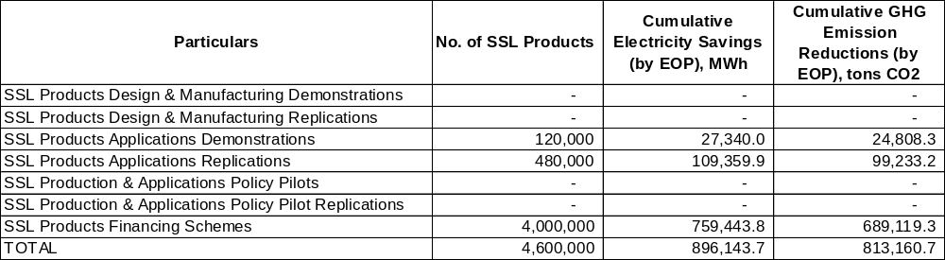

Alternative Scenario

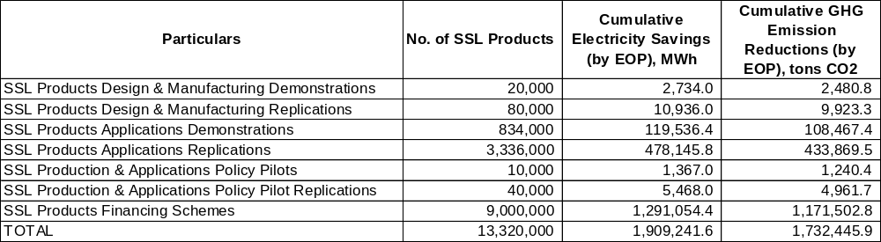

Incremental

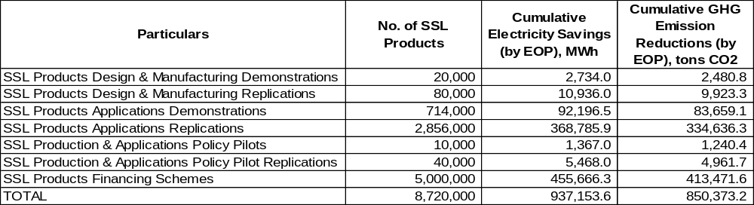

Direct CO₂ Emission Reductions (DER)

- DER_{EOP} = CO₂ emission reductions due to SSLED project intervention (cumulative by end-of-project) = 919,285 tons CO₂
- DER_{LIFETIME}
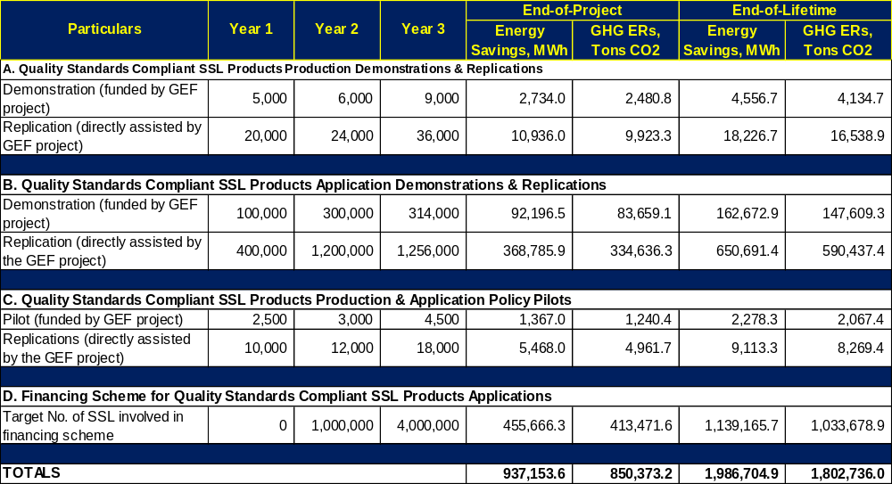
DER_{LIFETIME}= CO₂ emission reductions from all SSL products used in the SSLED project up to their lifetime (3 years) = 1,802,736 tons CO₂

Direct Post-Project CO₂ Emission Reductions (DPPER)

During the course of the SSLED project implementation, there will be direct assistance provided to SSL manufacturers and users. These beneficiaries will implement their SSL initiatives and realized energy savings (and CO₂ emission reductions). However, not all of them are expected to implement their SSL initiatives during the life span of the SSLED project. Some may only do their SSL applications and realize CO₂ emission reductions (from the lighting energy savings) after the SSLED project completion. Such GHG emission reductions can still be attributed to the SSLED Project as part of Direct Post Project Emission Reductions (DPPER).

Also, if the financing schemes (e.g., subsidy, rebate, etc.) that are developed and implemented by the SSLED projects are continued after the completion of the SSLED projects, the energy saving and CO₂ emission reductions from the SSL initiatives that will be supported by such financing schemes can still be attributed to SSLED Project as part of DPPER. On the assumption that the Financing Scheme developed and implemented by the SSLED Project will continue. For each million SSLs, the lifetime CO₂ ERs would be about 206,736 tons. If the scheme will run for 3 years, the estimated lifetime CO2 ERs would be around 620,207 tons per million SSL products.

To be conservative, the estimation of the lifetime direct post project CO2 emission reductions will assume that the financing scheme will not continue, but other similar financing schemes will be developed and implemented by banks and financing institutions, or by the government. Hence, for the SSLED Project, the Lifetime Direct Post Project CO2 ERs is ZERO.

Lifetime DPPER = 0 tons CO₂

Consequential CO₂ Emission Reductions (CER)

Bottom-up Approach (BUA)

In estimating the Lifetime Consequential Emission Reductions using the bottom-up approach (CER_{BUA}), the sum of the Lifetime DER and Lifetime DPPER is multiplied by a replication factor (RF). As a market transformation and demonstration project, the GEF prescribed RF value is 3. In this case:

CER_{BUA} = (Lifetime DER + Lifetime DPPER) x 3 = (1,802,736 + 0) = 5,408,208 tons CO₂

Top-Down Approach

The 10-year influence period starts from the year after the SSLED completion.
Forecast total quality compliant SSLs sold during the 10-year influence period = 74,453,263
- Estimated Forecast Total Electricity Savings from using quality compliant SSLs during the 10 year influence period (ES_{TDA}) = 5,654.3 GWh
- Estimated Forecast Total CO₂ ERs from using SSLs during the 10 year influence period (ER_{TDA}) = 5,130,718tons CO₂

Considering the: (a) enabling environment that the SSLED project will create for the SSL industry; and, (b) total potential emissions reduction during the 10 year influence period, a causality factor = 0.8 is deemed appropriate.

CER_{TDA} = Lifetime Consequential CO₂Emission Reductions = ER_{TDA} * CF = 4,104,574tons CO₂

Summary of CO₂ Emission Reductions

CO₂ Emission Reduction Type | Quantity, tCO₂
End-of-Project Direct CO₂ Emission Reduction (DER_{EOP}) | 850,373
Lifetime Direct CO₂ Emission Reduction (DER_{TOTAL}) | 1,802,736
Lifetime Direct Post Project CO₂ Emission Reduction (DPPER_{TOTAL}) | 0
Lifetime Consequential CO₂ Emission Reduction - BU Approach (CER_{BUA}) | 5,408,208
Lifetime Consequential CO₂ Emission Reduction - TD Approach (CER_{TDA}) | 4,104,574

Range of Lifetime Consequential CO₂ Emission Reduction: CER_{BUA}& CER_{TDA}: 4.1 – 5.4 billion tons

Annex IV: Annual Project Targets

Strategy | Objectively Verifiable Indicators |  |  | Annual Targets
Strategy | Indicator Description | Baseline | Target | Year 1 | Year 2 | Year 3
Project Objective:  Facilitation of the enhanced production and widespread application of quality solid state lighting (SSL) products in China | - Annual direct energy savings in China by EOP (GWh) | - 158 | • 937.2 | - 193 | - 462 | - 937.2
 | - Annual direct CO₂ emissions reduced in China by EOP (kilotons) | - 143 | - 850.4 | - 175 | - 419 | - 850.4
 | - No. of new jobs available in the ESL industry by EOP | - 0 | - 1000 | - 100 | - 500 | - 1000
 | - No. of women employed in new jobs in the ESL industry by EOP | - 0 | - 200 | - 20 | - 100 | - 200
Outcome 1  Enabling of enhanced and strategic SSL technology and market developments based on comprehensively assessed and documented up-to-date status of the SSL industry and market in China | - The value of quality standards compliant SSL products produced in China by EOP (billion RMB) | - 117.1 | - 184 | - 110 | - 142 | - 184
 | - The export value of quality standards compliant SSL products produced in China by EOP (billion USD) | - 5.4 | - 13.8 | - 8.9 | - 11.2 | - 13.8
Outcome2  Facilitation of support and incentives in the local production of quality SSL products, and in the application of SSL products compliant with established quality and energy performance standards | - No. of policy recommendations adopted and enforced by relevant government agency departments by EOP | • 3 | • 6 | - 4 | - 5 | - 6
 | - Qualified rate of quality standards compliant SSL products by EOP | • 50% | • 70% | - 55% | - 60% | - 70%
Outcome 3  Increased penetration rate of SSL products especially in the residential sector in China | - Market share of qualified SSL products in general lighting market in China by EOP | • 8.2% | • 28% | - 15% | - 21% | - 28%
Outcome 4  Enhanced quality and energy performance of locally produced SSL products both for the domestic and international markets | - No. of SSL quality and energy efficiency certificates issued by state-certified institutions by EOP | • 1200 | • 1500 | - 1300 | - 1400 | - 1500
 | - No. of local SSL manufacturers that are complying to the new EE standard/label for SSL products by EOP | • 0 | • 100 | - 10 | - 50 | - 100

Annex V: Terms of Reference for Project Staff and Consultants

1. National Project Manager (NPM)

a) Duties and Responsibilities: The post requires responsibility for implementation of the project, including mobilization of all project inputs, setup, implementation and maintenance of project’s internal control arrangements, supervision of project staff, consultants and oversight of sub-contractors. The NPM will be the leader of the Project Team (PT) and shall liaise with the government, UNDP, and all stakeholders involved in the Project. S/he will be specifically responsible for (a) overall management of the project, (b) work closely with project stakeholders and ensure the project deliveries as per project document and work plan, (c) ensure technical coordination of the project and the work related to regulatory, institutional, financial and implementation aspects, (d) mobilize all project inputs in accordance with UNDP procedures and GEF principles, (e) finalize the ToR for the consultants and subcontractors and coordinate with relevant organizations for recruitment, procurement and contracting, (f) supervise and coordinate the work of all project staff, consultants and sub-contractors, (g) ensure proper management of funds consistent with UNDP requirements, and budget planning and control, (h) prepare and ensure timely submission of monthly reports, quarterly consolidated financial reports, quarterly consolidated progress reports, annual, mid-term and terminal reports, and other reports as may be required by UNDP; (i) submit the progress reports and key issue report to the PAC, (j) prepare quarterly and annual work plan, (k) arrange for audit of all project accounts for each fiscal year, and (l) undertake any activities that may be assigned by UNDP and PAC.

b) Qualifications and Experience: The suitable candidate for the post should have a minimum Master degree in Engineering, Management or Environment and profession qualifications with at least six (6) years professional experience. S/he should have extensive experience and technical ability to manage a large project and a good technical knowledge in the fields related to policy/regulation/standard, climate change, energy efficiency, and lighting sector. S/he must have effective interpersonal and negotiation skills and ability to effectively manage project teams, and international and local consultants. Excellent communication skills both in English and Chinese are essential. S/he must have good knowledge of international project implementation procedures and requirements.

2. Admin Assistant (AA)

a) Duties and Responsibilities: The post requires responsibility to provide overall administration services of the Project in support of the Project team such as processing payments, raising requisition, purchase order, projects logs etc. The AA will also perform (a) word processing, drafting routine letters/messages/reports, mailing (b) arrange travel, itinerary preparation for project related travels, (c) assist to arrange workshops/seminar/training programs and mailing, (d) work at reception desk and make appointments and schedule meeting, (e) assist in work-plan and budgeting, (f) photocopying, binding and filing, (g) maintenance of all office equipment and any other duties assigned by Project Manager.

b) Qualifications and Experience: The suitable candidate for the post should have at least a Bachelor degree. S/he should have at least 3 years relevant working experience. Computer proficiency in MS Office and other common software is a prerequisite. Knowledge of international project implementation procedures and requirements is preferable. Fluent both in written and spoken English and Chinese is required.

3. Project Accountant (ACC)

a) Duties and Responsibilities: The post requires responsibility for the provision of overall financial services of the project such as processing payments, raising requisition, purchase order, projects logs etc. The ACC will also prepare work-plan budgets and Project expenditure and any other duties assigned by Project Manager.

b) Qualifications and Experience: The suitable candidate for the post should have at least a Bachelor degree. S/he should have at least 3 years relevant working experience. Computer proficiency in MS Office and other common software is a prerequisite. Basic knowledge in procurement and accounting systems is a basic requirement. Knowledge of international project implementation procedures and requirements is preferable. Fluent both in written and spoken English and Chinese is required.

4. Key Short-Term Consultants

Detailed TORs of the national and international consultants will be developed during the Project Inception period, by the NPM in consultation with UNDP and the implementing partners.

1) International Technical Specialist (ITS) for component 1 to 4:

  - Provide management oversight for project and recommend actions that focus work plans on achieving key milestones in a timely manner;
  - Recommend special expertise to be deployed on the Project to assist in its achievement of key milestones;
  - Provide the interface between Project team and key specialist consultants, both domestic and international when appropriate.

2) International Policy Specialist (IPS) for component 1 to 2:

  - Assess current policy, regulations, standards and specifications for LED;
  - Evaluate development of LED industry and establish project baseline;
  - Evaluate policy recommendations in the project outputs;
  - Support pilot project and provide recommendations for promotion of pilot experiences.

3) Domestic LED Policy Specialist for component 2 to 4:

  - Provide technical support for project team including the existing policy, laws and regulations, and standards for LED, and establish project baseline;
  - Provide strategic suggestion on formulation of the related policy, standards and specifications;
  - Evaluate the development of the related policy, standards and specifications and suggest on policy implementation and capacity building.

4) Domestic Capacity Building Advisor for component 4:

  - Evaluate the competence of stakeholders, including central government, local government, implementing parties, sector organization, retailer, testing labs and certified institutions, and establish project baseline;
  - Coordinate with project team to evaluate the training materials;
  - Coordinate with project team to plan and implement the related seminars and training sessions;
  - Coordinate with project team to evaluate the impact of the related seminars and training sessions.

5) Domestic LED Technical Specialist for component 1 to 3:

  - Provide technical supports for project team, evaluate the competence of manufactures, testing labs and certified institution and establish project baseline;
  - Provide strategic opinions on LED technical development;
  - Evaluate the production in demonstrative enterprises and improve the quality of LED products;
  - Evaluate the test in labs and ensure the quality of the test results of products.

6) Domestic technical engineer for component 3:

  - Provide technical consultation for pilot project's plan, design and implementation;
  - Evaluate and supervise pilot project's construction and operation;
  - Cooperate with project team to promote the pilot experience in a wider scope.

Annex VI: Description of Demonstrations

The demonstrations under the SSLED Project will be carried out in residential houses/buildings, central government offices, old people's home, hope primary school, large stadium, transportation infrastructures, intelligent housing estate and special environments such as smog area, high-altitude area and severe cold area. A total of 50 cities or towns will be selected based on the North Line A, North Line B, Middle Line and South Line of One Belt and One Road Plan to demonstrate the application of LED lighting in different location, different area and different climate conditions. The demonstrations will cover public building lighting, residential house lighting, industry lighting, transportation lighting, smart lighting and renewable energy. In addition, some innovative pilot projects of application will be planned, such as smart city lighting, sports venue lighting, medical and health lighting. These pilot projects can demonstrate to public that LED lighting will not only save energy but also provide quality lighting for different needs.

Residential housing lighting system demonstration

Based on the SSL market and manufacturers surveys that were done during the PPG exercise, the residence lighting demonstration has been designed for mostly lighting system retrofit and lamp replacement. The demonstration is based on the government LED demo program involving 175,000 different types of SSL products (see table below). Under the SSLED project, the demonstration for the manufacture and application of various types of SSL product types that are used in residential households will involve an incremental 5,182,400 SSL products, bulk of which will be through the financing scheme that will be developed and implemented under the project.

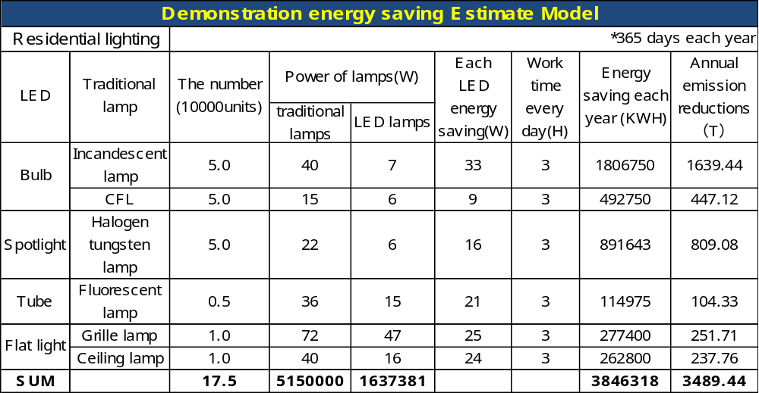

Public building lighting system demonstration

Based on the SSL market and manufacturers surveys that were carried out during the PPG exercise, the public lighting system demonstration has been designed to cover lighting systems in general public areas, government buildings, as well as sports and recreations venues. It involves the retrofit of existing lighting systems and replacement of lamps with SSL products. The demonstration is based on the government LED demo program involving 240,000 different types of SSL products (see table below). Under the SSLED project, the demonstration for the manufacture and application of various types of SSL product types that are used in public areas and buildings will involve an incremental 250,100 SSL products.
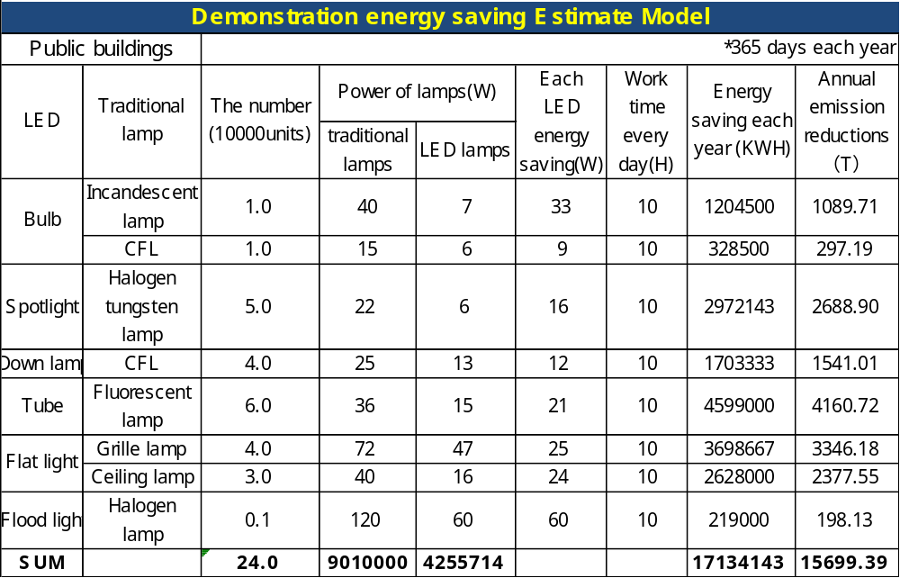

Industrial lighting system demonstration

The industry lighting demonstration is designed to feature mostly retrofits of existing lamps in industrial facilities replacing them with applicable SSL products. The demonstration is based on the government LED demo program involving 110,000 different types of SSL products (see table below). Under the SSLED project, the demonstration for the manufacture and application of various types of SSL product types that are used in industrial manufacturing facilities will involve an incremental 114,600 SSL products.

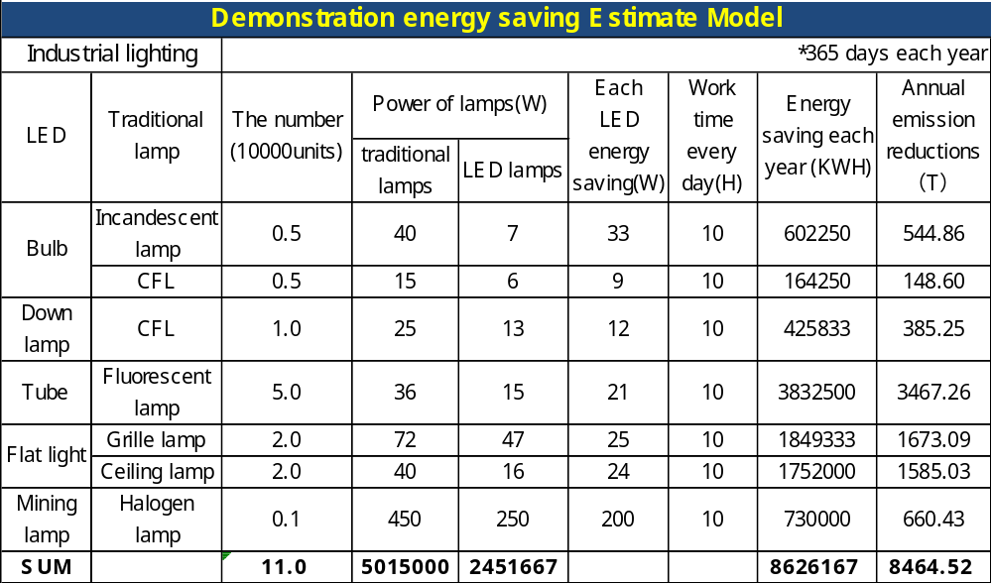

Traffic lighting system application demonstration

The demonstration of the application of SSL products in traffic management (lighting) has been designed for street and tunnel lighting. The demonstration is based on the government LED demo program involving 80,000 different types of SSL products (see table below). Under the SSLED project, the demonstration for the manufacture and application of various types of SSL product types that are used in traffic lighting systems will involve an incremental 83,400 SSL products.
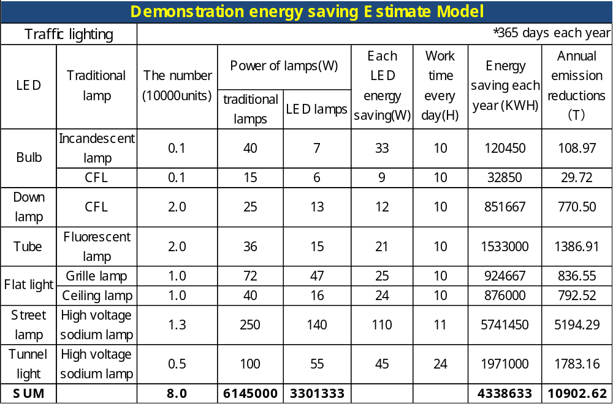

Intelligent lighting system demonstration

The demonstration on the application SSL products in what is presently termed as intelligent or smart lighting systems that aims for maximization energy savings of lighting on the premise of creating a comfortable and healthy lighting environment for people. It has been designed for showcasing improved lighting performance. The demonstration is based on the government LED demo program involving 104,000 different types of SSL products (see table below). Under the SSLED project, the demonstration for the manufacture and application of various types of SSL product types that will be used for intelligent lighting systems will involve an incremental 108,400 SSL products.
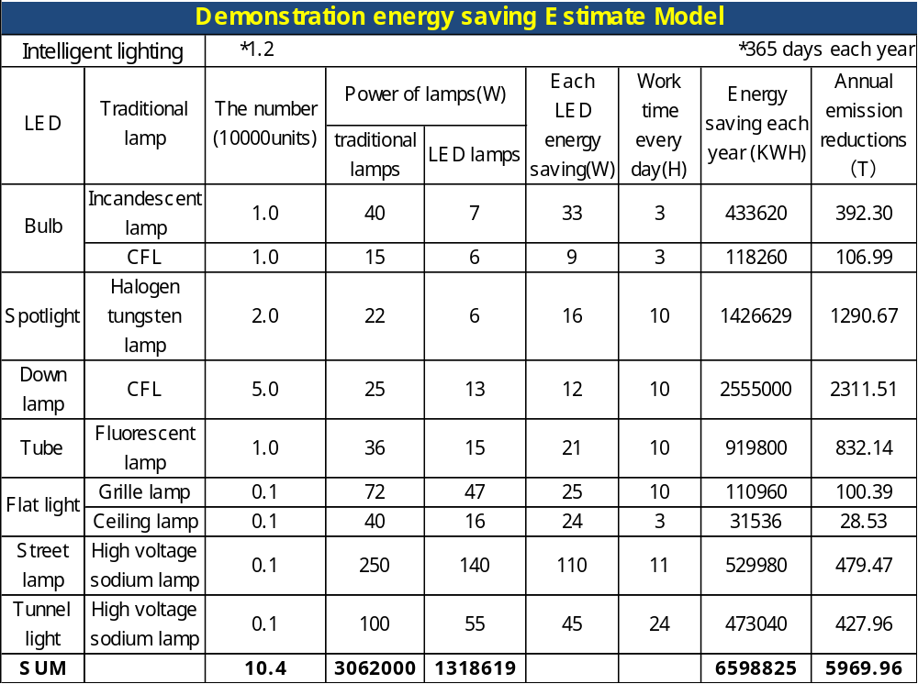

Renewable energy powered lighting system demonstration

The demonstration will be implemented in off-grid areas of the country where the energy (e.g., electricity) is supplied from RE resources. Based on the SSL market and manufacturers surveys that were carried out during the PPG exercise, the demonstration will focus on the applications of feasible SSL products in systems served by electricity produced from RE-based power generation systems. The demonstration is based on the government LED demo program involving 5,000 different types of SSL products (see table below). Under the SSLED project, the demonstration for the manufacture and application of various types of SSL product types that are used in off-grid areas (e.g., residences, buildings, streets) will involve an incremental 5,200 SSL products.

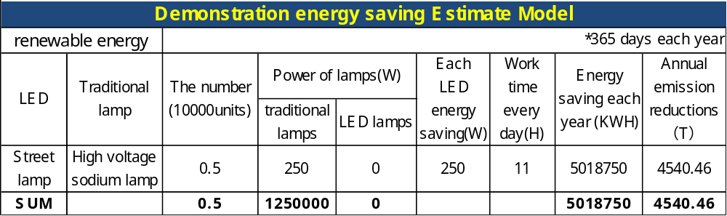

Annex VII: Service Agreement between UNDP and NDRC
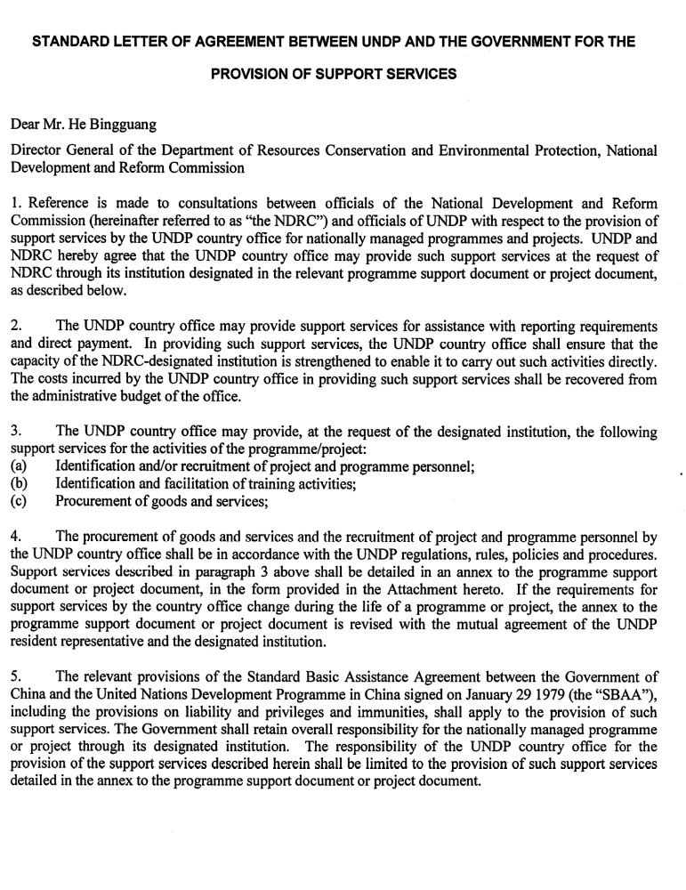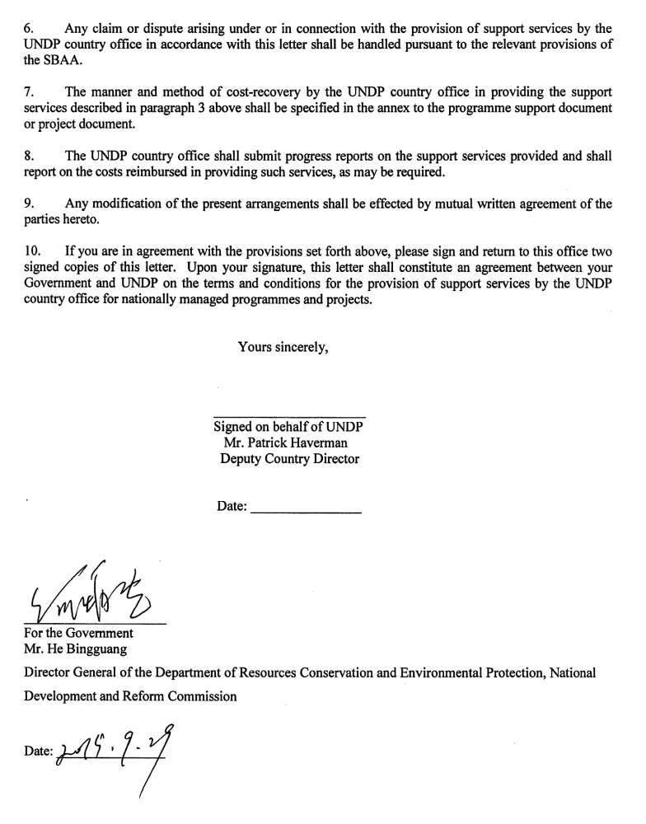

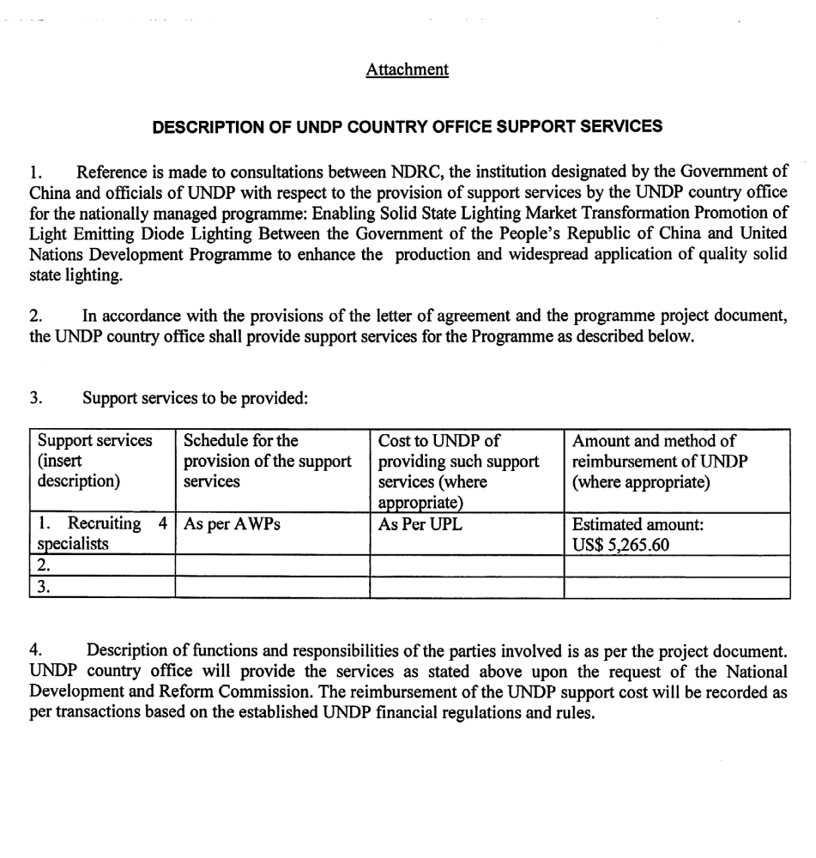

Annex VIII: Social and Environmental Screening

Project Information

Project Information
- Project Title | Enabling Solid State Lighting Market Transformation & Promotion of Light Emitting Diode (LED) Lighting
- Project Number | 5669
- Location (Global/Region/Country) | China

Part A. Integrating Overarching Principles to Strengthen Social and Environmental Sustainability

QUESTION 1: How Does the Project Integrate the Overarching Principles in order to Strengthen Social and Environmental Sustainability?
Briefly describe in the space below how the Project mainstreams the human-rights based approach

The market popularization of quality made SSL products that will facilitated through the proposed SSLED Project will promote employment (e.g., in new and accredited SSL manufacturing companies). Also, the applications downstream of the SSL industry value chain is also labor intensive, and would open prospects for new jobs if there will be increased manufacturing and utilization of SSL products. The project will also be designed and implemented with due consideration of human rights principles, through engagement of the concepts of equality in the dissemination of knowledge and sharing of benefits.

The project partners acknowledge human rights practices under international law and the application of human rights-related standards in the design and implementation of the project. The project is designed to enhance the availability, accessibility and quality of benefits and services for all relevant target groups including those that are potentially marginalized individuals and groups.
Briefly describe in the space below how the Project is likely to improve gender equality and women’s empowerment

The project is designed taking into account the need to promote gender equality; specifically to provide employment training for women, The training programs under the project will include activities that will promote the employment particularly for women in the SSL industry and in those that make up the value chain of the SSL industry. The project is expected to bring about employment for women in new jobs that will be created in the SSL industry in China.
Briefly describe in the space below how the Project mainstreams environmental sustainability

During the implementation of the project and for a long period after the completion of the project, the achievements of the project would boost the improvement of the quality of Chinese SSL products, promote market transformation and application and the development of the small and medium-sized enterprise of SSL, drive the transformation and upgrading of traditional lighting industry, improve the quality and energy efficiency of export products, and make great achievements in energy savings and emission reduction by the implementation of the project.

Part B. Identifying and Managing Social and Environmental Risks

QUESTION 2: What are the Potential Social and Environmental Risks?  Note: Describe briefly potential social and environmental risks identified in Attachment 1 – Risk Screening Checklist (based on any “Yes” responses). If no risks have been identified in Attachment 1 then note “No Risks Identified” and skip to Question 4 and Select “Low Risk”. Questions 5 and 6 not required for Low Risk Projects. | QUESTION 3: What is the level of significance of the potential social and environmental risks?  Note: Respond to Questions 4 and 5 below before proceeding to Question 6 |  |  |  | QUESTION 6: What social and environmental assessment and management measures have been conducted and/or are required to address potential risks (for Risks with Moderate and High Significance)?
Risk Description | Impact and Probability (1-5) | Significance  (Low, Moderate, High) | Comments |  | Description of assessment and management measures as reflected in the Project design. If ESIA or SESA is required note that the assessment should consider all potential impacts and risks.
Risk1: Would the Project potentially reproduce discriminations against women based on gender, especially regarding participation in design and implementation or access to opportunities and benefits? | I = 1  P=2 | Low | The SSLED Project would bring about increased local production of LED lighting products and could provide opportunities for women to work in such field. |  | One of human development indicators of the project is the number of trained and employed women in new SSL manufacturing companies. By implementing professional job training in this industry, for both men and women will improve and promote gender equality and improve the lot of qualified and capable Chinese women in technical areas such as the SSL industry.
Risk2: Would the Project potentially result in the release of pollutants to the environment due to routine or non-routine circumstances with the potential for adverse local, regional, and/or trans-boundary impacts? | I = 1  P=2 | Low | This could happen in cases where increased use of LED lamps will lead to replacement and improper disposal of Hg containing CFLs. |  | SSL products are Hg-free lighting devices, and would therefore not be detrimental to the natural environment when disposed-off after their useful lives. The project will also see to it that actions are taken to ensure: (1) compliance with photobiological safety standards for SSL products; and, (2) the proper disposal of lamps replaced with SSLs.
 | QUESTION 4: What is the overall Project risk categorization?
 | Select one (see SESP for guidance) |  |  |  |  | Comments
 | Low Risk |  |  |  |  | Strengthen communication with the government, manufacturers, project office and other agencies, to take preventive measures.
 | Moderate Risk |  |  | ☐
 | High Risk |  |  | ☐
 | QUESTION 5: Based on the identified risks and risk categorization, what requirements of the SES are relevant?
 | Check all that apply |  |  |  |  | Comments
 | Principle 1: Human Rights |  |  | ☐
 | Principle 2: Gender Equality and Women’s Empowerment |  |  |  |  | Gender equality and women's employment has been advocated by China, the project will raise the level of gender equality and women's employment.
 | 1. Biodiversity Conservation and Natural Resource Management |  |  | ☐
 | 2. Climate Change Mitigation and Adaptation |  |  | ☐
 | 3. Community Health, Safety and Working Conditions |  |  | ☐
 | 4. Cultural Heritage |  |  | ☐
 | 5. Displacement and Resettlement |  |  | ☐
 | 6. Indigenous Peoples |  |  | ☐
 | 7. Pollution Prevention and Resource Efficiency |  |  |  |  | In cases where increased LED lamps use will lead to replacement and improper disposal of Hg containing CFLs

Final Sign Off

Signature | Date | Description
QA Assessor |  | UNDP staff member responsible for the Project, typically a UNDP Programme Officer. Final signature confirms they have “checked” to ensure that the SESP is adequately conducted.
QA Approver |  | UNDP senior manager, typically the UNDP Deputy Country Director (DCD), Country Director (CD), Deputy Resident Representative (DRR), or Resident Representative (RR). The QA Approver cannot also be the QA Assessor. Final signature confirms they have “cleared” the SESP prior to submittal to the PAC.
PAC Chair |  | UNDP chair of the PAC. In some cases PAC Chair may also be the QA Approver. Final signature confirms that the SESP was considered as part of the project appraisal and considered in recommendations of the PAC.

SESP Attachment 1. Social and Environmental Risk Screening Checklist

Checklist Potential Social and Environmental Risks
Principles 1: Human Rights | Answer  (Yes/No)
1. Could the Project lead to adverse impacts on enjoyment of the human rights (civil, political, economic, social or cultural) of the affected population and particularly of marginalized groups? | No
2. Is there a likelihood that the Project would have inequitable or discriminatory adverse impacts on affected populations, particularly people living in poverty or marginalized or excluded individuals or groups? | No
3. Could the Project potentially restrict availability, quality of and access to resources or basic services, in particular to marginalized individuals or groups? | No
4. Is there a likelihood that the Project would exclude any potentially affected stakeholders, in particular marginalized groups, from fully participating in decisions that may affect them? | No
5. Is there a risk that duty-bearers do not have the capacity to meet their obligations in the Project? | No
6. Is there a risk that rights-holders do not have the capacity to claim their rights? | No
7. Have local communities or individuals, given the opportunity, raised human rights concerns regarding the Project during the stakeholder engagement process? | No
8. Is there a risk that the Project would exacerbate conflicts among and/or the risk of violence to project-affected communities and individuals? | No
Principle 2: Gender Equality and Women’s Empowerment
1. Is there a likelihood that the proposed Project would have adverse impacts on gender equality and/or the situation of women and girls? | No
2. Would the Project potentially reproduce discriminations against women based on gender, especially regarding participation in design and implementation or access to opportunities and benefits? | Yes
3. Have women’s groups/leaders raised gender equality concerns regarding the Project during the stakeholder engagement process and has this been included in the overall Project proposal and in the risk assessment? | No
4. Would the Project potentially limit women’s ability to use, develop and protect natural resources, taking into account different roles and positions of women and men in accessing environmental goods and services?  For example, activities that could lead to natural resources degradation or depletion in communities who depend on these resources for their livelihoods and well-being. | No
Principle 3: Environmental Sustainability: Screening questions regarding environmental risks are encompassed by the specific Standard-related questions below
Standard 1: Biodiversity Conservation and Sustainable Natural Resource Management
1.1 Would the Project potentially cause adverse impacts to habitats (e.g. modified, natural, and critical habitats)and/or ecosystems and ecosystem services?  For example, through habitat loss, conversion or degradation, fragmentation, hydrological changes | No
1.2 Are any Project activities proposed within or adjacent to critical habitats and/or environmentally sensitive areas, including legally protected areas (e.g. nature reserve, national park), areas proposed for protection, or recognized as such by authoritative sources and/or indigenous peoples or local communities? | No
1.3 Does the Project involve changes to the use of lands and resources that may have adverse impacts on habitats, ecosystems, and/or livelihoods? (Note: if restrictions and/or limitations of access to lands would apply, refer to Standard 5) | No
1.4 Would Project activities pose risks to endangered species? | No
1.5 Would the Project pose a risk of introducing invasive alien species? | No
1.6 Does the Project involve harvesting of natural forests, plantation development, or reforestation? | No
1.7 Does the Project involve the production and/or harvesting of fish populations or other aquatic species? | No
1.8 Does the Project involve significant extraction, diversion or containment of surface or ground water?  For example, construction of dams, reservoirs, river basin developments, groundwater extraction. | No
1.9 Does the Project involve utilization of genetic resources? (e.g. collection and/or harvesting, commercial development) | No
1.10 Would the Project generate potential adverse trans boundary or global environmental concerns? | No
1.11 Would the Project result in secondary or indirect development activities which could lead to adverse social and environmental effects, or would it generate cumulative impacts with other known existing or planned activities in the area?  For example, a new road through forested lands will generate direct environmental and social impacts (e.g. felling of trees, earthworks, potential relocation of inhabitants). The new road may also facilitate encroachment on lands by illegal settlers or generate unplanned commercial development along the route, potentially in sensitive areas. These are indirect, secondary, or induced impacts that need to be considered. Also, if similar developments in the same forested area are planned, then cumulative impacts of multiple activities (even if not part of the same Project) need to be considered. | No
Standard 2: Climate Change Mitigation and Adaptation
2.1 Will the proposed Project result in significantgreenhouse gas emissions or may exacerbate climate change? | No
2.2 Would the potential outcomes of the Project be sensitive or vulnerable to potential impacts of climate change? | No
2.3 Is the proposed Project likely to directly or indirectly increase social and environmental vulnerability now or in the future (also known as maladaptive practices)?  For example, changes to land use planning may encourage further development of floodplains, potentially increasing the population’s vulnerability to climate change, specifically flooding | No
Standard 3: Community Health, Safety and Working Conditions
3.1 Would elements of Project construction, operation, or decommissioning pose potential safety risks to local communities? | No
3.2 Would the Project pose potential risks to community health and safety due to the transport, storage, and use and/or disposal of hazardous or dangerous materials (e.g. explosives, fuel and other chemicals during construction and operation)? | No
3.3 Does the Project involve large-scale infrastructure development (e.g. dams, roads, buildings)? | No
3.4 Would failure of structural elements of the Project pose risks to communities (e.g. collapse of buildings or infrastructure)? | No
3.5 Would the proposed Project be susceptible to or lead to increased vulnerability to earthquakes, subsidence, landslides, and erosion, flooding or extreme climatic conditions? | No
3.6 Would the Project result in potential increased health risks (e.g. from water-borne or other vector-borne diseases or communicable infections such as HIV/AIDS)? | No
3.7 Does the Project pose potential risks and vulnerabilities related to occupational health and safety due to physical, chemical, biological, and radiological hazards during Project construction, operation, or decommissioning? | No
3.8 Does the Project involve support for employment or livelihoods that may fail to comply with national and international labor standards (i.e. principles and standards of ILO fundamental conventions)? | No
3.9 Does the Project engage security personnel that may pose a potential risk to health and safety of communities and/or individuals (e.g. due to a lack of adequate training or accountability)? | No
Standard 4: Cultural Heritage
4.1 Will the proposed Project result in interventions that would potentially adversely impact sites, structures, or objects with historical, cultural, artistic, traditional or religious values or intangible forms of culture (e.g. knowledge, innovations, practices)? (Note: Projects intended to protect and conserve Cultural Heritage may also have inadvertent adverse impacts) | No
4.2 Does the Project propose utilizing tangible and/or intangible forms of cultural heritage for commercial or other purposes? | No
Standard 5: Displacement and Resettlement
5.1 Would the Project potentially involve temporary or permanent and full or partial physical displacement? | No
5.2 Would the Project possibly result in economic displacement (e.g. loss of assets or access to resources due to land acquisition or access restrictions – even in the absence of physical relocation)? | No
5.3 Is there a risk that the Project would lead to forced evictions? | No
5.4 Would the proposed Project possibly affect land tenure arrangements and/or community based property rights/customary rights to land, territories and/or resources? | No
Standard 6: Indigenous Peoples
6.1 Are indigenous peoples present in the Project area (including Project area of influence)? | No
6.2 Is it likely that the Project or portions of the Project will be located on lands and territories claimed by indigenous peoples? | No
6.3 Would the proposed Project potentially affect the human rights, lands, natural resources, territories, and traditional livelihoods of indigenous peoples (regardless of whether indigenous peoples possess the legal titles to such areas, whether the Project is located within or outside of the lands and territories inhabited by the affected peoples, or whether the indigenous peoples are recognized as indigenous peoples by the country in question)?  If the answer to the screening question 6.3 is “yes” the potential risk impacts are considered potentially severe and/or critical and the Project would be categorized as either Moderate or High Risk. | No
6.4 Has there been an absence of culturally appropriate consultations carried out with the objective of achieving FPIC on matters that may affect the rights and interests, lands, resources, territories and traditional livelihoods of the indigenous peoples concerned? | No
6.5 Does the proposed Project involve the utilization and/or commercial development of natural resources on lands and territories claimed by indigenous peoples? | No
6.6 Is there a potential for forced eviction or the whole or partial physical or economic displacement of indigenous peoples, including through access restrictions to lands, territories, and resources? | No
6.7 Would the Project adversely affect the development priorities of indigenous peoples as defined by them? | No
6.8 Would the Project potentially affect the physical and cultural survival of indigenous peoples? | No
6.9 Would the Project potentially affect the Cultural Heritage of indigenous peoples, including through the commercialization or use of their traditional knowledge and practices? | No
Standard 7: Pollution Prevention and Resource Efficiency
7.1 Would the Project potentially result in the release of pollutants to the environment due to routine or non-routine circumstances with the potential for adverse local, regional, and/or trans boundary impacts? | Yes
7.2 Would the proposed Project potentially result in the generation of waste (both hazardous and non-hazardous)? | No
7.3 Will the proposed Project potentially involve the manufacture, trade, release, and/or use of hazardous chemicals and/or materials? Does the Project propose use of chemicals or materials subject to international bans or phase-outs?  For example, DDT, PCBs and other chemicals listed in international conventions such as the Stockholm Conventions on Persistent Organic Pollutants or the Montreal Protocol. | No
7.4 Will the proposed Project involve the application of pesticides that may have a negative effect on the environment or human health? | No
7.5 Does the Project include activities that require significant consumption of raw materials, energy, and/or water? | No

For UNDP supported GEF funded projects as this includes GEF-specific requirements.
Data source: Sandia National Laboratory of DOE of the USA, 2007.
Data source: Disciplinary Development Report on Lighting Science and Technology 2012-2013, CAST, CIES, 2014.
Data source: Disciplinary Development Report on Lighting Science and Technology 2012-2013, CAST, CIES, 2014.
Data source: Life-Cycle Assessment of Energy and Environmental Impacts of LED Lighting Products, DOE, 2012.
Data source: CSA Research, 2014.
Data source: “Life-Cycle Assessment of Energy and Environmental Impacts of LED Lighting Products”, DOE, 2012.
Data source: Graph of Phase-out of Incandescent Lamps by Steps of China, NDRC, MOC, GAC, SAIC, AQSIQ, 2011.
Data source: National Analysis and Forecast Report on Power Supply and Demand in 2015, China CEC, 2015.
Data source: Survey and Analysis Report on Chinese Lighting Market in 2012, CIES, Beijing Huatongren Commercial Information Co., Ltd. (ACMR), 2012.
Data source: CALI, 2014.
Data source: General LED lighting products refer to the indoor and outdoor functional lighting products, excluding the products for landscape lighting decoration, car lighting, etc. CSA Research, 2014
Data source: Data and Development Situation of China’s Semiconductor Lighting Industry in 2014, CSA Research.
Data source: CIES, CSA Research, 2014.
Data source: Overview of the Data and Development of Solid State Lighting Industry in China in 2014, CSA Research.
Data source: China Customs, CSA Research, 2014.
Data source: Promotion of Electric Power Construction of Areas without Power Supply by SGCC, China Power Network, 2013.
Data source: Overview of the Data and Development of Solid State Lighting Industry in China in 2014, CSA Research.
Examples are LEDinside, the GSC (Guangdong Solid Lighting Industry Innovation Center), GGLED, etc. It is not uncommon that the SSL industry output in Guangdong Province as reported by GSC is sometimes more than the overall SSL industry output in China as reported by the CSA.
25 Based on the GHG emission reduction estimates shown in Annex 3.
26According to the Program for SSL Industry issued jointly by six ministries and administrations of the PRC in 2013, LED functional lighting products will cover more than 20% of market shares.
2⁷ By reference to the growth of market shares for recent years, it is calculated that the market shares of LED general lighting in china will reach 40% in 2018with GEF fund.
This refers to the "Silk Road Economic Belt" and "21st Century Maritime Silk Road". It's an "Asia-Africa-Europe Infrastructure Plan", and covers the provinces in the west of China.
This refers to systems that involve intelligent control of lighting equipment via distributed wireless tele-measurement, tele-control and telecommunication control systems composed of computer, wireless data transmission, spread spectrum communication technology, computer intelligent information processing and energy saving electrical control system.
This may include: CIE S009-2002: Photobiological Safety of Lamps and Lamp Systems; ANSI/IES RP27: Recommended Practice for Photobiological Safety for Lamps and Lamp Systems; IEC/EN 62471: Photobiological Safety of Lamps and Luminaires. Supporting guidance is provided in IEC/TR 62471-2 (2009) and IEC/TR 62778 (2012).
Prohibited grounds of discrimination include race, ethnicity, gender, age, language, disability, sexual orientation, religion, political or other opinion, national or social or geographical origin, property, birth or other status including as an indigenous person or as a member of a minority.References to “women and men” or similar is understood to include women and men, boys and girls, and other groups discriminated against based on their gender identities, such as transgender people and transsexuals.
In regards to CO_{2,} ‘significant emissions’ corresponds generally to more than 25,000 tons per year (from both direct and indirect sources). [The Guidance Note on Climate Change Mitigation and Adaptation provides additional information on GHG emissions.]
Forced evictions include acts and/or omissions involving the coerced or involuntary displacement of individuals, groups, or communities from homes and/or lands and common property resources that were occupied or depended upon, thus eliminating the ability of an individual, group, or community to reside or work in a particular dwelling, residence, or location without the provision of, and access to, appropriate forms of legal or other protections.

